Form F9
[Insert court] Sheriff Court | Ref: [insert case reference] | Form F9

Name
Address Line 1
Address Line 2
City
Postcode

Dear [insert child’s first name]
You have been sent this letter because the sheriff will need to make a decision about you. The sheriff (sometimes called a judge) is a person who makes important decisions for children and families. [Insert short summary of the section 11 order(s) sought, using child-friendly language.] The sheriff has to decide about that.
The sheriff wants to know what you think about that. You have a right to tell the sheriff what you think, but you do not have to tell the sheriff what you think if you do not want to. What you think is very important, and it will help the sheriff to make a decision about what is best for you. Sometimes this might be different from what you would like to happen.
If you want to tell the sheriff what you think, you can use the What I Think form sent with this letter. You can write or draw anything you like. There is no right or wrong answer. Please send the form back to the sheriff when you have filled it in. We have sent you an envelope, which should already have a stamp on it. Just put the form in the envelope and put the envelope in a post box within 2 weeks, or as soon as you can.
The sheriff might not tell anyone exactly what you have written or said, but the sheriff has to think about this and say in court what you would like to happen.
If you are not sure what to do, you can show this letter to someone you trust. If you want to know more about what will happen next, you might get free help from a lawyer or from these places that can help children:

If there’s anything you are worried or upset about and you don’t know what to do, you can speak to someone at ChildLine who will listen and help you. You can phone ChildLine free on 0800 1111.
If what you think changes, you can contact a lawyer or call the phone numbers for the Scottish Child Law Centre or Clan Childlaw.
From
the Sheriff Clerk, (the person who helps the sheriff)


[Insert court] Sheriff Court | Ref: [insert case reference] | Form F9

What I Think Form

Name:
How do you feel just now about [insert short summary of the section 11 order(s) sought, using child-friendly language]?

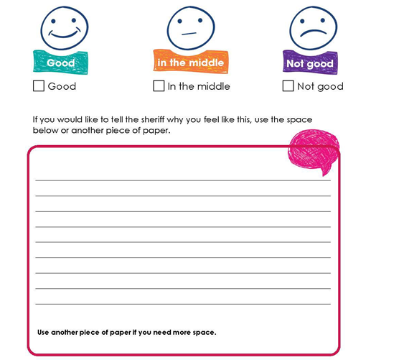



[Insert court] Sheriff Court | Ref: [insert case reference] | Form F9

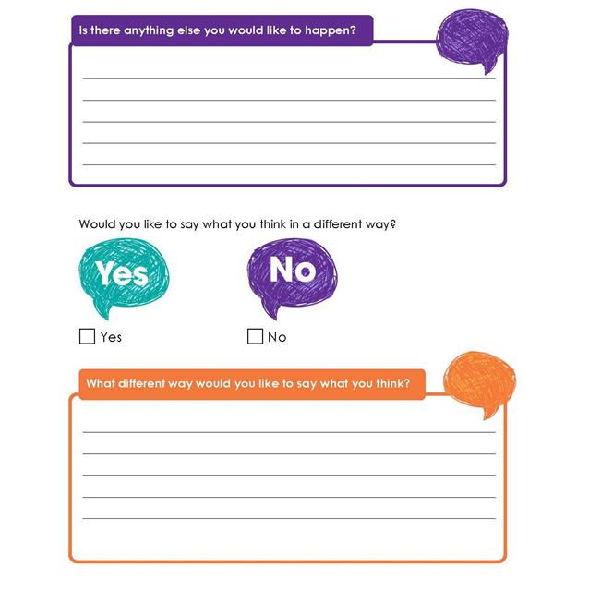


[Insert court] Sheriff Court | Ref: [insert case reference] | Form F9

