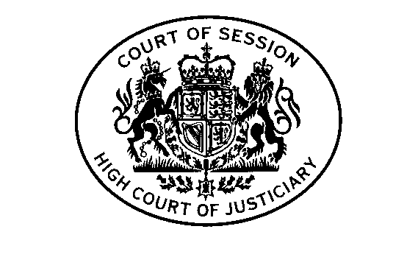
Criminal Courts Rules Council
Meeting – Monday 21 February 2022 at 1030am
By Webex video

AGENDA

- Welcome and apologies.

- Minutes of 10 February 2020 meeting and matters arising [Paper 1].

- Scottish Government update: [Paper 2- private paper].

- Rules request from DVLA regarding amendment to Form 16.1C [Papers 3 and 3A].
- Rules request from Scottish Government regarding amendment of solemn witness citation [Papers 4 and 4A –private papers].
- AOCB.

- Date of next meeting –tbc

