

**Visiting**

**Wick Sheriff Court**

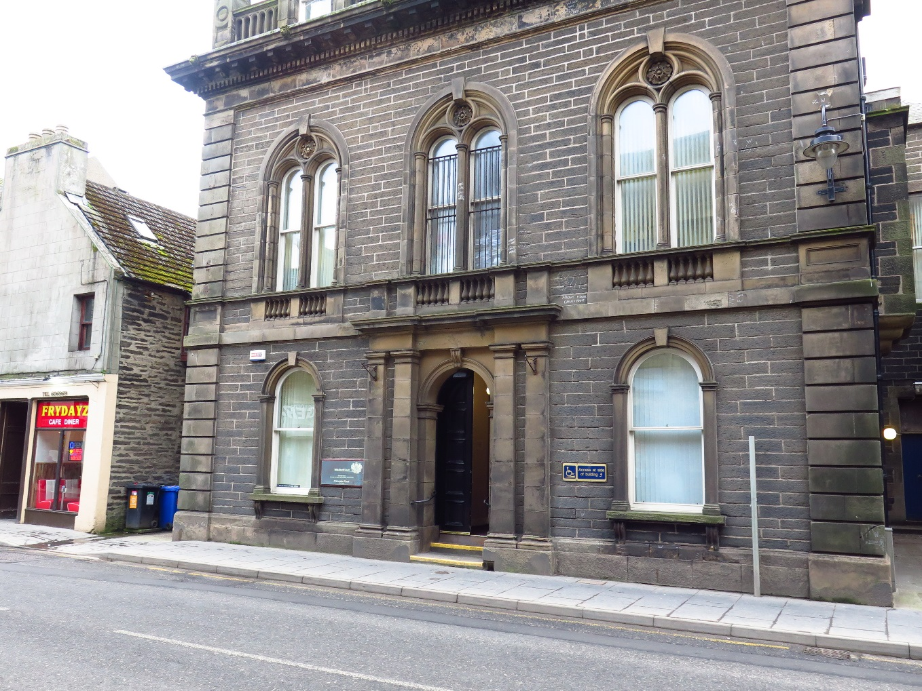





This leaflet will help you to plan your visit to the Wick Sheriff Court.

If you require more information about anything here you can email:

[enquires@scotcourts.gov.uk](mailto:enquires@scotcourts.gov.uk)

or telephone the Property and Services Unit on:

**0131 440 3300**

or text phone

**18001 0131 444 3300**

(Full contact details are on

Page 20)

**Contents**

**Location Details**

Page 4

……………………………………………..

**Ways of getting to the Court Building**

Pages 5 to 8

………………………………………………

**On Arrival**

Pages 9 to 10

………………………………………………

**Facilities**

Pages 11 to 15

……………………………………………….

**Floor Plans**

Pages 16 and 18

………………………………………………

**Opening Times & Public Holidays**

Page 19

………………………………………………

**Contact Information**

Page 20

………………………………………………

**Accessibility Contact**

Page 21

**Additional Information**

Pages 22 and 23

**Location Details**

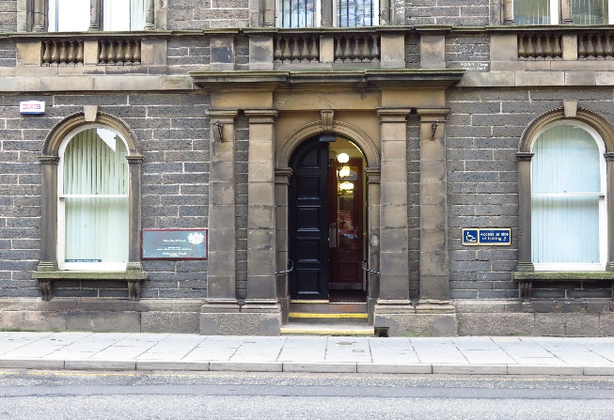

Wick Sheriff Court is located on Bridge Street. The Court opened in 1866 and was designed by the Edinburgh architect David Rhind who adopted many Renaissance features, in particular copying the middle floor windows from the Vendramini Palace in Venice.

**Ways of getting to the Court Building**



**By Bus**

There are three bus stops within a few minutes walk of the Sheriff Court in Wick. These would be found on Bridge Street and opposite the Norseman Hotel.

Adjacent Bus stops

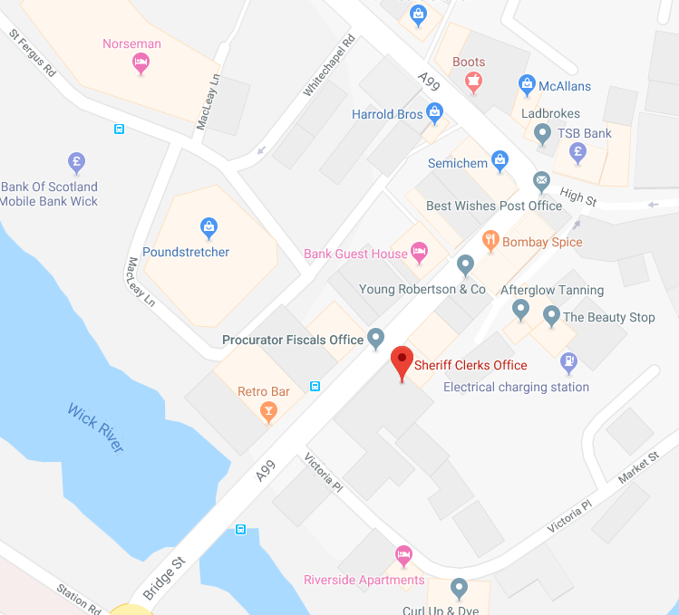

Map data @2016 Google

**By Train**

The main train station in Wick is just a 5 minute walk from the court building

Visit [www.nationalrail.co.uk](http://www.nationalrail.co.uk)

or call **03457 484 950** for train times.



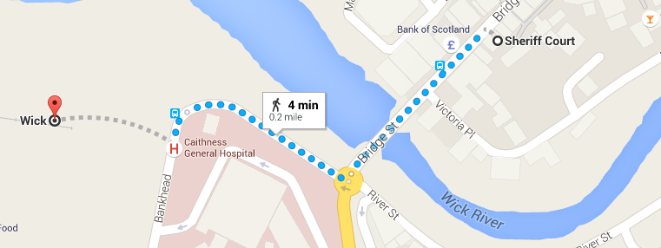

Map data @2016 Google

Train station location

**By Public Transport**

Contact Traveline Scotland for all public transport enquiries and assistance on **0871 200 22 33** or visit

[www.travelinescotland.com](http://www.travelinescotland.com)

**By Car**

There is one disabled car park place available at this court. There are also a few general public places, but these are limited. Free public car parking available (at River Side across from Norseman Hotel) and Victoria Place, Wick



**By Taxi**

Wick Taxi Services:

* Annettes Taxis 1955603030
* D & A Taxis 01955605766
* Jimmy's Taxis Freephone 0800 666666 or 01955 602727, 01955 603362
* Johnny's Taxis 01955 05041
* Millers Cabs 01955 606464
* Thurso Taxi Services: Alan's Taxis 01847 892142
* Harbour Taxis 01847 892827
* Meiklejohn Taxis 01847 892827
* Ormlie Taxis 01847 893434



**On Arrival**

**Entrance**

The public entrance is located on Bridge Street and has three steps. There is a ramp within the entrance to assist with restricted mobility.

Wheelchair users can assess the court by calling for assistance with the intercom provided or making prior arrangements with the Court or Sheriff Clerk Office.

Please report to the Sheriff Clerk Office on arrival and state the reason for your visit. The staff will then direct you accordingly.

Staff can assist you if you have any question about the court building or your visit.

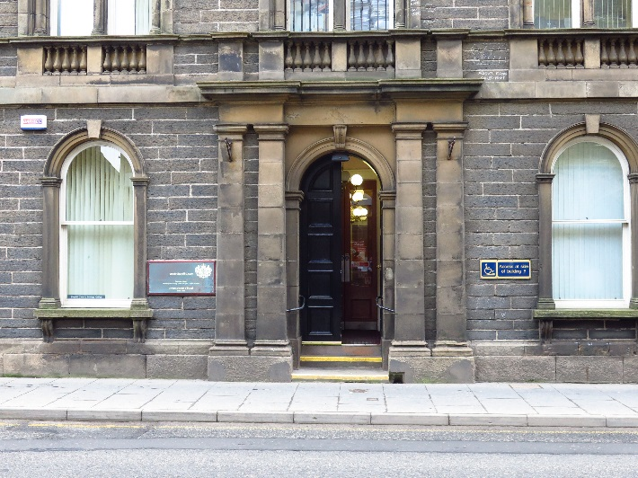

Entrance steps

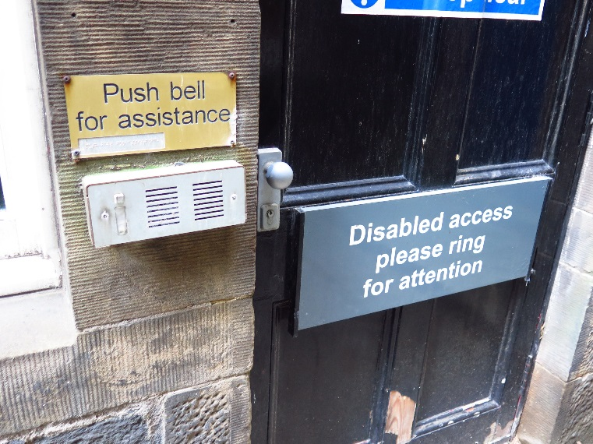

Disables access





If you have a wheelchair or a pushchair and you require specific access assistance, please telephone:

**01955 602846**

or textphone

**18001 01955 602846**

For further information on the layout of the court building please refer to the floor plan layouts on pages 17,18,19.

**Facilities**







**Toilets**

Toilets are available on ground level of the courthouse. An accessible toilet is provided on the ground floor opposite the entrance.

**Signage**

High contrast signage is provided around all circulation areas to ensure the public zones are easily navigated.





**Refreshments**

There are various cafes within a short walking distance from courthouse. If you are sitting on a jury, lunch and refreshments will be provided if the court sits into the afternoon.

**Hearing Loop**

For people who are hard of hearing a fixed loop induction service is available within Courtroom 1.

On arrival please inform the reception desk staff if you require this facility.

**Courtrooms**

Court 1 is well lit, spacious and has good acoustic qualities including full induction loop facilities but is not accessible to wheelchair users. Court 2 is available to wheelchair users and is accessible on the ground floor.

**Internal Access**

The ground floor corridors and hall serve as the central point of orientation to access the rest of the building. The hall spacious enough to accommodate wheelchair users. The main staircase to the first floor levels is found on the right of the main hall.

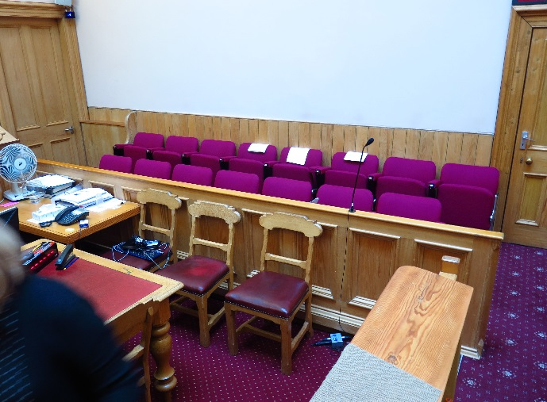

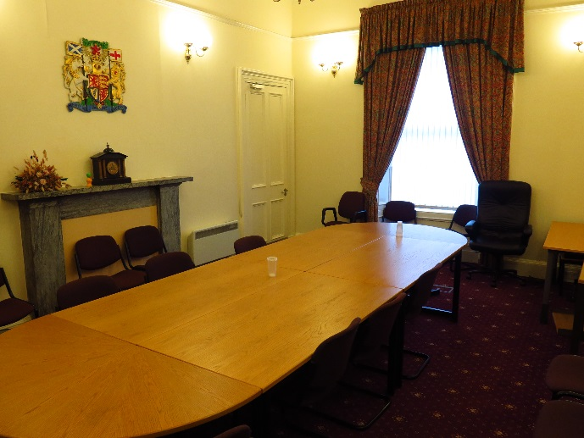

Typical court room

[](https://www.google.co.uk/url?sa=i&rct=j&q=&esrc=s&source=images&cd=&cad=rja&uact=8&ved=0ahUKEwijmeXk2NnJAhWFLhoKHaetCAcQjRwIBw&url=https://www.iconfinder.com/icons/41952/elevator_lift_icon&psig=AFQjCNFBzdPzzcb-7dUs7YIenjllh-kU0g&ust=1450125533140326)

There is no lift available in this court. Access to the ground floor Court can be arranged and assisted by Court staff.

**Witness Rooms**

There are two witness rooms located on the second floor, and as such, not accessible for wheelchair users. There is also a Vulnerable Witness room with video links. Users with visual impairment may wish to contact the court for any need they require to access the accommodation.

**Jury Room**

There is one Jury room located on the first floor, and as such, this room is not accessible for wheelchair users. Users with visual impairment may wish to contact the court for any need they require to access the accommodation.

Fines and Criminal Office

**Fines and Criminal Office**

Fines and legal documents are received at the Sheriff Clerk Office on the ground floor.

**Sheriff Clerks Office**

The Sheriff clerk’s office is located on the ground floor. General enquiries can be made here and the payment of fines.

While a good amount of space is provided in door sizing and the width of corridors for wheelchairs to manoeuvre freely in, assistance may be needed to open these doors. A drop counter is available for a seated visitor.

**Floor Plans**

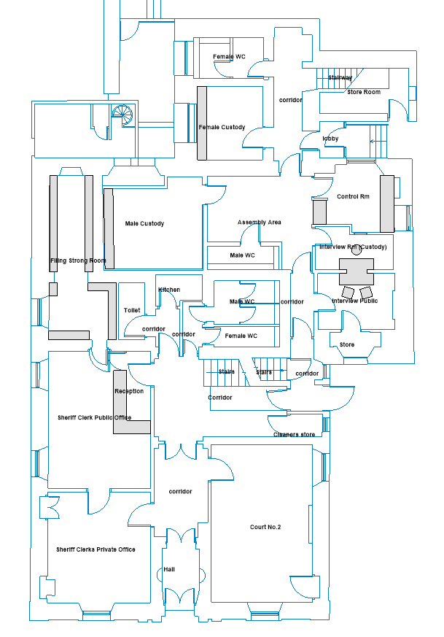

Public WCs

Reception

Fines & Payments

Main Access

Wheelchair access

Court No.2

BRIDGE STREET

Ground Floor Layout

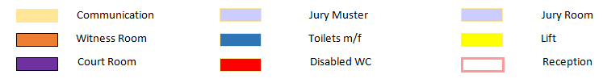

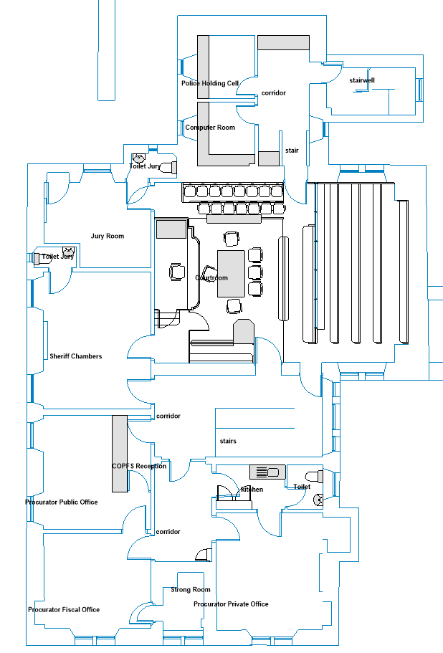 First Floor Layout

Jury WC

Jury Room

Hallway & Stairs

Reception

Procurator Fiscal

**Court No.1**

`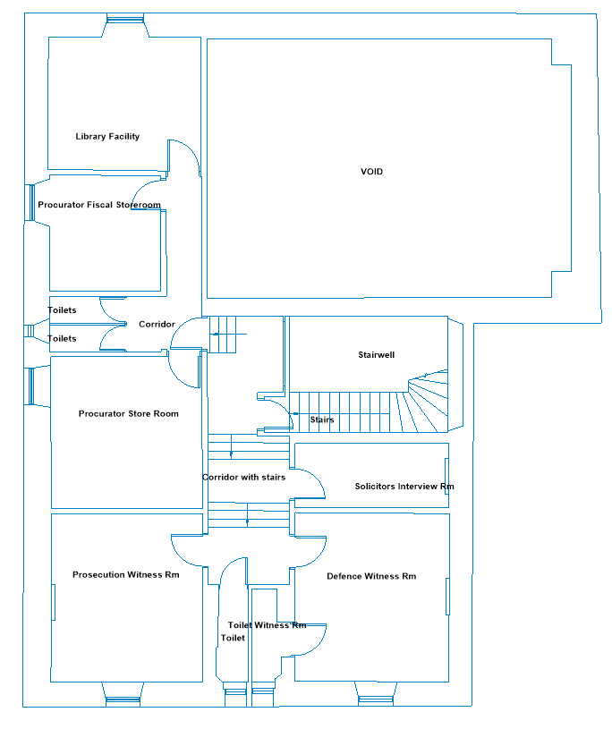

Witness WCs

Stairs and circulation

Witness Support

Witness Room

Witness Room

Witness Room

Second Floor Layout

**Opening Times**

**Weekly**

Monday to Friday: 9 am to 4 pm

**Public Holidays**

**2018**

25 – December Tuesday **Christmas Day**

26 – December Wednesday **Boxing Day**

**2019**

01 – January Tuesday New Year’s Day

02 – January Wednesday 2nd January

19 – April Friday Good Friday

22 – April Monday Easter Monday

06 – May Monday Early May Bank Holiday

01 – July Monday Local Bank Holiday

05 – August Monday Summer Bank Holiday

30-September Monday Local Bank Holiday

02 – December Monday St Andrew’s Day (substitute day)

25 – December Wednesday Christmas Day

26 – December Thursday Boxing Day **Contact Information**







**Postal Address**

Sheriff Court House

Bridge Street

Wick

Caithness

KW1 4AJ

**Sheriff Clerk**

Peta Donachie

**Main Telephone**

01955 602 846

**Email**

[wick@scotcourts.gov.uk](mailto:wick@scotcourts.gov.uk)

### Accessibility contact

If you want to contact us using text relay please follow the guidance at this link -  [the Next Generation Text Service](https://www.btplc.com/inclusion/MakingCallingEasier/Textrelay/index.htm)

If you require the support of an interpreter when you contact a court (by phone or attend in person), a telephone interpretation service is available.  To access this service ask for telephone interpreting and the language required. This service is NOT available during actual court proceedings.

If you use British Sign Language (BSL) and wish to phone us using a sign language interpreter, you can use the online video relay interpreting service. For more information see the contactSCOTLAND website. [www.contactscotland-bsl.org](http://www.contactscotland-bsl.org/)

**Additional Information**

If you require this document

in an alternative format

please contact the Property

and Services Unit at the

below address.

[enquires@scotcourts.gov.uk](mailto:enquires@scotcourts.gov.uk)

**The Scottish Courts and**

**Tribunals Service**

Saughton House

Broomhouse Drive

Edinburgh

EH11 3XD

**0131 444 3300**

or text phone

**18001 0131 444 3300**







**This Report**

This report has been compiled using the Scottish Accessible Information Forum, ‘Making Information Accessible’ guidance published September 2014.

A copy of our Court Users’ Charter can be accessed [here](http://www.scotcourts.gov.uk/docs/default-source/scs-board/charter.pdf?sfvrsn=8)

Should you require this document in another language or format please contact:

Court Services Branch

Scottish Courts and Tribunals Service

Spur N1,

Saughton House

Broomhouse Drive

Edinburgh

EH11 3XD

[csbenquiries@scotcourts.gov.uk](mailto:csbenquiries@scotcourts.gov.uk)

0131 444 3455

