

**Visiting**

**Oban Sheriff Court and**

**Justice of the Peace Court**



This leaflet will help you to plan your visit to the Oban Sheriff Court and Justice of the Peace Court.

If you require more information about anything here you can email:

[enquires@scotcourts.gov.uk](mailto:enquires@scotcourts.gov.uk)

or telephone the Property and Services Unit on:

**0131 440 3300**

or text phone

**18001 0131 444 3300**

**For specific assistance or access issues please phone the following number in advance:**

**01631 562414**





**Contents**

**Location Details**

Page 4

……………………………………………..

**Ways of getting to the Court Building**

Pages 5 to 8

………………………………………………

**On Arrival**

Pages 9 to 11

………………………………………………

**Facilities**

Pages 12 to 17

……………………………………………….

**Floor Plans**

Pages18 and 19

………………………………………………

**Opening Times & Public Holidays**

Page 20

………………………………………………

**Contact Information**

Page 21

………………………………………………

**Additional Information**

Pages 22 to 24

**Location Details**



Oban Sheriff Court and Justice of the Peace Court is located on Albany Street, in the centre of Oban next to the Police Station. The Court House is a traditional Court building having been built in the 1890's.

**Ways of getting to the Court Building**

**By Bus**

Local buses and buses from outlying areas stop at the bus terminus in Station Square, 150 yards from the courthouse. Traveline Scotland has some details:

[Check timetable online.](https://www.travelinescotland.com/)

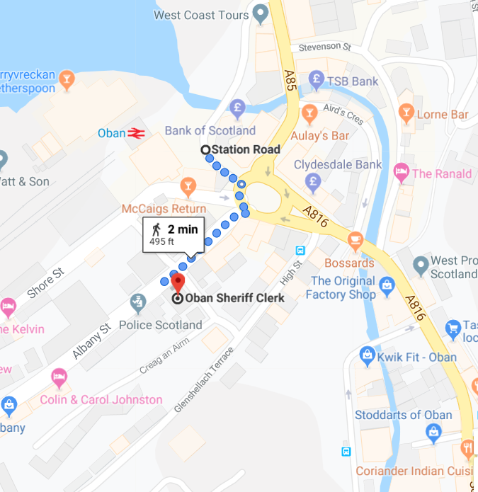

Bus station location

Map data @2016 Google

**By Train**

The train station is 200 yards from the courthouse. Visit [scotrail](http://www.scotrail.co.uk/) or [national rail](http://www.nationalrail.co.uk/) for train times or call **03457 484 950**



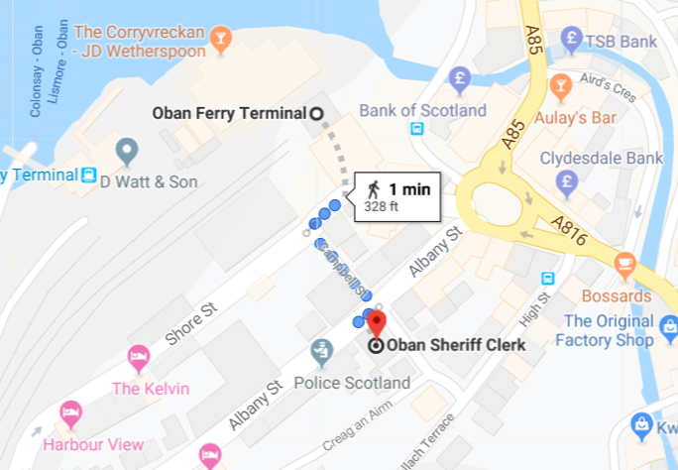

Map data @2016 Google

Train station location

**By Public Transport**

Contact Traveline Scotland for all public transport enquiries and assistance on **0871 200 22 33** or **0800 066 5000** for the assistance team or visit

[www.travelinescotland.com](http://www.travelinescotland.com)

**By Car**

There is no public car parking available at the courthouse. There are a limited number of on street meter parking spaces on the streets surrounding the court. There are pay car parking facilities, off Albany Street, off Tweedale Street and on the North Pier and Lochavullin Road. All are within a 10 minute walk from the court.



**By Taxi**

There is a taxi rank in Station Square, a few minutes’ walk from the court. There is sufficient space for visitors to be dropped off at the front entrance.

**By Ferry**

The Ferry Terminal in Oban is just a 9 minute walk from the court building. These are operated by [Caledonian MacBrayne](https://www.calmac.co.uk/destinations/kintyre) to Colonsay, Craignure, Coll, Castlebay, Lochboisdale and Lismore.

Tel: 01475 650 397



[](https://www.bing.com/images/search?view=detailV2&ccid=NuJM4FtL&id=DFB3DE45D1DF6DC3ECFDBA09D7C031BA712E1B48&thid=OIP.NuJM4FtLjFLWyZuSHXGs4AHaHa&mediaurl=https://free-icon.org/material/005-map-icon.jpg&exph=640&expw=640&q=international+ferry+map+symbol&simid=608009433444649736&selectedIndex=4&adlt=strict)

**On Arrival**

**Entrance**

The public entrance is accessed by four steps. All visitors and those on jury duty should report to the Sheriff Clerk's Office, which is immediately on the left hand side as you enter the building.

There is signposted disabled access to the rear of the building which is covered by CCTV cameras visible from the Sheriff Clerk's Office. Wheelchair users can assess the building. Users should access the back of the court building where they will find an intercom which can be used to contact Sheriff Clerk’s Office.

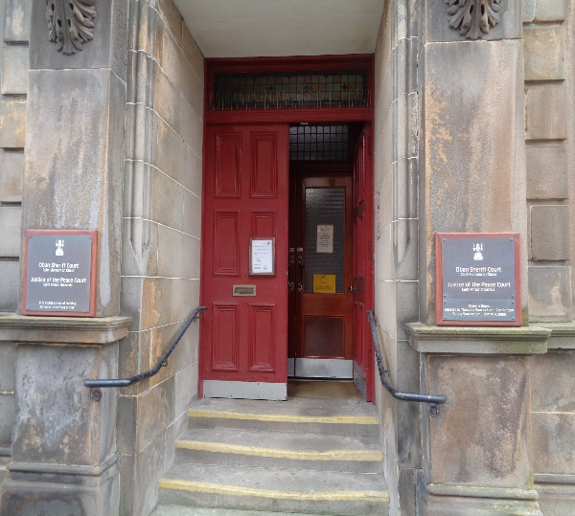

Entrance steps

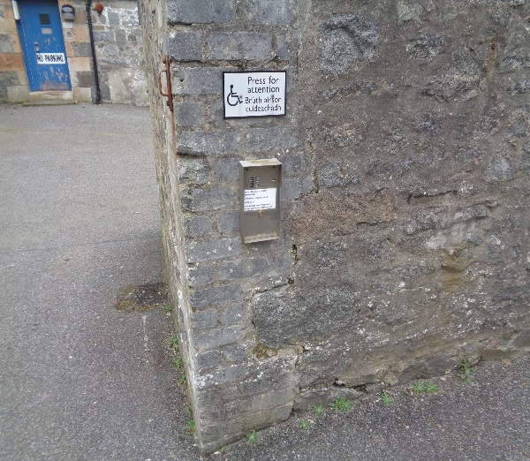

Accessible entrance

**Reception**

When you enter the building you should firstly attend at the Sheriff Clerk’s Office, which is on the left hand side of the main hall, which serves as the central point of access the rest of the building.

It is here that all visitors should report to for advice on direction to the appropriate court. The area around this reception is ample enough for wheelchair users to manoeuvre freely. A public telephone at the bottom of the main staircase. Court cases are highlighted on a flip chart in the main hall.

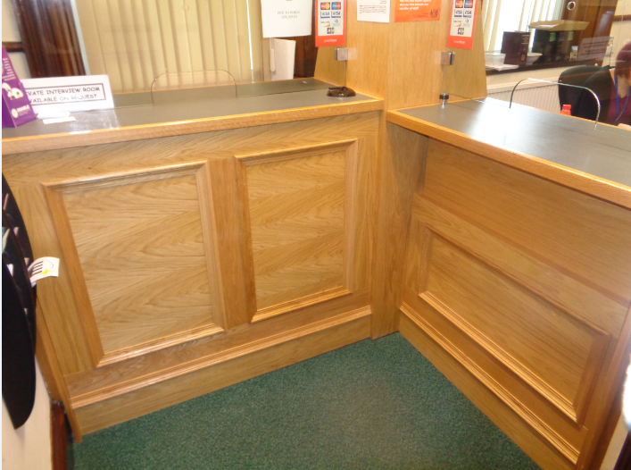

Reception





If you have a wheelchair or a pushchair and you require specific access assistance, please telephone:

**01631 562414**

or textphone

**18001 01631 562414**

For further information on the layout of the court building please refer to the floor plan layouts on pages 18 and 19.

**Facilities**







**Toilets**

Public accessible toilets are available on ground of the court. There are also toilets on the first floor in the witness rooms and jury room.

**Signage**

High contrast signage is provided around all circulation areas to ensure the public zones are easily navigated.





**Refreshments**

There are water dispensers in the Prosecution witness room and jury room. There are cafes, restaurants and hotels which serve food all day, within a few minutes walking distance from the court. If you are sitting on a jury, lunch and refreshments will be provided for you if the court sits into the afternoon.

**Hearing Loop**

For people who are hard of hearing a fixed loop induction service is available at all reception counters. Portable mobile loop induction services are available for all courtrooms.

On arrival please inform the reception desk staff if you require this facility.

**Courtrooms**

The courtroom on the first floor is well lit, spacious and has good acoustic qualities including full induction loop facilities. As such it demonstrates a good ability to access most users. While there is no provision for wheelchair users to reach this courtroom on the first floor, the space within the area is ample for other ambulant users.

Wheelchairs and people with mobility difficulties can be accommodated in the courtroom on the ground floor.

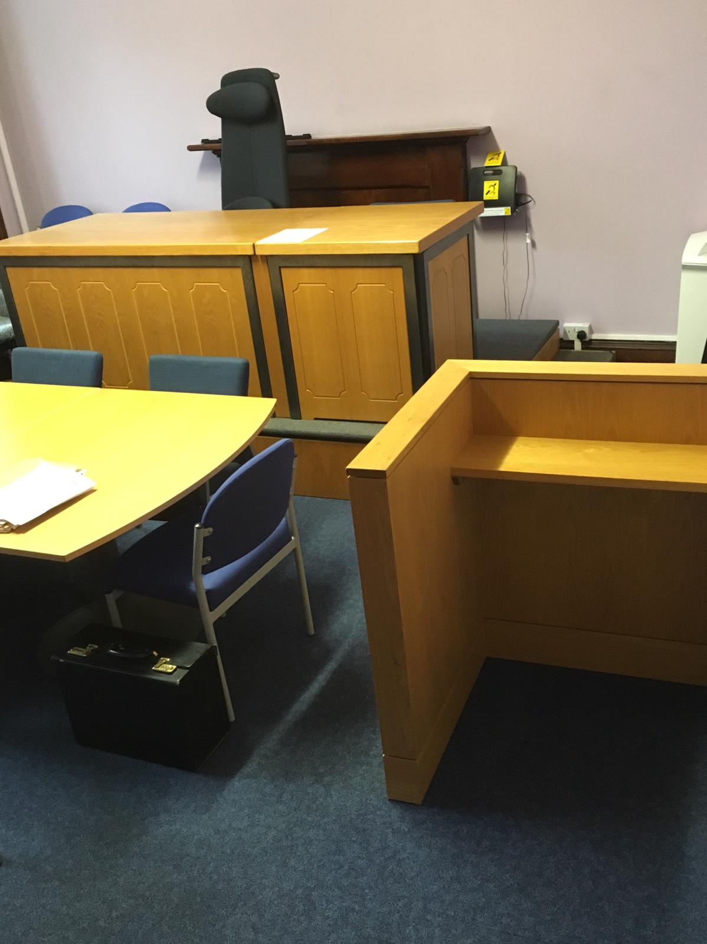

Typical court room

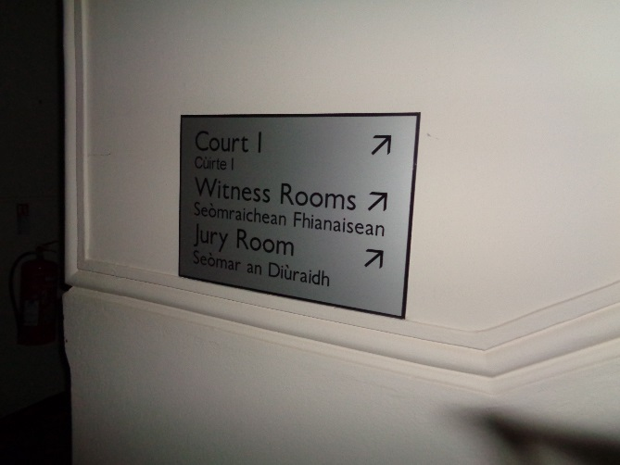

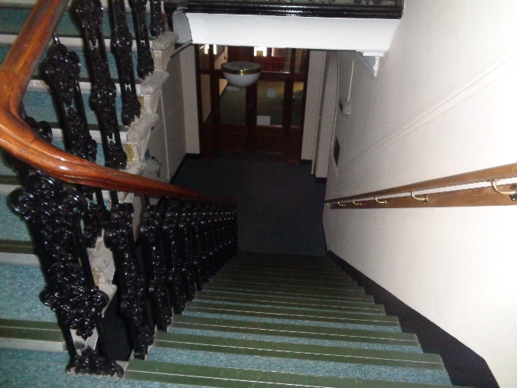

**Internal Access**

The ground floor main lobby serves as the central point of orientation to access the rest of the building. This lobby is wide, spacious and able to accommodate large numbers at peak times.

The main staircase to the first floor levels is found across from the main entrance. There is no lift in this court.

**Witness Rooms**

One witness room are located on the ground floor can easily be reached on the ground floor for all users. Wide corridors can accommodate the passage of wheelchairs. Assistance may be needed to open doors though as these are not self-opening and the corridors light quality can vary. Users with visual impairment may wish to contact the court for any need they require to access the accommodation.

Two witness rooms are located on the first floor. As such, these rooms are not accessible for wheelchair users.

**Jury Rooms**

There is one Jury room located to the right of the court room on the first floor. As such, this room is not accessible for wheelchair users.

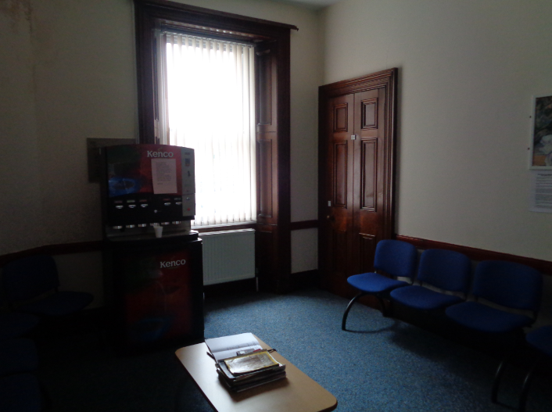

Typical witness room

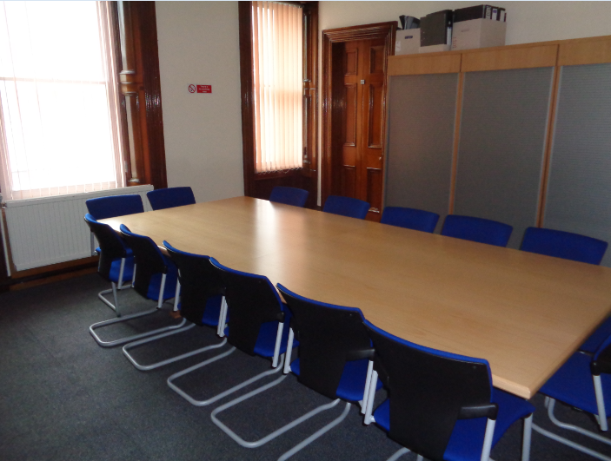

Typical Jury room

**Sheriff Clerk’s Office**

The Sheriff Clerk’s Office is located on the ground floor. General enquiries can be made here and the payment of fines. An induction loop facility is provided for the hard of hearing in both these offices. While a good amount of space is provided in door sizing and the width of corridors for wheelchairs to manoeuvre freely in, powered doors are not fitted presently and assistance may be needed to open these doors.

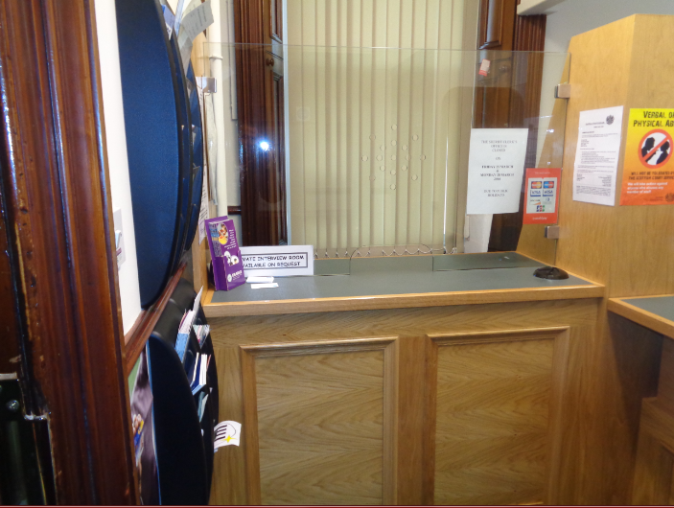

Sheriff Clerk’s Office

**Floor Plans**



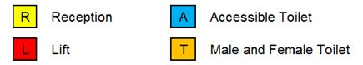

**S Stairs**

Ground Floor Layout



Jury Room



**S Stairs**

Ground Floor Layout

**Opening Times**

**Weekly**

Monday to Thursday 9:00 to 13:00 14:00 to17:00 or 5 pm

Friday 9:00 to 13:00 14:00 to16:30 or 4.3pm

Please note our office will close at 2.00pm on the following dates for staff training during 2019. The building will only remain open until the days court business is finished on these days.

25 July

19 September

14 November

**Public Holidays**

**2019**

01 – January Tuesday **New Year’s Day**

02 – January Wednesday **2nd January**

19 – April Friday **Good Friday**

22 - April Monday

06 – May Monday **Early May Bank Holiday**

27 – May Monday **Spring Bank Holiday**

29 – July Monday **Summer Bank Holiday**

02 – September Monday

02 – December Monday **St Andrew’s Day (substitute day)**

25 – December Wednesday **Christmas Day**

26 – December Thursday **Boxing Day**

**Contact Information**







**Postal Address**

Sheriff Court House

Albany Street

Oban

PA34 4AL

**Sheriff Clerk**

Caroline Brady

**Main Telephone**

01631 562 414

**Jury helpline**

01631 562414 (recorded message entered for jurors)

**Email**

[oban@scotcourts.gov.uk](mailto:oban@scotcourts.gov.uk)

**Additional Information**

If you require this document

in an alternative format

please contact the Property

and Services Unit at the

below address.

[enquires@scotcourts.gov.uk](mailto:enquires@scotcourts.gov.uk)

**The Scottish Courts and**

**Tribunals Service**

Saughton House

Broomhouse Drive

Edinburgh

EH11 3XD

**0131 444 3300**

or text phone

**18001 0131 444 3300**







### Accessibility contact

If you want to contact us using text relay please follow the guidance at this link -  [the Next Generation Text Service](https://www.btplc.com/inclusion/MakingCallingEasier/Textrelay/index.htm)

If you require the support of an interpreter when you contact a court (by phone or attend in person), a telephone interpretation service is available.  To access this service ask for telephone interpreting and the language required. This service is NOT available during actual court proceedings.

If you use British Sign Language (BSL) and wish to phone us using a sign language interpreter, you can use the online video relay interpreting service. For more information see the contactSCOTLAND website. [www.contactscotland-bsl.org](http://www.contactscotland-bsl.org/)

**This Report**

This report has been compiled using the Scottish Accessible Information Forum, ‘Making Information Accessible’ guidance published September 2014.

A copy of our Court Users’ Charter can be accessed [here](http://www.scotcourts.gov.uk/docs/default-source/scs-board/charter.pdf?sfvrsn=8)

Should you require this document in another language or format please contact:

Court Services Branch

Scottish Courts and Tribunals Service

Spur N1,

Saughton House

Broomhouse Drive

Edinburgh

EH11 3XD

[csbenquiries@scotcourts.gov.uk](mailto:csbenquiries@scotcourts.gov.uk)

0131 444 3455

