

**Visiting**

**Kirkwall Sheriff Court**

**and**

**Justice of the Peace Court**

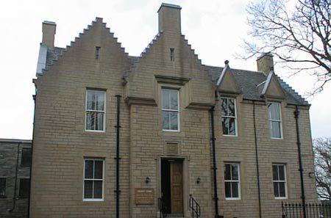





This leaflet will help you to plan your visit to the Kirkwall Sheriff Court and Justice of the Peace Court.

If you require more information about anything here you can email:

[enquires@scotcourts.gov.uk](mailto:enquires@scotcourts.gov.uk)

or telephone the Property and Services Unit on:

**0131 440 3300**

or text phone

**18001 0131 444 3300**

(Full contact details are on

page 19)

**Contents**

**Location Details**

Page 4

……………………………………………..

**Ways of getting to the Court Building**

Pages 5 to 7

………………………………………………

**On Arrival**

Pages 8 to 9

………………………………………………

**Facilities**

Pages 10 to 4

……………………………………………….

**Floor Plans**

Pages15 to 16

………………………………………………

**Opening Times & Public Holidays**

Page 17

………………………………………………

**Contact Information**

Page 18

………………………………………………

**Additional Information**

Pages 19

**Location Details**

Kirkwall Sheriff Court sits between the Historic Scotland sites of the Earls and Bishops Palaces. Kirkwall Sheriff Court covers the whole of the Orkney Islands area.

The public façade of the courthouse faces over the Bishop’s Palace grounds towards Palace Road. The main entrance is raised above pavement level and is accessed by a series of 4 steps.

For users with restricted mobility there is a ramp provided to the side of the steps.

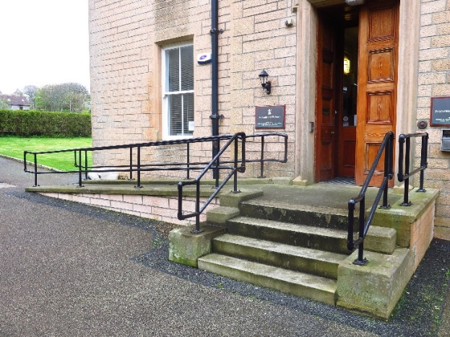

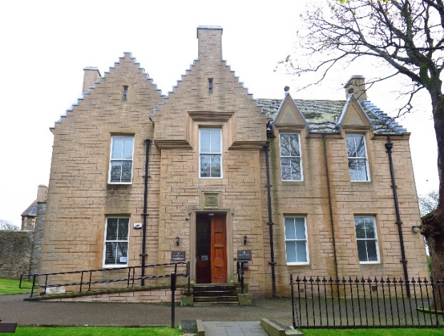

**Ways of getting to the Court Building**

**By Bus**

The Orkney Coaches bus station is 1 mile away, which is a 20 minute walk from the Court House.



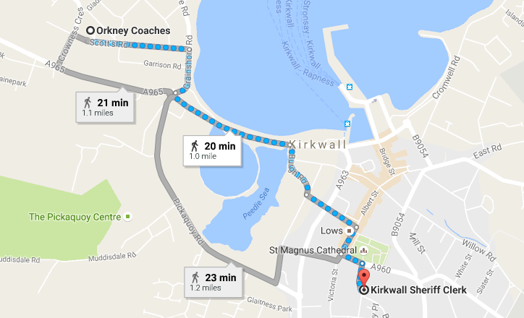

Map data @2016 Google

Bus station location

**By Ferry**

The main Ferry Terminal in Kirkwall is located 0.5 miles away from the Court House.

Alternately from Scrabster to Stromness requires a 15mile journey to reach the Court.

Visit [www.northlinkferries.co.uk](http://www.northlinkferries.co.uk)

or call **0845 6000 449** for details.



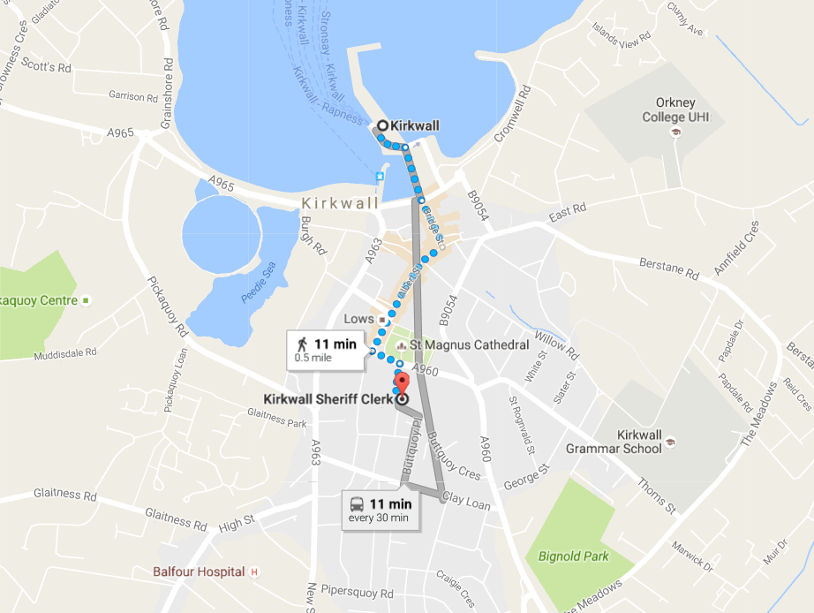

Map data @2016 Google

Ferry Terminal location

**By Public Transport**

Contact Traveline Scotland for all public transport enquiries and assistance on **0871 200 22 33** or visit

[www.travelinescotland.com](http://www.travelinescotland.com)

**By Car**

There is no public car park at the court.





Parking

**By Taxi**

Craigies Taxis 01856 878787

Orkney Taxis 01856 875511

**On Arrival**

**Entrance**

The public entrance is accessed via steps and a footpath from Watergate. An alternative level route is available from Place Road. The access is by four steps, or by a side ramp for those with restricted mobility.

There is an intercom at the front door for those who require assistance entering the building.

Entrance steps



Access ramp photo

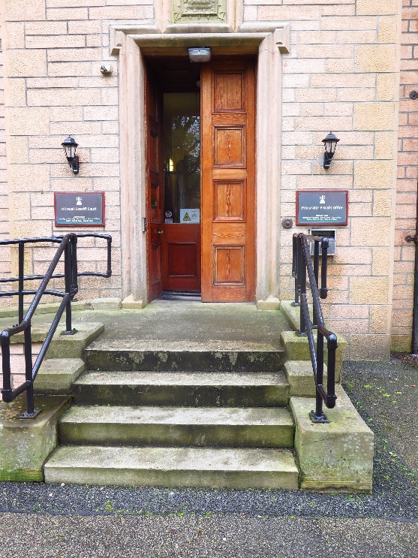

**Reception**

Please report to the Court Officer and state the reason for your visit. They will then direct you accordingly. Staff can assist you if you have any question about the building or your visit.

If you have a wheelchair or a pushchair and you require specific access assistance, please telephone:

**01856 872110**

or textphone

**18001 856 872110**

For further information on the layout of the court building please refer to the floor plan layouts on pages 16 and 17.





**Facilities**

**Toilets**

There are toilets on the first floor.

An accessible toilet is available at ground floor level.

**Signage**

High contrast signage is provided around all circulation areas to ensure the public zones are easily navigated.









**Refreshments**

There are a small number of cafes and hotels near to the court building where meals and snacks can be purchased. There are no refreshment facilities at the court. If you are sitting jury, lunch and refreshments will be provided for you if the court sits into the afternoon.

**Hearing Loop**

For people who are hard of hearing a fixed loop induction service is available at the public counter. Portable mobile loop induction services are available for the courtrooms.

On arrival please inform the Court Officer if you require this facility.

**Courtrooms**

The courtroom is well lit, spacious and has good acoustic qualities including full induction loop facilities.

While no provision is given for wheelchair users to access the seated area in the public gallery or the witness box, the space in the court room is ample.

When accessing the court itself, assistance will be needed to use the stair lift.

**Lifts**

There is no lift within the property, however a seated stair lift is available. Wheelchair users will need to transfer to the stair lift and will require assistance to transfer their wheelchair to the first floor.

Typical court room

[](https://www.google.co.uk/url?sa=i&rct=j&q=&esrc=s&source=images&cd=&cad=rja&uact=8&ved=0ahUKEwijmeXk2NnJAhWFLhoKHaetCAcQjRwIBw&url=https://www.iconfinder.com/icons/41952/elevator_lift_icon&psig=AFQjCNFBzdPzzcb-7dUs7YIenjllh-kU0g&ust=1450125533140326)

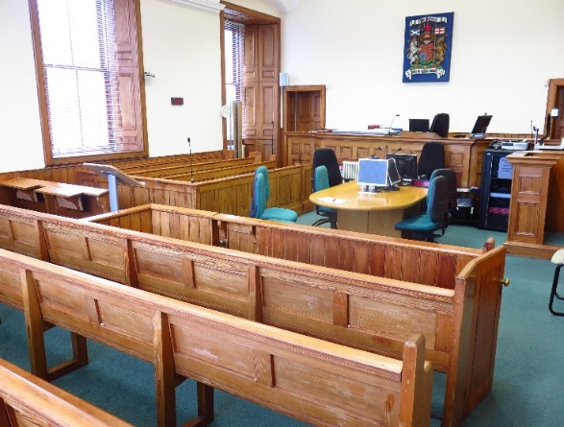

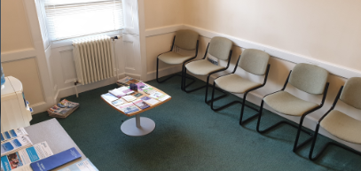

Typical witness room

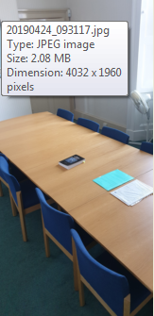

Typical Jury room

**Witness Rooms**

Witness rooms are located at the first floor level and are therefore subject to the same restrictions on access as the main court room.

**Jury Rooms**

Jury rooms are located at first floor level and are therefore subject to the same restrictions on access as the main courtroom.

Fines and Criminal Office

**Public Office**

The Sheriff Clerk’s offices are located on the left of the entrance hallway. The counter is single height and more suited for standing visitors, rather than seated.

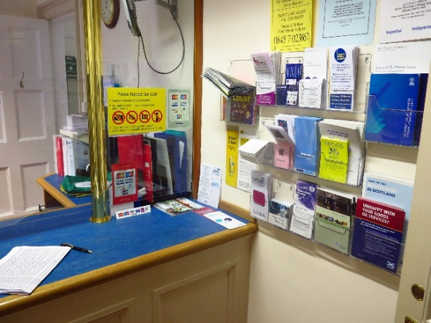

**Floor Plans**

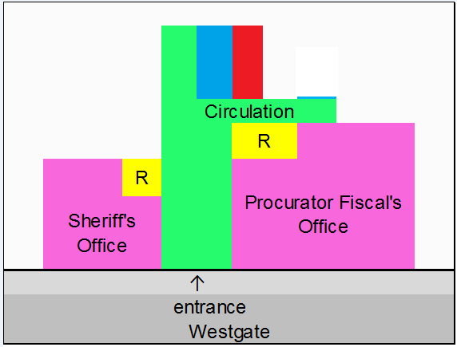

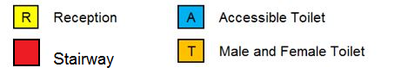

Ground Floor Layout





First Floor Layout

**Opening Times**

**Weekly**

Monday to Thursday: 9am to 4.30pm

Friday: 9am to 4.00pm

The office closes for lunch between 1pm and 2pm

**Public Holidays**

**2019**

01 – January Tuesday **New Year’s Day**

02 – January Wednesday **2nd January**

19 – April Friday **Good Friday**

22 – April Monday

06 – May Monday **Early May Bank Holiday**

05 – August Monday **Summer Bank Holiday**

30 September Monday

02 – December Monday **St Andrew’s Day (substitute day)**

25 – December Wednesday **Christmas Day**

26 – December Thursday **Boxing Day**

**Contact Information**







**Postal Address**

Sheriff Court House

Watergate

Kirkwall

Orkney

KW15 1PD

**Sheriff Clerk**

Laura Beth Macvie

**Main Telephone**

01856 872 110

**Email**

[Kirkwall@scotcourts.gov.uk](mailto:Kirkwall@scotcourts.gov.uk)

**Additional Information**

If you require this document

in an alternative format

please contact the Property

and Services Unit at the

below address.

[enquires@scotcourts.gov.uk](mailto:enquires@scotcourts.gov.uk)

**The Scottish Courts and**

**Tribunals Service**

Saughton House

Broomhouse Drive

Edinburgh

EH11 3XD

**0131 444 3300**

or text phone

**18001 0131 444 3300**









**This Report**

This report has been compiled using the Scottish Accessible Information Forum, ‘Making Information Accessible’ guidance published September 2014.

A copy of our Court Users’ Charter can be accessed [here](http://www.scotcourts.gov.uk/docs/default-source/scs-board/charter.pdf?sfvrsn=8)

Should you require this document in another language or format please contact:

Court Services Branch

Scottish Courts and Tribunals Service

Spur N1,

Saughton House

Broomhouse Drive

Edinburgh

EH11 3XD

[csbenquiries@scotcourts.gov.uk](mailto:csbenquiries@scotcourts.gov.uk)

0131 444 3455