

**Visiting**

**Banff Sheriff Court and**

**Justice of the Peace Court**

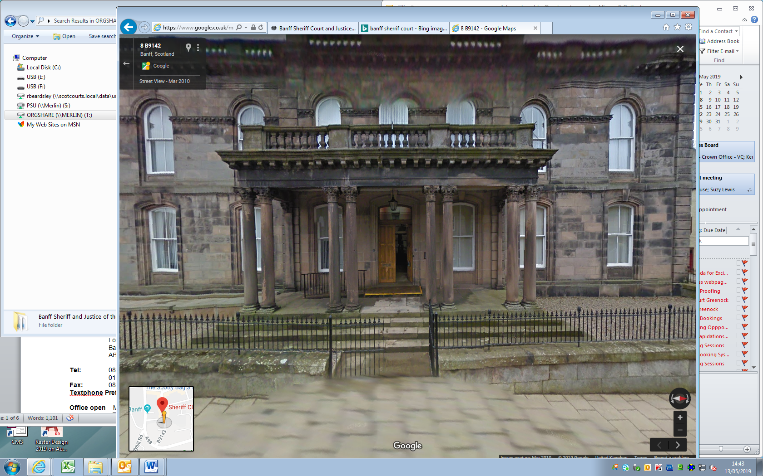

This leaflet will help you to plan your visit to the Banff Sheriff Court and Justice of the Peace Court.

If you require more information about anything here you can email:

[enquires@scotcourts.gov.uk](mailto:enquires@scotcourts.gov.uk)

or telephone the Property and Services Unit on:

**0131 440 3300**

or text phone

**18001 0131 444 3300**

**For specific assistance or access issues please phone the following number in advance:**

**01738 620546**





**Contents**

**Location Details**

Page 4

……………………………………………..

**Ways of getting to the Court Building**

Pages 5 to 8

………………………………………………

**On Arrival**

Pages 9 to 11

………………………………………………

**Facilities**

Pages 12 to 15

……………………………………………….

**Floor Plans**

Pages 16 and 17

………………………………………………

**Opening Times & Public Holidays**

Page 18

………………………………………………

**Contact Information**

Page 19

………………………………………………

**Additional Information**

Pages 20

………………………………………………

**Accessibility contact**

Pages 21

**Location Details**

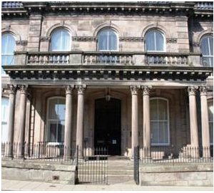

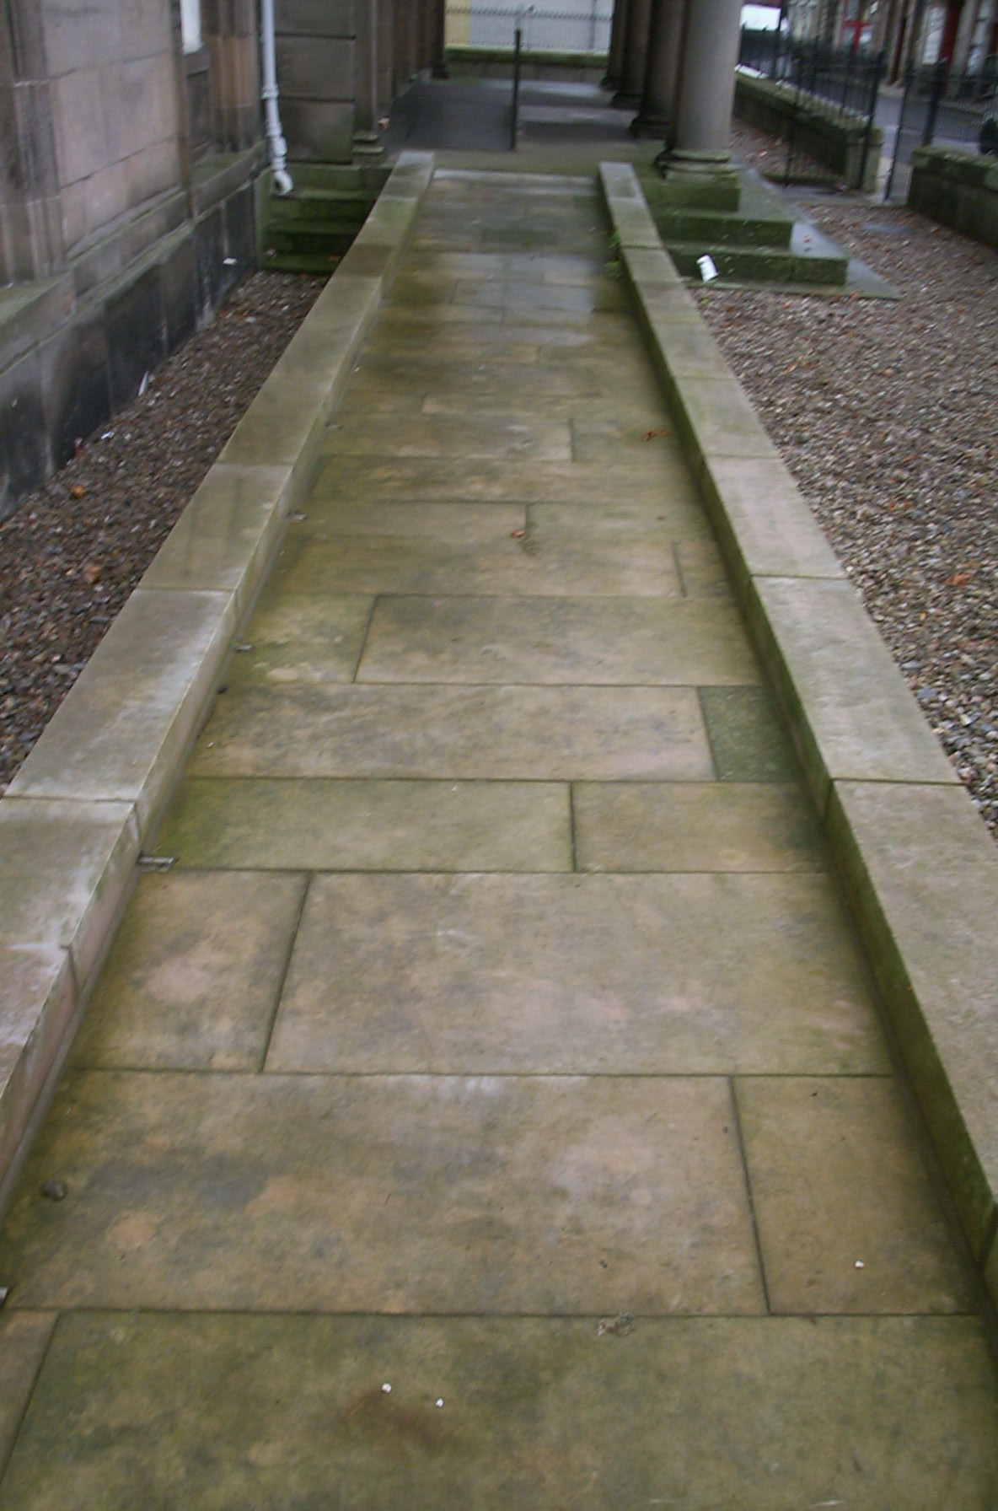

Banff Sheriff Court and Justice of the Peace Court is located on Low Street in Banff town centre.

The main entrance to the building is via a flight of five steps from Low Street pavement. There is a disabled ramp suitable for wheelchair access which can provide access via the Low Street Main doorway.

The internal swing doors have a width of 72cms approximately and there is an intercom on the ground floor to request assistance.

[insert]

**Ways of getting to the Court Building**

**By Bus**

Buses from Aberdeen to Banff arrive hourly at 54 minutes past the hour and buses to Aberdeen depart hourly at 45 minutes past the hour.

Buses from Elgin to Banff arrive hourly at 45 minutes past the hour and buses to Elgin depart hourly at 54 minutes past the hour.

The bus stop is 200 yards from the court off Low Street.



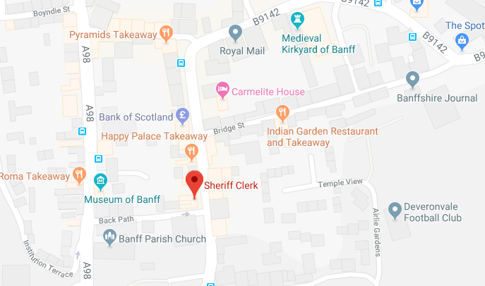

Map data @2016 Google

Bus stops and cafes within Court vicinity

**By Train**

There is no railway station at Banff the nearest railway stations are Elgin (35 miles), Huntly (21 miles) and Keith (21 miles).

Visit [ScotRail](http://www.scotrail.co.uk/) or [National Rail Enquiries](http://www.nationalrail.co.uk/) for train times visit [www.nationalrail.co.uk](http://www.nationalrail.co.uk)

or call **03457 484 950** for train times.

### By Air

The nearest airport is [Aberdeen](http://www.aberdeenairport.com/) (46 miles), and at [Inverness](http://www.hial.co.uk/inverness-airport/) (75 miles).



**By Public Transport**

Contact Traveline Scotland for all public transport enquiries and assistance on **0871 200 22 33** or visit

[www.travelinescotland.com](http://www.travelinescotland.com)

**By Car**

There are no parking facilities at the court house. St May's car park is located next to the court. Some spaces painted green are free - see signs within the car park. All other spaces require a pay and display ticket.

To request advice about parking for disabled drivers please contact the main reception desk.



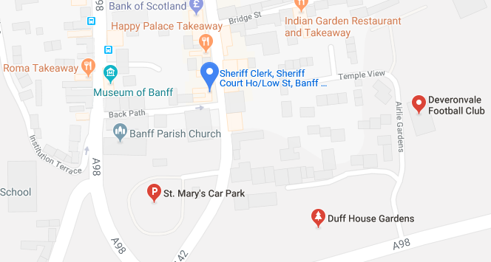

Parking

Map data @2016 Google

**By Taxi**

Taxis are available at Banff town train station and ranks are available within walking distance to the Court.



**On Arrival**

**Entrance**

There is access for disabled people through a separate gate at the front of the building, and a ramp up to the front door.

There is a chair stair lift to the first floor where the Procurator Fiscals public office is situated.

Please report to the sheriff clerk's public office on the ground floor on arrival or to the court officer. You will then be directed to the appropriate area.

Jurors should report to the court officer on arrival.

Alternative access, other than through the main front door, for witnesses or anyone who feels vulnerable, can be arranged if contact is made with the sheriff clerk's office prior to attendance

All witness should report to the court officer in the foyer or report to the Sheriff Clerk's office.

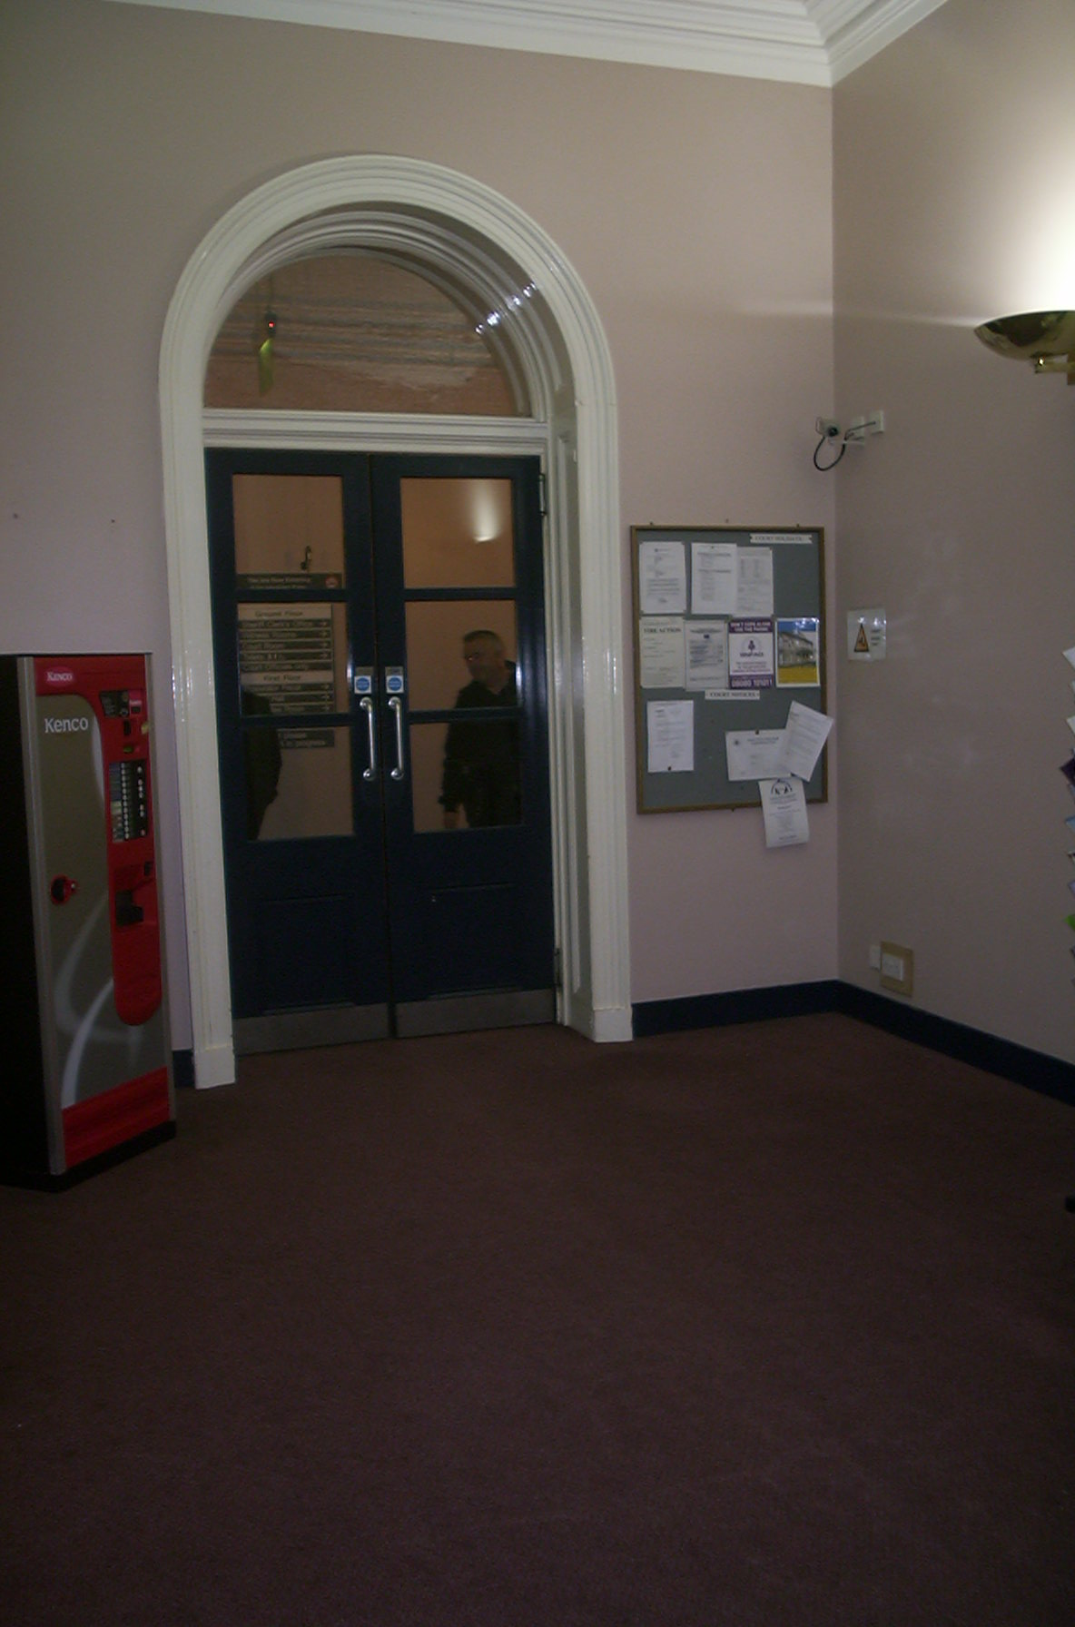

Entrance Hall & Stair Lift

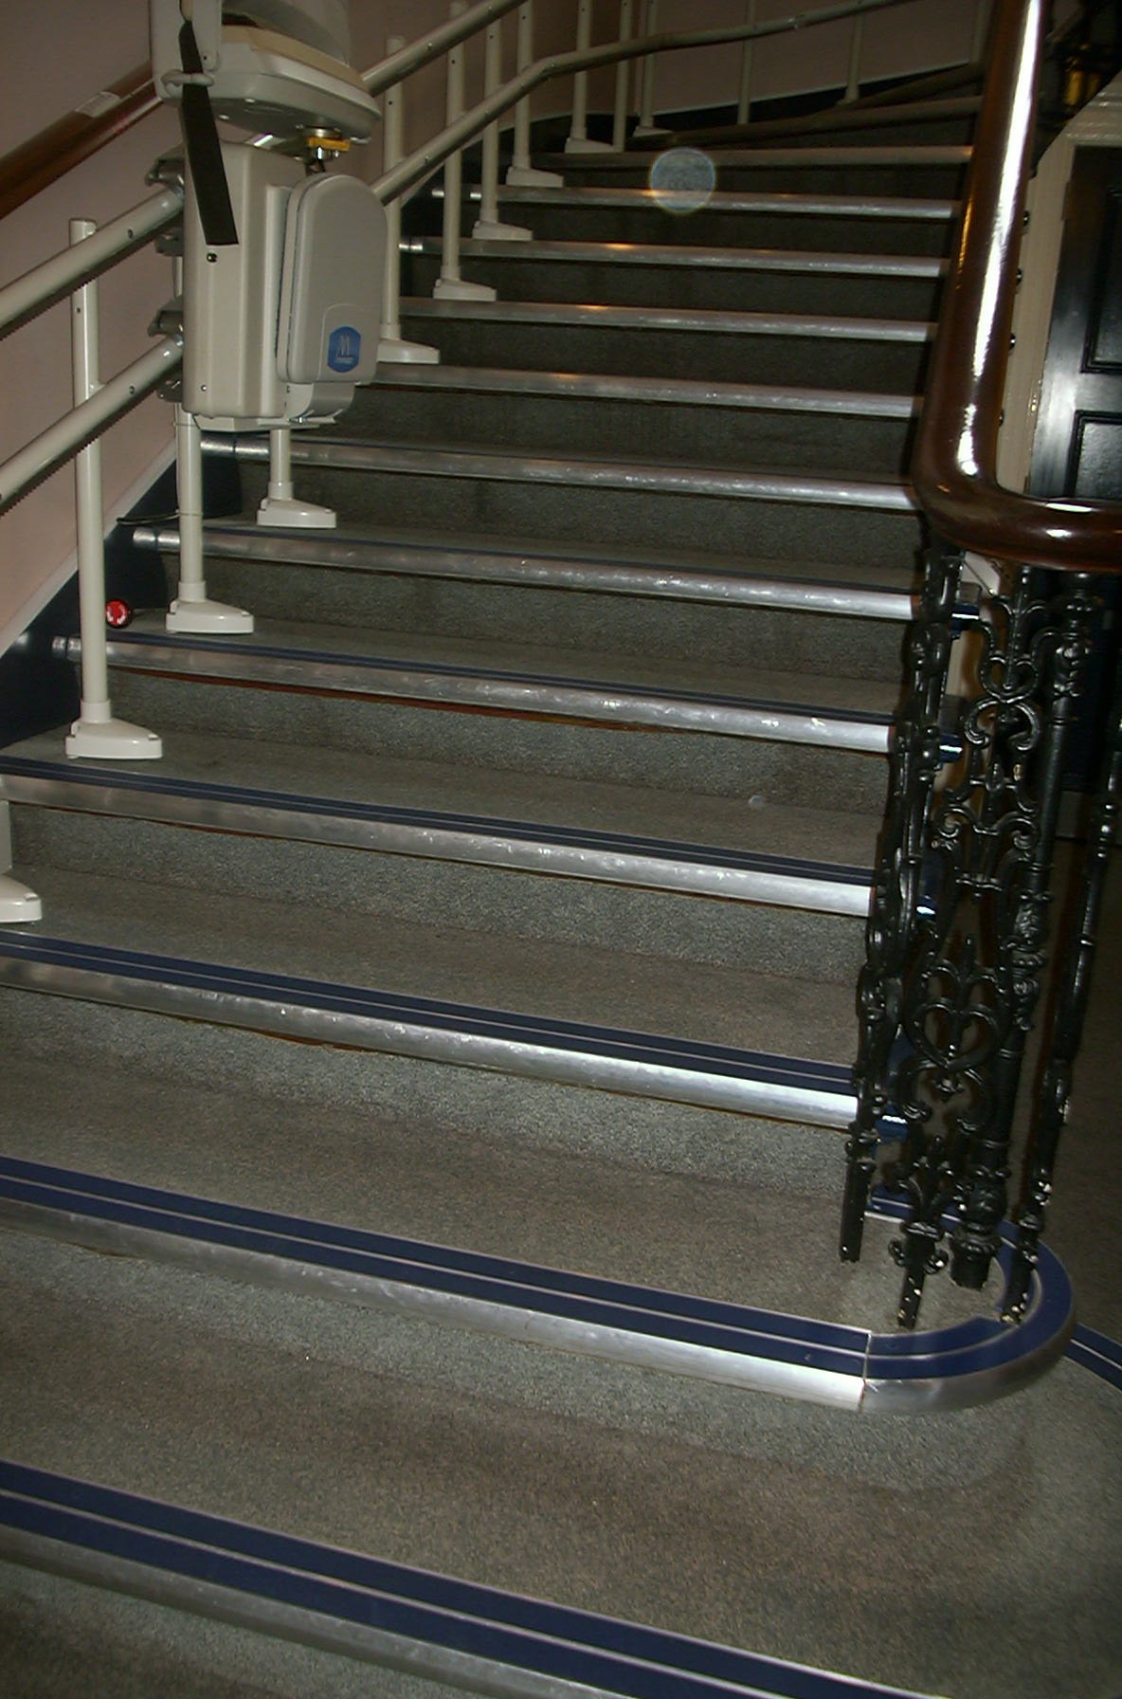

Accessible pathway

[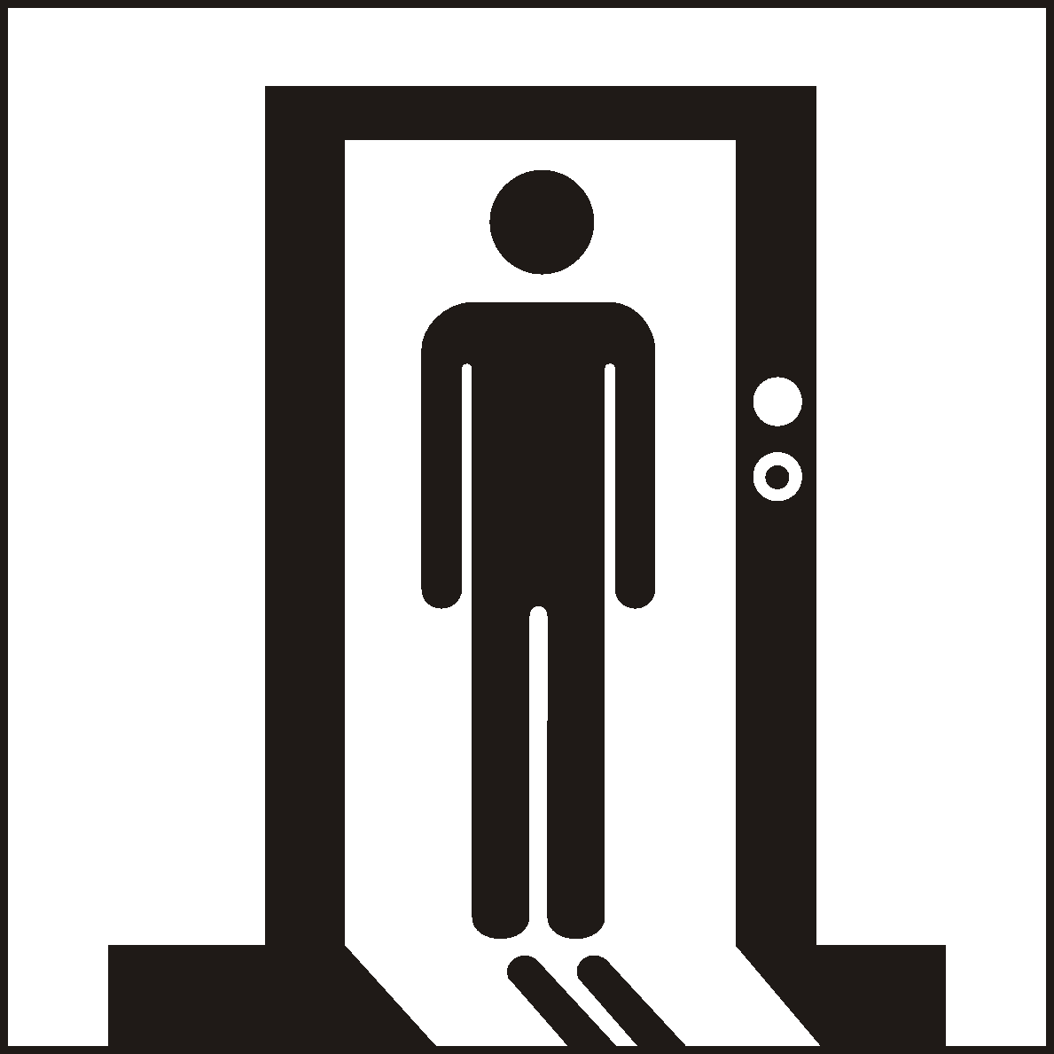](http://www.google.co.uk/url?sa=i&rct=j&q=&esrc=s&source=images&cd=&cad=rja&uact=8&ved=0ahUKEwialYnHwtPJAhUKWhoKHUKJBs4QjRwIBw&url=http://www.standard.org.cn/dgsymbol/list.aspx?sid%3D12%26stid%3D%26Page%3D5%26searchtxt%3D&bvm=bv.109395566,d.d2s&psig=AFQjCNEa1EVlPPeWeUJ-gD_trfHzICP1Hw&ust=1449913041342312)

**Security Check**

You will enter the security lobby where trained security staff will request that you pass through a metal detector.

Wheelchair users are scanned by a paddle scanner. Your bags or briefcases may also be searched.

When you are ready, the security staff will direct you to the reception desk located to the left of the main hall, which serves as the central point of access the rest of the building.

Please report to the General Office and state the reason for your visit. The staff will then direct you accordingly.

Staff can assist you if you have any question about the court building or your visit.





If you have a wheelchair or a pushchair and you require specific access assistance, please telephone:

**01261 812140**

or textphone

**18001 01261 812140**

For further information on the layout of the court building please refer to the floor plan layouts on pages 17.

**Facilities**

**Toilets**

There is unisex wheelchair accessible toilet on the ground floor.

**Signage**

High contrast signage is provided around all circulation areas to ensure the public zones are easily navigated.

**Hearing Loop**

For people who are hard of hearing a loop induction system is available in the courtroom and Sheriff Clerk's office for hearing aid users. Please contact 01261 812140.







**Refreshments**

There are no food or drink facilities in the court house. Water dispensers are located in Witness rooms. There are several cafes and hotels nearby, please ask staff for information or see notices on notice boards.

Witnesses are advised that they should bring refreshments with them prior to attending court. No food or drink is allowed in the court room

If you are sitting on a jury, lunch and refreshments will be provided for you if the court sits into the afternoon. The jury room has water, tea and coffee facilities. Lunch will be provided at a local hotel where you will be accompanied by the court officer to and from lunch.





**Courtrooms**

All courtrooms are on the ground floor and are accessible to wheelchair users by contacting the Clerk or Court Officers who can provide directions to avoid the steps at the main public entrance.

A loop induction system is available in the courtroom and Sheriff Clerk's office for hearing aid users.

The public Gallery seating in the Courtroom is tiered, but there may be room on the adjacent level surface for a chair.

**Lifts**

There is a stair lift to access the first floor of this building.

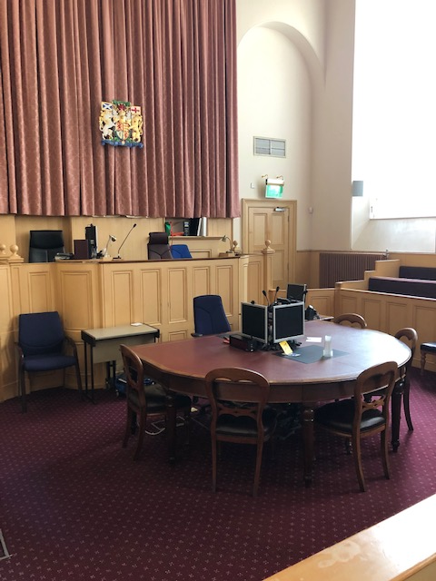Typical court room

If you have any queries please contact the court on 01261 812140 so that any reasonable adjustment can be made.

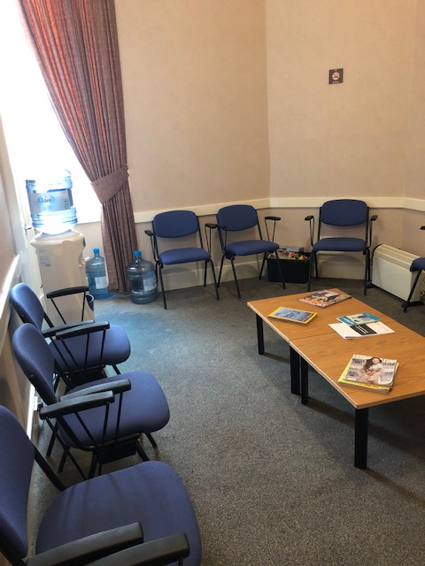

Witness room

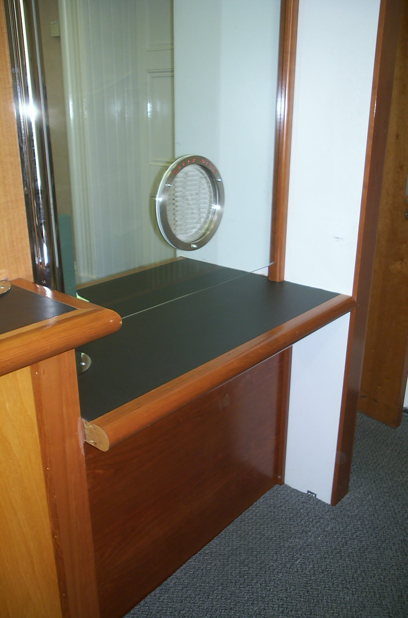

Fines Office

**Witness Rooms**

All Witness Rooms are located on the ground floor.

Both rooms have toilets located near to the Disabled WC on the ground floor.

**Sheriff Clerk’s Office**

The Sheriff Clerks Office is located on the ground floor level. This is the main enquiries desk and is provided a fixed induction loop system.

**Fines Office**

Fines are received at the Sheriff Clerks Office on the Ground Floor.

**Floor Plans**

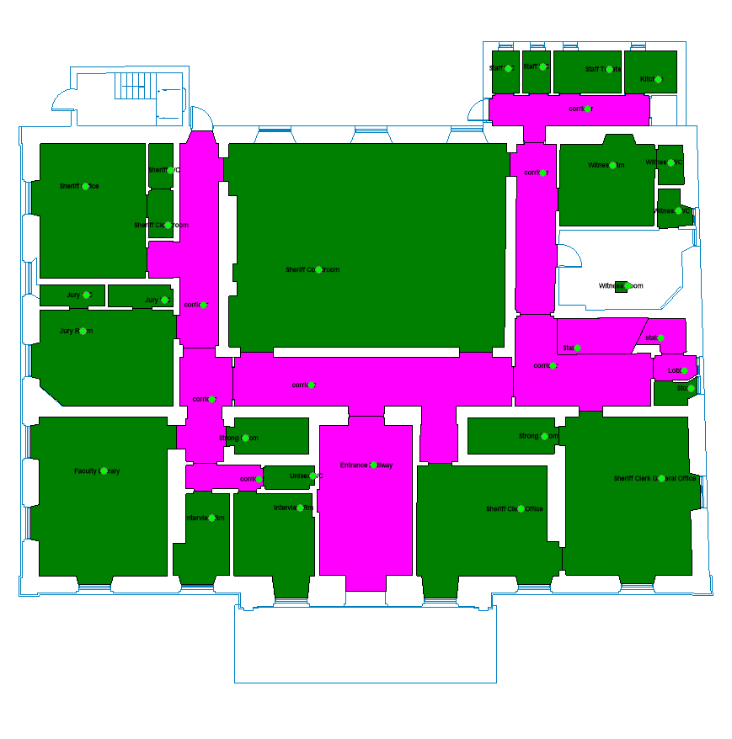

**Low Street**

MAIN ENTRY

Chair Lift & Stairs

WCs

Witness Room

Witness Room

Public Office

Jury Room

Sheriff Court

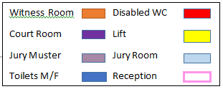

Ground Floor Layout

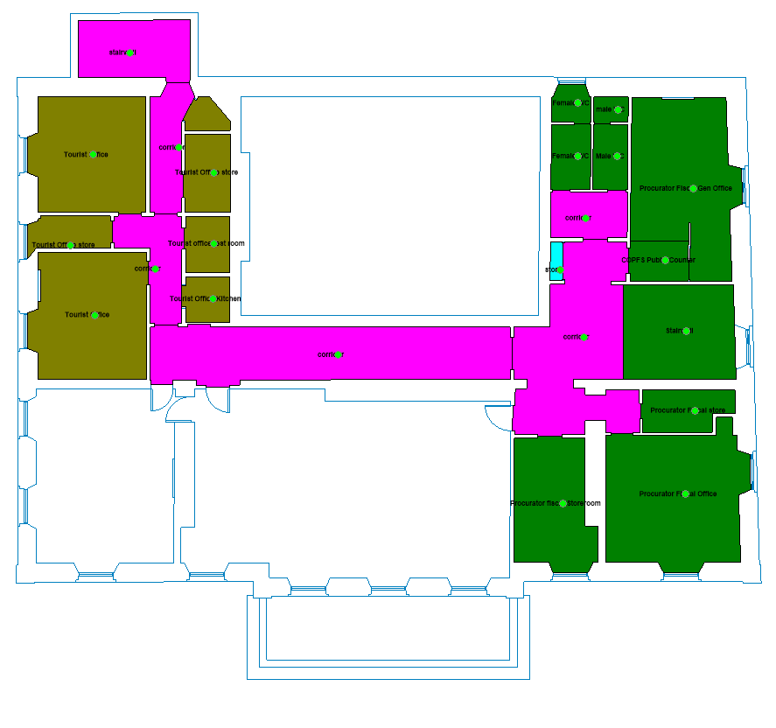

Chair Lift & Stairs

WCs

Stairs

Procurator Fiscal Public Office



First Floor Layout

**Opening Times**

**Court**

Monday to Thursday: 09:00 am to 16:30

Friday 09:00 to 16:00

The office is closed between 13:00 and 14:00 for lunch.

**Public Holidays**

**2019**

01 – January Tuesday New Year’s Day

02 – January Wednesday 2nd January

19 – April Friday Good Friday

22 – April Monday

06 – May Monday Early May Bank Holiday

08 – July Monday Summer Bank Holiday

02 – September Monday

14 – October Monday

02 – December Monday St Andrew’s Day (substitute day)

25 – December Wednesday Christmas Day

26 – December Thursday Boxing Day **Contact Information**

**Postal Address**

Sheriff Court House,  
Low Street,  
Banff,  
AB45 1AU

**Sheriff Clerk**

Bruce Graham

**Main Telephones**

01261 812140

Jury Helpline

01261 812140

Fax

01261 818394

Crown Office & Procurator Fiscal

0844 5612660 or 01224 578975

**Email**

[banff@scotcourts.gov.uk](mailto:banff@scotcourts.gov.uk)







**Additional Information**

If you require this document

in an alternative format

please contact the Property

and Services Unit at the

below address.

[enquires@scotcourts.gov.uk](mailto:enquires@scotcourts.gov.uk)

**The Scottish Courts and**

**Tribunals Service**

Saughton House

Broomhouse Drive

Edinburgh

EH11 3XD

**0131 444 3300**

or text phone

**18001 0131 444 3300**







### Accessibility contact

If you want to contact us using text relay please follow the guidance at this link -  [the Next Generation Text Service](https://www.btplc.com/inclusion/MakingCallingEasier/Textrelay/index.htm)

If you require the support of an interpreter when you contact a court (by phone or attend in person), a telephone interpretation service is available.  To access this service asks for telephone interpreting and the language required. This service is NOT available during actual court proceedings.

If you use British Sign Language (BSL) and wish to phone us using a sign language interpreter, you can use the online video relay interpreting service. For more information see the contactSCOTLAND website. [www.contactscotland-bsl.org](http://www.contactscotland-bsl.org/)

**This Report**

This report has been compiled using the Scottish Accessible Information Forum, ‘Making Information Accessible’ guidance published September 2014.

A copy of our Court Users’ Charter can be accessed [here](http://www.scotcourts.gov.uk/docs/default-source/scs-board/charter.pdf?sfvrsn=8)

Should you require this document in another language or format please contact:

Court Services Branch

Scottish Courts and Tribunals Service

Spur N1,

Saughton House

Broomhouse Drive

Edinburgh

EH11 3XD

[csbenquiries@scotcourts.gov.uk](mailto:csbenquiries@scotcourts.gov.uk)

0131 444 3455



Information to be confirmed

1. Picture of witness room
2. Picture of jury room
3. Picture of court room
4. Description of Refreshments provision
5. Description of Lift provision
6. Picture and description Fines and Criminal Office