

**Visiting**

**Ayr Sheriff Court and**

**Justice of the Peace Court**



This leaflet will help you to plan your visit to Ayr Sheriff Court and Justice of the Peace Court.

If you require more information about anything here you can email:

[enquires@scotcourts.gov.uk](mailto:enquires@scotcourts.gov.uk)

or telephone the Property and Services Unit on:

**0131 440 3300**

or text phone

**18001 0131 444 3300**

(Full contact details are on

page 20)





**Contents**

**Location Details**

Page 4

……………………………………………..

**Ways of getting to the Court Building**

Pages 5 to 8

………………………………………………

**On Arrival**

Pages 9 to 11

………………………………………………

**Facilities**

Pages 12 to 16

……………………………………………….

**Floor Plans**

Pages 17 and 18

………………………………………………

**Opening Times & Public Holidays**

Page 19

………………………………………………

**Contact Information**

Page 20

………………………………………………

**Additional Information**

Page 21

………………………………………………

### Accessibility contact

Page 22

**Location Details**



Ayr Sheriff Court and Justice of the Peace Court is within the Sheriffdom of South Strathclyde Dumfries & Galloway. The courthouse is centrally located within the town centre and was formally opened in 1822. Over the years the building has been extended and in 2010 the Justice of the Peace Court was established in the same building.

[insert]

**Ways of getting to the Court Building**



**By Bus**

The main bus station in Ayr is just a 5 minute walk from the court building.

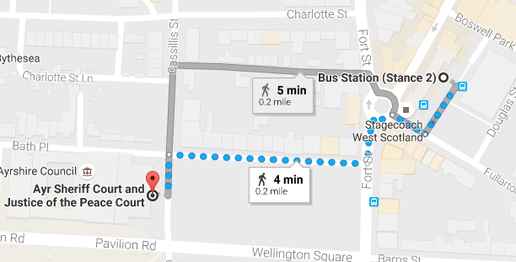

Map data @2016 Google

Bus station location

**By Train**

The nearest railway station is Ayr, which is 0.7 mile walk from the court building. Trains run to and from Glasgow regularly.

Visit [www.nationalrail.co.uk](http://www.nationalrail.co.uk)

or call **03457 484 950** for

train times.



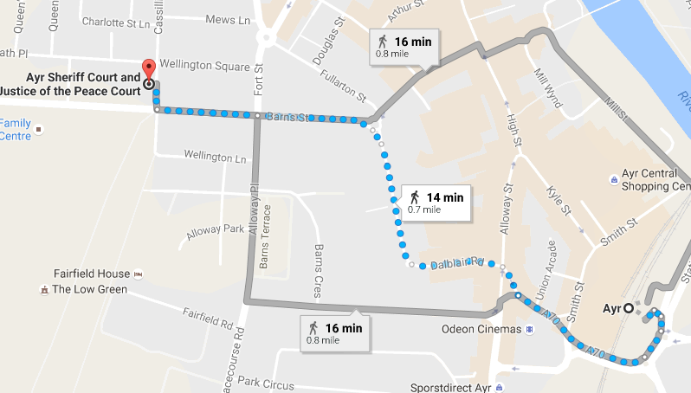

Map data @2016 Google

Train station location

**By Public Transport**

Contact Traveline Scotland for all public transport enquiries and assistance on **0871 200 22 33** or visit

[www.travelinescotland.com](http://www.travelinescotland.com)

**By Car**

There is no public car parking available at the court house. There are a number of pay and display, on-street parking places in Wellington Square and surrounding streets. The nearest long stay car park is at Charlotte Street.



Parking

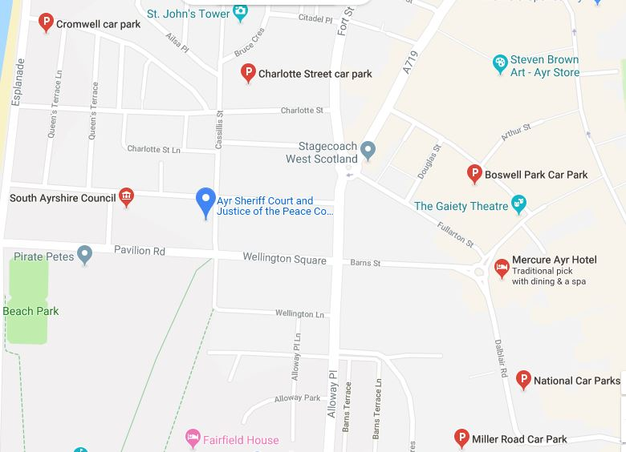

Car parking in vicinity

**By Taxi**

The main taxi rank is situated at the train station with a small rank located close to the bus station at Sandgate.



**On Arrival**

**Entrance**

Public entrance to the court building faces on to Wellington Lane and is accessed from pavement level by six steps or by a side ramp for those with restricted mobility.

Entrance steps

Entrance ramp

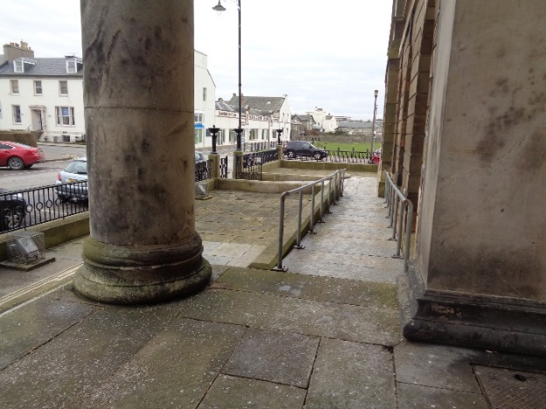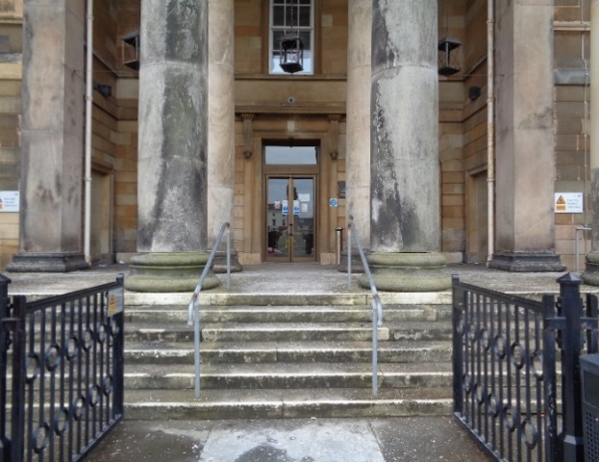

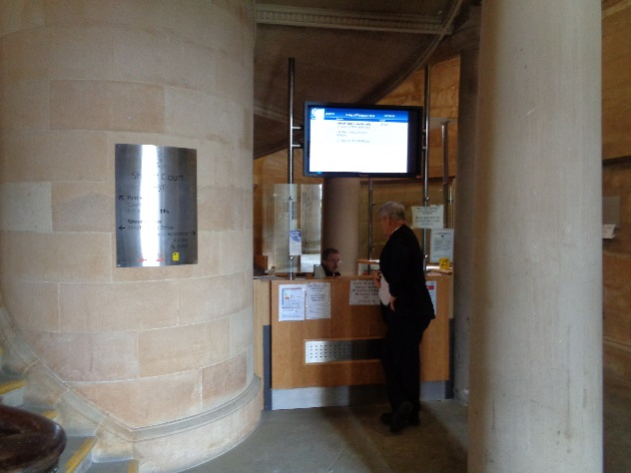

Reception

Please report to the reception desk and state the reason for your visit. Reception staff will then direct you accordingly. Staff can assist you if you have any questions about the building or your visit.

If you have a wheelchair or a pushchair and you require specific access assistance, please telephone:

**01292 292 200**

or textphone

**18001 01292 292 200**

For further information on the layout of the court building please refer to the floor plan layouts on pages 17 and 18.





**Facilities**







**Toilets**

Public toilets are available on the ground floor and first floor levels of the building.

Accessible toilets are available on the ground floor and first floor levels of the building.

**Signage**

High contrast signage is provided around all circulation areas to ensure the public zones are easily navigated.

**Refreshments**

There is a canteen located on the ground floor of the building. Hospital Volunteers supply light refreshments in the courthouse between 09:30am and 12 noon. There are shops and restaurants within a five minute walk from the courthouse. If you are a serving juror, lunch and refreshments will be provided for you if the court sits into the afternoon.

**Hearing Loop**

For people who are hard of hearing a fixed loop induction service is available at all reception counters. Portable mobile loop induction services are available for all courtrooms.

On arrival please inform the reception desk staff if you require this facility.





**Courtrooms**

There are 5 courtrooms in Ayr, Courts 1, 2, 3 and 4 are located on the first floor, and Court 5 is on the ground floor. All courts are well lit, spacious and have good acoustic qualities including full induction loop facilities. As such they demonstrate a good ability to access all users. Whilst no provision is given for wheelchair users to access the seated area in the public gallery or the witness box, the space in the courtrooms is ample. Wheelchairs can be accommodated in areas just outside the witness box and the gallery. When making the journey to the court from the main reception zone or the lift lobby, some assistance may be needed in opening doors.

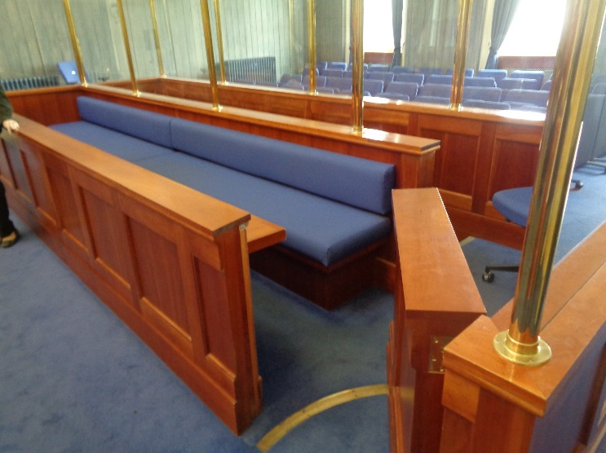

Typical court room

[](https://www.google.co.uk/url?sa=i&rct=j&q=&esrc=s&source=images&cd=&cad=rja&uact=8&ved=0ahUKEwijmeXk2NnJAhWFLhoKHaetCAcQjRwIBw&url=https://www.iconfinder.com/icons/41952/elevator_lift_icon&psig=AFQjCNFBzdPzzcb-7dUs7YIenjllh-kU0g&ust=1450125533140326)

Typical witness room

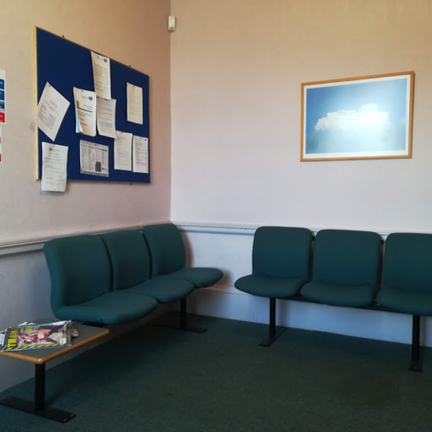

**Lifts**

The entrance lobby area accommodates the central stairwell. There is one lift located behind the main stairwell. The lift is wide enough for wheelchair users.

**Witness Rooms**

Witness rooms are located on the first floor and ground floor levels of the building. They can easily be reached by all users. Ramps and wide corridors can accommodate the passage of wheelchairs. Assistance may be needed to open doors though as these are not self-opening and the corridors light quality can vary. Users with visual impairment may wish to contact the court for any need they require to access the accommodation.

Typical Jury Room

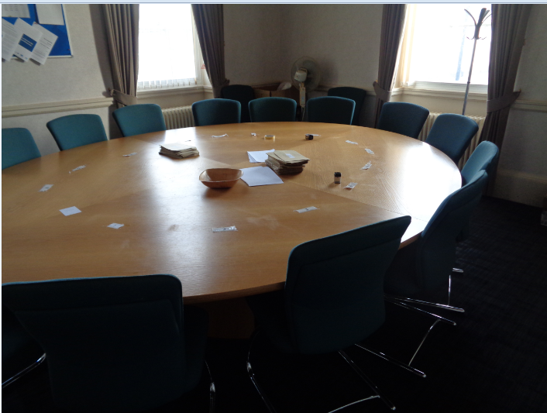

**Jury Room**

The jury room is located on the first floor of the building and is accessible to all users. Assistance may be needed to open doors.

**Fines and Criminal Office**

The Fines Payment Office is accessed via the glazed double doors opening from the reception hall.

**The Civil Office**

The Civil Office Fines Payment Office is accessed via the glazed double doors opening from the reception hall.

Both Counters have a dropped section and induction loops.

Fines and Criminal Office

Reception desk

Door to Fine Payments Counter, Criminal and Civil Offices

**Floor Plans**

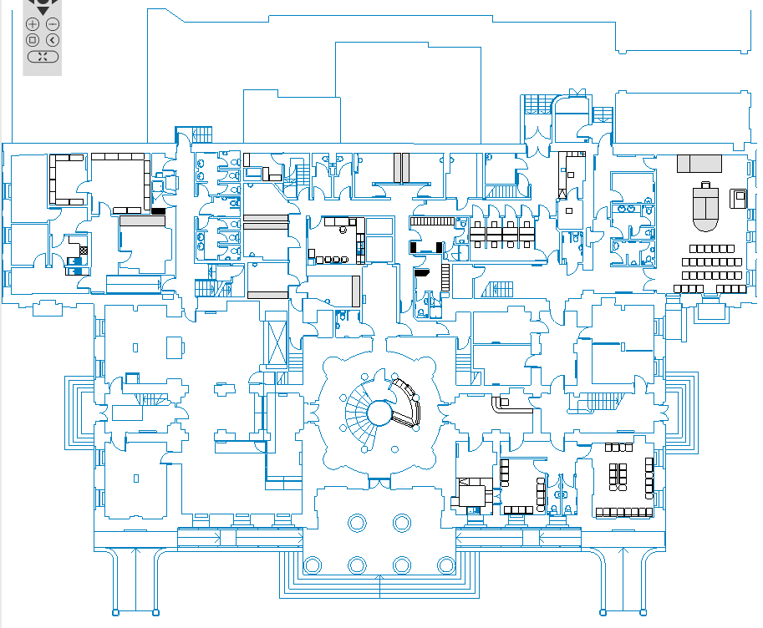

Reception

WitnessRoom

Sheriff Clerk FINES

Entrance Hall

Lift

WC

Court 5

WC

cafe

Witness Waiting

Witness Waiting

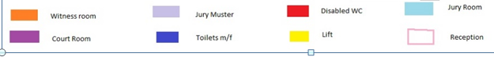

Ground Floor Layout

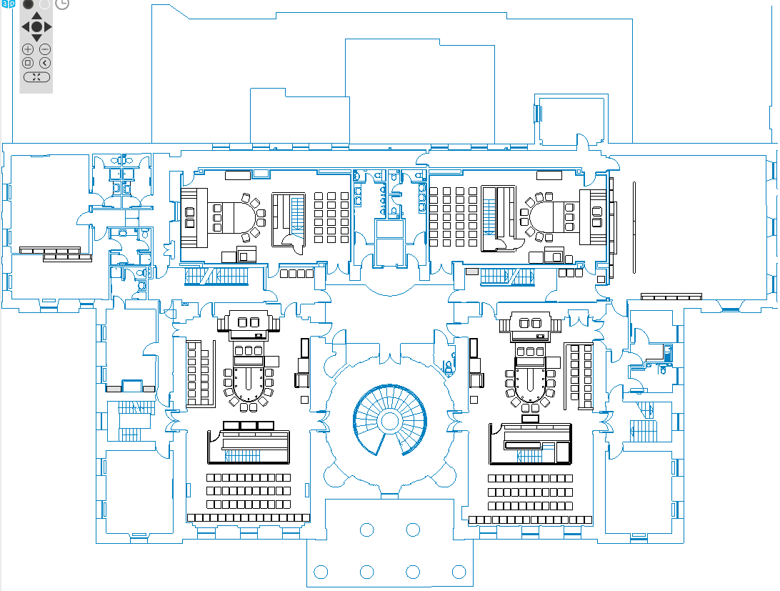

DisabledWC

Witness Rm

Witness Rm

Jury Rm

Court 3

Court 1

Court 2

Court 4

Lift

WC



First Floor Layout

**Opening Times**

**Weekly**

Monday to Thursday: 9am to 5pm

Friday: 9am to 4:30pm

**Public Holidays**

**2019**

01 – January Tuesday **New Year’s Day**

02 – January Wednesday **2nd January**

19 – April Friday **Good Friday**

22- April Monday

06 – May Monday **Early May Bank Holiday**

05 – August Monday **Summer Bank Holiday**

23 – September Monday

14 – October Monday

02 – December Monday **St Andrew’s Day (substitute day)**

25 – December Wednesday **Christmas Day**

26 – DecemberThursday  **Boxing Day**

**Contact Information**







**Postal Address**

Sheriff Court House

Wellington Square

Ayr

KA7 1EE

**Sheriff Clerk**

Jean Flanagan

**Main Telephone**

01292 292 200

**Fax**

01292 292249

**Email**

[ayr@scotcourts.gov.uk](mailto:ayr@scotscourts.gov.uk)

**Additional Information**

If you require this document

in an alternative format

please contact the Property

and Services Unit at the

below address.

[enquires@scotcourts.gov.uk](mailto:enquires@scotcourts.gov.uk)

**The Scottish Courts and**

**Tribunals Service**

Saughton House

Broomhouse Drive

Edinburgh

EH11 3XD

**0131 444 3300**

or text phone

**18001 0131 444 3300**







### Accessibility contact

If you want to contact us using text relay please follow the guidance at this link -  [the Next Generation Text Service](https://www.btplc.com/inclusion/MakingCallingEasier/Textrelay/index.htm)

If you require the support of an interpreter when you contact a court (by phone or attend in person), a telephone interpretation service is available.  To access this service ask for telephone interpreting and the language required. This service is NOT available during actual court proceedings.

If you use British Sign Language (BSL) and wish to phone us using a sign language interpreter, you can use the online video relay interpreting service. For more information see the contactSCOTLAND website. [www.contactscotland-bsl.org](http://www.contactscotland-bsl.org/)

The assistance of Typetalk run by the RNID and Language Line covering 100 foreign languages is available.



**This Report**

This report has been compiled using the Scottish Accessible Information Forum, ‘Making Information Accessible’ guidance published September 2014.

A copy of our Court Users’ Charter can be accessed [here](http://www.scotcourts.gov.uk/docs/default-source/scs-board/charter.pdf?sfvrsn=8)

Should you require this document in another language or format please contact:

Court Services Branch

Scottish Courts and Tribunals Service

Spur N1,

Saughton House

Broomhouse Drive

Edinburgh

EH11 3XD

[csbenquiries@scotcourts.gov.uk](mailto:csbenquiries@scotcourts.gov.uk)

0131 444 3455