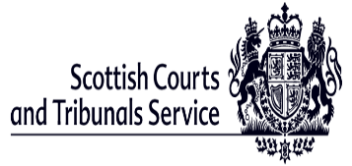

Attending a Civil Court in Scotland
Easy Read

What this booklet is about.

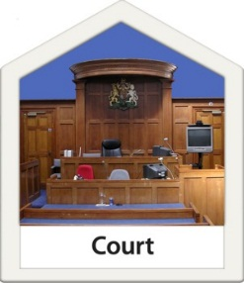 | This booklet is about going to a civil court in Scotland.
 | A civil court is a place where people go to sort things out when they do not agree.
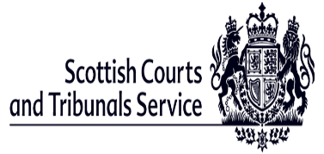 | This booklet was written by the Scottish Courts and Tribunals Service.
 | The Scottish Courts and Tribunals Service is in charge of the buildings that are used for courts.
 | Any big words in this booklet have been put in bold.
 | Words in bold will be explained in the booklet.

What happens before court?

 | When someone has made a legal complaint about someone else the person they complained about is given a letter.
 | This is called serving papers.
 | The person who was served papers has 21 days to answer.
 | When they answer they say if they want to go to court.
 | If they say that the complaint is right they don’t have to go to court.
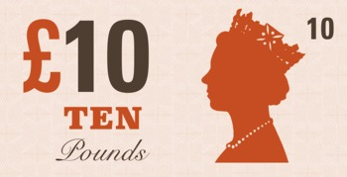 | If they don’t go to court they might have to pay some money.

Why people might go to a civil court.

 | Civil courts are there to help parties who do not agree.
 | Parties is the name given to the two sides in the court.
 | Parties might be a person, a company or any other organisation.
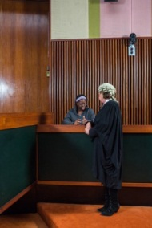 | When people go to court it is called a civil action.

Who will be in Court?

The Sheriff is the person in charge of everything that happens in the court room.

Solicitors are people who have trained in law.

Solicitors help people to know what to say in court.

Solicitors can also be called lawyers.

People do not need to have a solicitor but getting advice about legal things is a good idea.

The kind of things parties talk about in court.

Debt

 | Debt is money that you owe another person or a company like a bank.
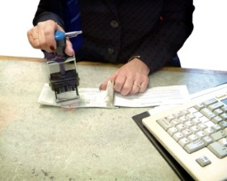 | The person might have to go to court to agree a way to pay back the debt.
Divorce
 | When a married couple want to get divorced.
 | Getting divorced means they will not be married to each other anymore.
 | When a couple get divorced they might need to go to court to agree how to split up their money and house.

Access to Children

Sometimes parents have to go to court to sort out when they see their children.

Sometimes parents go to court when social workers are worried about their children.

Which court do people go to for civil actions?

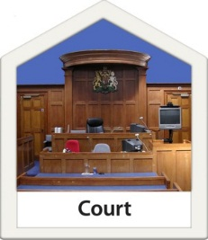 | For civil actions people will go to either the Sheriff Court or the Court of Session.
 | The Court of Session is in Edinburgh.
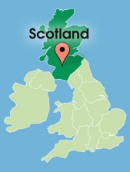 | There are Sheriff Courts all across Scotland.

The different types of Civil Actions.

 | Simple Procedure actions are when the money involved is up to £5000.
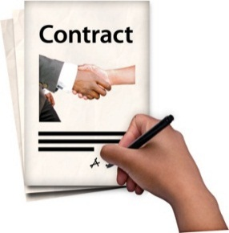 | Simple Procedure claims are made when someone has not done something they should do such as pay money.
 | Summary Cause is when the money involved is up to £5000 and is for damages because of personal injuries.
 | Summary Cause is also used when the owner is trying to get back the property from the person they rented it to.
 | Ordinary Actions are things like divorce or when parents are trying to agree when they see their children or when money is involved over £5000.
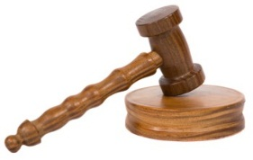 | Miscellaneous Actions are other things that relate to the law.
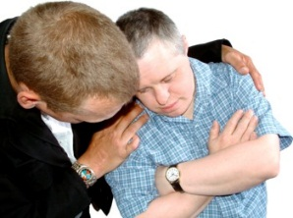 | Examples of miscellaneous actions are when the court has to help to protect a child or an adult at risk of harm.
 | Other miscellaneous actions are when a business or person runs out of money and can’t pay money it owes.
 | This is called being bankrupt.
 | If someone wants to adopt a child this has to go to court.

What will happen in a civil court?

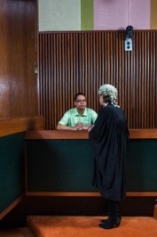 | First there will be a hearing.
 | The hearing is when the people involved go to court to try and agree the steps to take to sort out the case.
 | They might agree on a date to come back to court for a diet of proof.
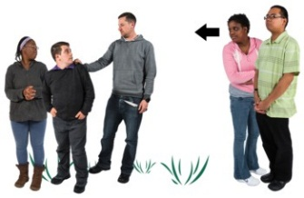 | A diet of proof is when the Sheriff listens to each side of the argument.  At the diet of proof there may be witnesses  A witness is a person who knows something about what happened.
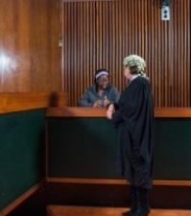  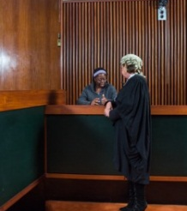 | They tell the people in the court what they know.  Talking in court about what you know is called giving evidence.  The Sheriff listens to both sides when they talk about what happened.
 | The Sheriff makes a decision called a judgment.
 | The Sheriff might speak in court to say what they have decided or they might write it down.

What happens after a court case?

 | What the Sheriff decides is called an order.
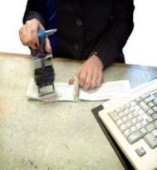 | The order might mean that the person has to pay money.
 | The order might be to decide who is to look after children.
 | The order might say who gets to keep things if a couple has divorced.
Appeals.

 | If someone is not happy about the decisions made in court they can appeal.
 | An appeal is when you ask for the decision to be thought about again.

If you need more information.

You can look on the website
www.scotcourtstribunals.gov.uk

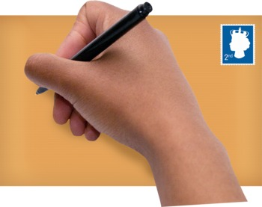 | You can write a letter to  Scottish Courts and Tribunals Service,  Saughton House,  Broomhouse Drive,  Edinburgh,  EH11 3XD.
You can write an email to
enquiries@scotcourtstribunals.gov.uk

 | You can telephone 0131 444 3352

V6. SCTS 13.03.19

