How to complete the online application | 

These guidelines have been developed to assist you with filling in your online application as fully as possible.

For applicants with a disability, the Scottish Court Service will make details of all posts available, on request, in Braille, in large print, or on tape, and you may submit applications in an alternative format. If you require this service, then please e-mail recruitment@scotcourts.gov.uk or telephone 0131-444-3433 or 0131-444-3432

Click on the relevant section below:
Your application- General Information
- Registration
- STEP 1 - Personal Details, Disabilities
- STEP 2 - Right to Work in the UK
- STEP 3 - Personal Character
- STEP 4 – Your Education and Qualifications
- STEP 5 – Employment History
- STEP 6 – How do you meet the requirements of the post
- WHAT DOES A GOOD RESPONSE LOOK LIKE?
- STEP 7 – References
- STEP 8 – Key Employment Information
- STEP 9 – Why have you applied for this position?
Equal Opportunities Monitoring
STAGE A – Ethnic Origin, Age
STAGE B - Gender, Disability, Sexual Orientation, Religion or Belief
Declaration

Your application- General Information
- You must fully complete the on-line application form for each vacancy you apply for in the Scottish Court Service. Unfortunately we do not accept Curriculum Vitaes (CVs) as a form of application.
- Before completing the application form you should read any information provided about the job, particularly the Person Specification and Job Description. The Job Description is found alongside the Person Specification at the bottom of the `Job Detail` page.
- It is possible to save and exit your application part of the way through. You can then complete it later, but please do remain aware of the closing date. We are not able to consider late applications.
- Incorrect/ missing information will be shown with a red star (*) or a red error message onscreen
- You are currently not able to print your application at the end of the application, if you need a copy of your application email recruitment@scotcourts.gov.uk quoting your application number and job reference number
- Any applications which are left ‘unsubmitted’ will not be retained within the system.

TIME OUT!! Please note that the system has been designed so that, if you leave the application form on the screen without moving from one screen to another or clicking on the save button for more than 15 minutes, it will time out. This is for your security and to help protect your privacy if you are using a shared PC to apply for the vacancy.

TIP: If you need to enter a lot of information, it is worthwhile clicking on the ‘Save’ button every 15 minutes or so to ensure the system does not time out. Alternatively you can compile your responses within a word document and copy and paste the information across to the online system when ready. In doing this you will also have a record of your application.

If your time on the system expires you will be see the following message:
"Sorry! Your session on the SCS Recruitment server has timed out. You can access the system again using the link on the SCS website."

- When the system times out, you will lose any new information that you have entered or amended on the current page only. If you log back in using your email address and password you will be able to access your application with all the information that you have entered apart from the most recent information on the screen that was active when the time out occurred.

The On-line Application Form

Registration
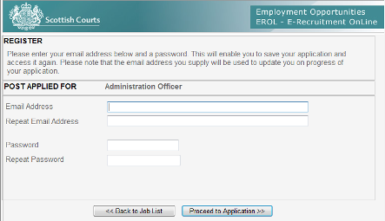

Please enter your e-mail address twice. This allows us to confirm that we have the correct contact details for you. Please also enter and confirm a password. Please note: The email address you supply will be used to update you on the progress of your application.

- To start your application click the ‘Proceed to application’ button

You can save your application at any stage and return to it later for completion, to do this click exit at the bottom of the page. This will take you to the screen below which asks you whether you want to ‘Cancel’ or ‘Save’ your application. Clicking ‘Cancel’ will delete all information you have entered so far.
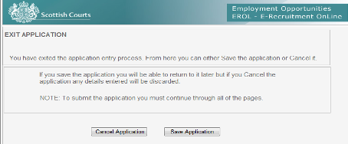
To get back into a saved application, go back into the job list and click the link ‘Log in’ button at the bottom of the page. You will then need to enter the email address and password you entered during registration.
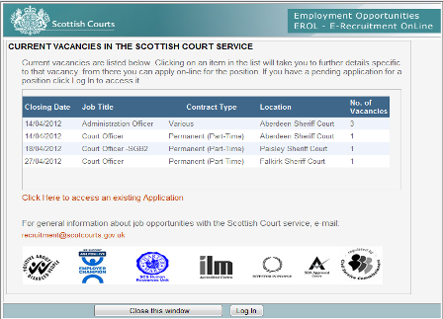
- Click ‘Log in’
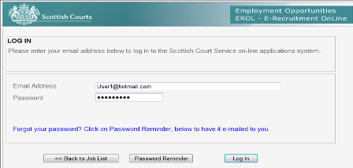

- If you have forgotten your password, click the ‘password reminder’ button.
STEP 1 - Personal Details, Disabilities
Personal Details
Please ensure you complete this section in full so that we can contact you when necessary.
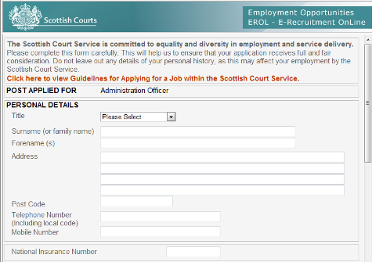
Disability
Please use this part of the form to indicate if you consider yourself to have a disability, and also whether any special provisions need to be made for you, for example, a sign language interpreter at interview.
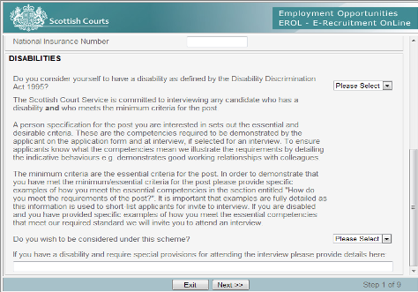
- Please select from the drop down menu, whether you consider yourself to have a disability as defined by the Equality Act 2010.
The Scottish Court Service holds the Disability symbol (Guaranteed Interview Scheme) and is committed to interviewing any candidate with a disability that fully meet the minimum (essential) criteria for the post.

- If you wish to be considered under guaranteed interview scheme, then please select this option from the drop down menu on the first page.

The Person Specification for the post you are interested in sets out the essential and desirable criteria for the post. These values and behaviours are what we need you to demonstrate in your application form and at interview (if selected). To ensure applicants know what the corporate values mean we illustrate the requirements by detailing Illustrative Behaviours, for example “recognises and be responds to customers/visitors and their individual needs” would be an indicative behaviour for the `Providing a High Quality Service` value.

The ‘essential’ criteria for the post are those which the applicant must have/meet. In order to demonstrate that you have met the essential criteria for the post please provide specific examples of how you meet each value and behaviour in the section entitled "How do you meet the requirements of the post?"

This information is used to short-list applicants for interview, so it is important that you spend time to complete this section fully. Failure to provide specific examples will result in your application being rejected.

STEP 2 - Right to Work in the UK 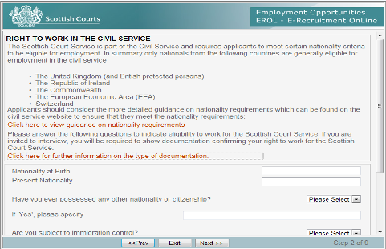
You can access guidance on our nationality requirements by clicking the orange link (shown above).

- Enter your Nationality at birth and also your present Nationality in the text boxes.
- Use the drop down menu to indicate if you have ever possessed any other nationality or citizenship. If you have answered ‘yes’ to this question, then you must specify the other nationality or citizenship in the space below.
- Use the drop down menu to indicate whether you are subject to immigration control. If you have answered yes to this question, then please specify the details in the space below.
- Use the drop down menu to indicate whether there any restrictions on your continued residence or employment in the United Kingdom. Again, if you have answered ‘yes’ to this question, please specify what these restrictions are in the space provided.
- Use the drop down menu to indicate whether you lawfully resident in the United Kingdom Please use the drop down menu to indicate whether you are free to remain and take up Civil Service employment in the United Kingdom?

Please note that the SCS as a Civil Service Agency must comply with the Nationality Rules specified by the Cabinet Office. These rules restrict employment in the UK Civil Service to certain categories of citizen, although not solely to its own nationals. It prohibits the employment of aliens (anyone who is not a British or Commonwealth citizen, a British protected person or a citizen of the Republic of Ireland) to Civil Service posts except if the person is a member of the European Economic Area (EEA).

In summary, only nationals from the following countries (or associations of countries) are eligible for employment in the Civil Service:

♦ UK nationals
♦ The Republic of Ireland
♦ The Commonwealth
♦ The EEA
♦ Switzerland
♦ Turkey (Turkish nationals are not automatically eligible for employment
with the Civil Service.)

There are some countries (including those that have recently joined the EEA) whose citizens may need to satisfy further criteria in order to work for the Civil Service. Please refer to the website below for a list of the relevant countries and the criteria they need to satisfy:

http://www.civilservice.gov.uk/about/resources/nationality-rules

If you fail to meet the nationality eligibility criteria, your application will unfortunately be rejected.

STEP 3 - Personal Character 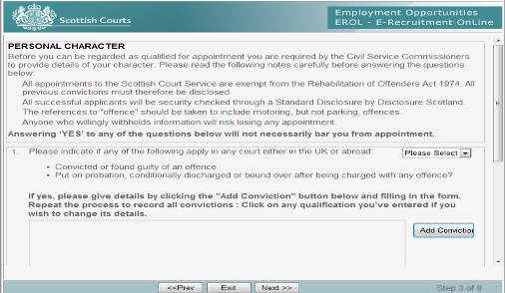

- Indicate using the drop down menu whether you have been convicted or found guilty of an offence, put on probation, conditionally discharged or bound over after being charged with any offence. If you indicate ‘Yes’, click the ‘add conviction’ button to enter the details. Repeat the process to record all convictions. Please click on any conviction you’ve entered if you wish to change its details. Please note that answering YES to any of the questions will not necessarily bar you from appointment, however these details will be taken into account and your application may be rejected after further consideration.

The Scottish Court Service is exempt from the Rehabilitation of Offenders Act 1974 and you must disclose all previous convictions regardless of whether they are spent. Successful applicants will be security checked through a ‘Standard’ level Disclosure check; this includes convictions held on central records and records of both spent and unspent convictions. This means that even minor convictions, perhaps dating from years ago, are included on the Disclosure. If you withhold information in your application you risk us withdrawing our offer.

You should include motoring, but not minor offences such as speeding or parking tickets.

- Next, use the drop down menu to confirm if any charge in respect of any offence has been brought against you and not yet disposed of. If you have answered `yes`, then please give details in the space provided.
- Last of all; please use the drop down menu to confirm if you are:
  - Insolvent
  - A person in respect of whose property a Receiving Order is in effect?
  - An undischarged bankrupt?

Disclosure Scotland is part of the Scottish Criminal Record Office (SCRO). Disclosure Scotland is a service designed to enhance public safety by providing potential employers and organisations with criminal history information on individuals applying for posts. Disclosure Scotland issue certificates - known as "Disclosures" - which give details of an individual's criminal convictions or state that they have none.

STEP 4 – Your Education and Qualifications
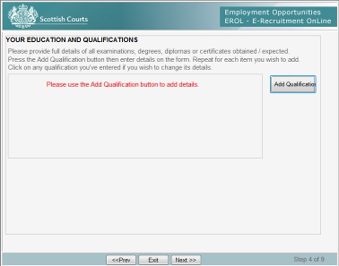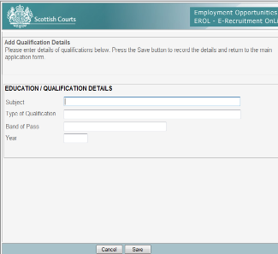
You should detail any qualifications or certification required or relevant for the post as detailed in the job advert. These may include, but are not limited to, Standard Grades, Highers, SVQs, HNDs and Degrees. You should provide details of the subject, the type of Qualification and Band of Pass, and the Year attained. For example: If the job you are applying for requires you to have certain qualifications, you should bring the original copies of these with you to interview.

- To complete this screen please press the ‘Add Qualification’ button then enter details on the form. When complete, click ‘Save’. Repeat for each item you wish to add. Click on any qualification you’ve entered if you wish to change its details.

STEP 5 – Employment History
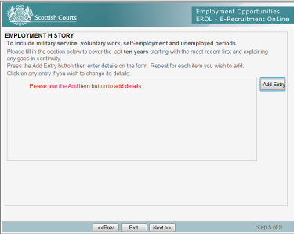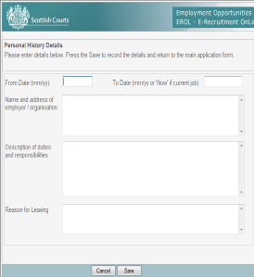

- As with the previous step press the `Add Entry` button to enter details. Repeat for each item you wish to add. Click on any entry if you wish to change its details.

You should provide information on your employment/ education (if little or no work experience) up to the last 10 years, beginning with your most recent. Please explain any gaps in employment or full time education. You should include periods of unemployment or voluntary work and time spent caring for relatives. If you have spent 6 months or more over the past 3 years abroad please give a reasonable account and details of this.

STEP 6 – How do you meet the requirements of the post?
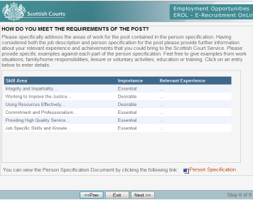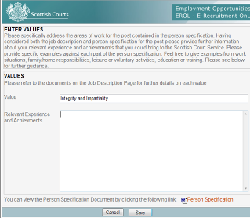
This section is of particular importance as it is how the selection board will assess whether you meet the requirements for the job.

- You should refer to the Person Specification (bottom right) for the job you are applying for. This sets out the essential and desirable criteria which you will be assessed against to test your suitability for the job. In this section, you should provide specific examples of how you meet each of the criteria. Remember that relevant experience is not always obtained from a formal work setting, so consider any voluntary work, courses, placements or leisure activities that you have achieved, particularly if you have never been in paid employment or have not worked for a long time.

- The values and behaviours for the post and whether they are essential or desirable are detailed on this page. If you click on each entry you can enter / change details and examples against each criteria. Once you have written your response click the ‘save’ button.

You can gain an understanding of what makes a good response from the information below.

WHAT DOES A GOOD RESPONSE LOOK LIKE?

One of the common errors applicants make is that they give generic responses when it comes to detailing how they meet the requirements of the post or they make general assertions about meeting the specification but do not support this up with appropriate examples. As indicated above, we are looking for specific information and examples which back up what an applicant is saying.
The following examples demonstrate this so you can gain an understanding of what we are looking for when assessing. In relation to a requirement to have experience of improving processes applicants could answer in different ways, as follows:
Example 1 (Poor response):
One my key skills is improving processes and I believe the key to this is exploiting information technology. Process improvement is fundamental to ensuring savings are made for the organisation both in terms of time and increased efficiency. I have utilised this skill throughout my career and I believe my track record clearly demonstrates that I can add real value to your organisation.
Example 2 (Good response):
One my core skills is recognising where process improvements can be made to deliver efficiency and identifying solutions to make cost savings. An example of this is at Seinfeld Consultancy where I identified that our manual process for recording queries on a tally sheet was time intensive, difficult to process and challenging to analyse. I undertook some analysis of the current process and calculated that the department spent on average 7 hours per week recording, processing and analysing query data. This meant that around 52 days per year was being spent on this task at a cost of £4,500.
I investigated a number of query management systems and produced a system specification to enable a procurement exercise to be undertaken to find an electronic solution. The result was that I introduced a new electronic query management system to the organisation at a cost of £6,000. The new system reduced the time spent recording, processing and analysing query data by 5 hours per week, saving £3,000 of resource in the first year. In addition the new system enabled me and other managers to easily analyse query trends and monitor response times to customer queries, this helped to identify a number of other key areas for improvement to be identified and gave a key measure to monitor service deliver in terms of response times for our customer base.

STEP 7 - References
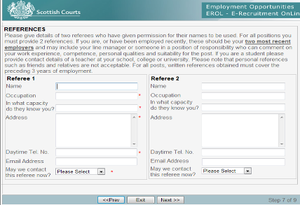

- Please give details of two referees who have given permission for their names to be used. The first should be your most recent employer, school, college or university. The next should be an additional employer, school, college or university referee.

In order to comply with the HMG Baseline Personnel Security Standard outlined by the Cabinet Office the Scottish Court Service we must verify a successful candidates employment history for the past 3 years, please ensure that the references you provide cover this minimum period. If your two references do not cover a 3 year period you may be asked to supply details for additional referees.

- Please indicate under each Referee if we can approach them for a reference by using the drop down menu. We will only request references after you have been offered a job with us.

STEP 8 – Key Employment Information
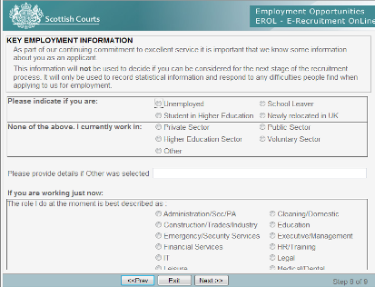

As part of our continued commitment to provide an efficient service, it is important that we get your thoughts as an applicant on the Scottish Courts Services recruitment process.

The information you provide in this section will not be viewed by the selection board Members and this information will not be used to decide if you can be considered for the next stage of the recruitment process. It will only be used to record statistical information and respond to any difficulties people find when applying to us for employment.

- To complete this section, simply click on the appropriate answer. If you have answered `other` to any question, then there is room provided to add more detail.

STEP 9 – Why have you applied for this position?
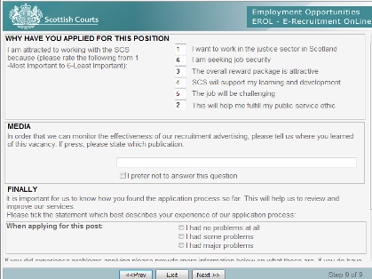
In this section we want to discover what attracted you to working with the Scottish Court Service so that we can adapt our recruitment strategy.

- Rank the reasons for applying from 1 to 6 (1 = Most Important and 6 = Least Important) in the boxes provided. Please not that you can only use a number once and cannot duplicate them (see above).

Media
To enable us to measure the effectiveness of our recruitment advertising we ask that you let us know where you heard about the vacancy in the space provided on screen.
- Please ensure that you state the original website/publication that you saw the vacancy advertised e.g. ‘S1Jobs’ or ‘Sunday Times Scotland’. By only specifying ‘internet’ or ‘newspaper’ this restricts the validity of the data we collect for our advertising strategy.

Finally
It is very important for us to know how you found the application process thus far. This helps us to review and improve our recruitment services.
- Please tick the statement which best describes your experience of our application process. If you experienced problems applying please tell us about it in the space provided. Additionally, if you do have any suggestions to help us make our application process better, let us know here.

None of the information you enter can be viewed by the selection board Members and this information will not be used to decide if you can be considered for the next stage of the recruitment process.

Once you have completed the 9 steps of your application you will be navigated to an additional page which captures your equal opportunities data. This is in 2 stages and explained below:

Equal Opportunities Monitoring
The Scottish Court Service is committed to equality of opportunity in employment. It is committed to providing a high quality service and practices that are free from discrimination.

Information provided in the next two Screens will be used for two purposes only:

- To monitor our recruitment and selection process to ensure that there is no discrimination;
- If you are a successful applicant, to record on our payroll system and to be used for anonymised statistical and research purposes

The information you provide will not be seen by the selection panel and will remain strictly confidential.
- Please complete all sections of the form by selecting the relevant box. If you wish, for whatever reason, not to complete any section, then there is a box that you can tick to indicate this.

If you feel that Equal Opportunities has not been followed then you should write to Craig Hennessy, Recruitment Manager, Scottish Court Service Headquarters, Spur A1, Saughton House, Broomhouse Drive, Edinburgh, EH11 3XD or e-mail recruitment@scotcourts.gov.uk

STAGE A – Ethnic Origin, Age
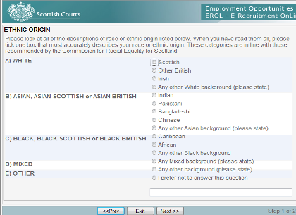

- Please look at all of the descriptions of ethnic origin listed and tick one box that most accurately describes your ethnic origin. The information you provide will not be seen by the selection panel and will remain strictly confidential.
- There is a space for you to complete if your ethnic origin is not covered in the list.
- We also ask you to select your age from the list provided.

STAGE B - Gender, Disability, Sexual Orientation, Religion or Belief
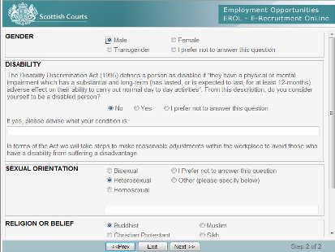

The Equality Act 2010 defines a person as disabled if "they have a physical or mental impairment which has a substantial and long-term (has lasted, or is expected to last, for at least 12-months) adverse effect on their ability to carry out normal day to day activities".

- If, from this description, you consider yourself to be a disabled person, you should tick the appropriate box and provide details.
- Sexual Orientation and Religion or Belief, are monitored to allow us to make sure that there is no discrimination along these lines. There is a tick box to choose from and, once again, the option not to answer. The information you provide will not be seen by the selection panel and will remain strictly confidential.
Declaration
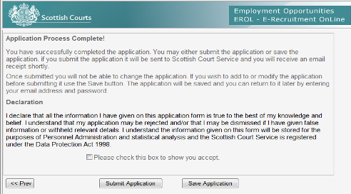
You have now successfully completed the application.

- The final step is to carefully read the declaration and put a check in the box to show that you accept the declaration.

You may now either submit the application or save the application. If you submit the application it will be sent to Scottish Court Service and you will receive an email receipt shortly afterwards acknowledging that your application has been received. Once submitted you will not be able to change the application. If you wish to modify the application before submitting it, click the <<Prev button.

If you wish to come back to your application at a later stage, click the ‘Save’ button. You will be able to access your application up till the closing date.

