**Visiting**

##### Falkirk Sheriff Court and

##### Justice of the Peace Court

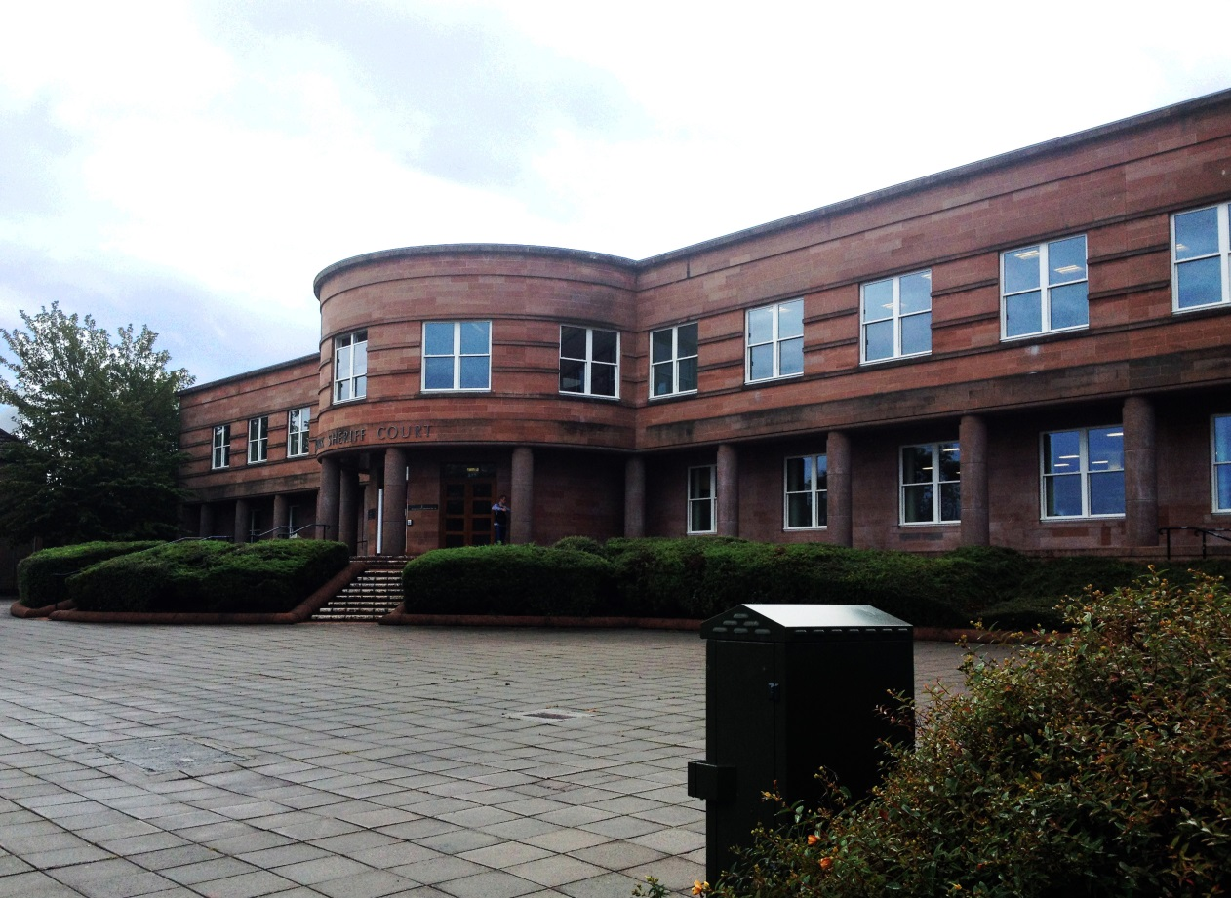



[](http://www.bing.com/images/search?q=Phone+Symbol&view=detailv2&&id=66CED88CCFB20CC9EB9C955ABD258FACE9200A23&selectedIndex=61&ccid=NLXDtiSr&simid=608051032150313885&thid=OIP.M34b5c3b624ab2e77aecc5b51235ed993o0)

This leaflet will help you to

plan your visit to the

Falkirk Sheriff Court and

Justice of the Peace Court.

If you require more information

about anything here you can

Email:

[enquires@scotcourts.gov.uk](mailto:enquires@scotcourts.gov.uk)

or telephone the Property

and Services Unit on:

**0131 440 3300**

or text phone

**18001 0131 444 3300**

(Full contact details are on

Page 22)

**Contents**

**Location Details**

Page 4

……………………………………………..

**Ways of getting to the Court Building**

Pages 5 to 7

………………………………………………

**On Arrival**

Pages 8 to 9

………………………………………………

**Facilities**

Pages 10 to 18

……………………………………………….

**Floor Plans**

Pages 19 and 20

………………………………………………

**Opening Times & Public Holidays**

Page 21

………………………………………………

**Contact Information**

Page 22

………………………………………………

**Additional Information**

Pages 23 and 24

**Location Details**

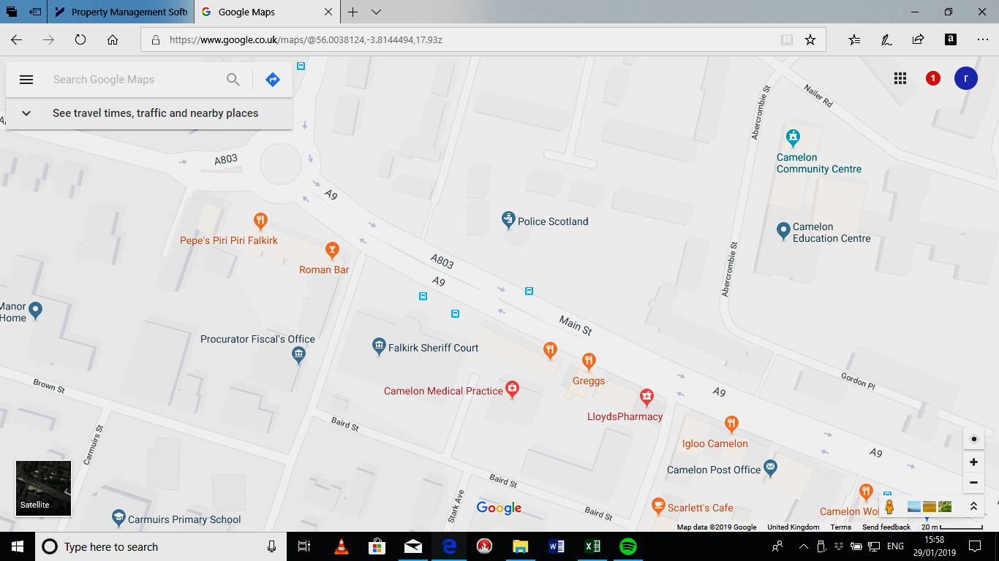

The public entrance to the courthouse faces onto Main Street. The main doorway is raised above street level and is accessed by a series of 12 steps.

For users with restricted mobility there are two ramps provided at the eastern and western sides of the main entry to the building. A push pad is located on the right hand side of the double swing doors.

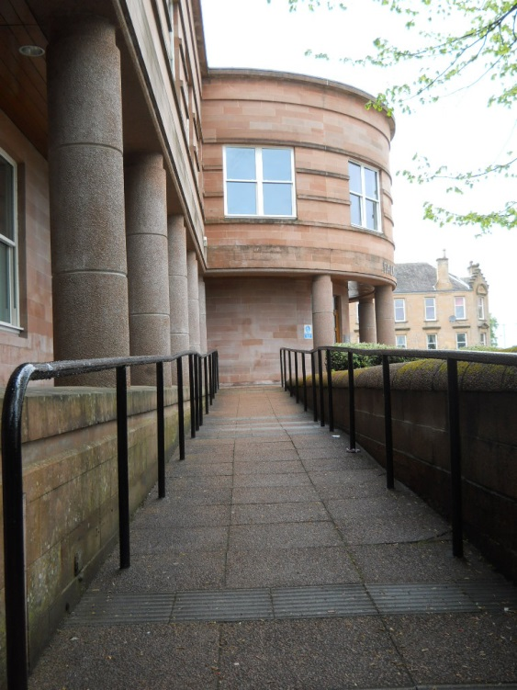



**Ways of getting to the Court Building**

**By Bus**

If travelling by bus, there are a number of buses that serve Falkirk Sheriff Court, all of which stop outside or a short walking distance.

Local and out of town buses stop in the Main Street, Camelon on both sides of the road including:

First Bus services 4/4A, X35, X37, 59, X81A and X86. The bus stop across the street stopping outside the court building has services 2/2A/2B, 38/38A and X86C,



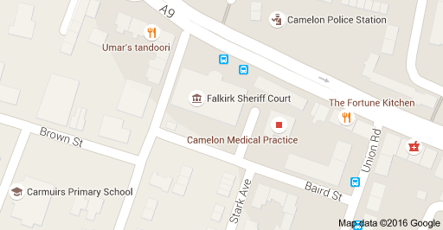



**By Train**

The main train station is Camelon which is a short 0.3 mile walk from the court building.

Trains run to and from Glasgow and Edinburgh regularly.

There are also stations at Camelon, Grahamston and Falkirk High. A taxi will be needed if alighting from these other stations.

Visit [www.nationalrail.co.uk](http://www.nationalrail.co.uk)

or call **03457 484 950** for

train times.

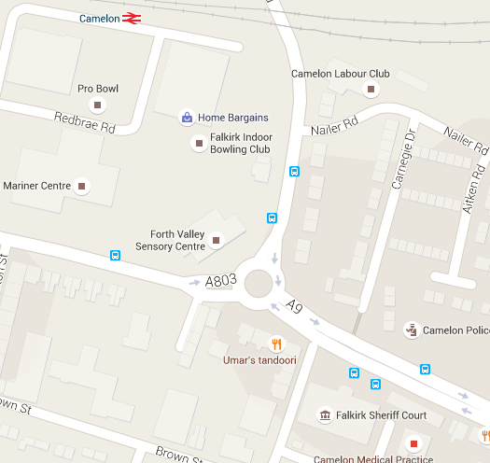

Train stations



**By Public Transport**

Contact Traveline Scotland

for all public transport

enquiries and assistance on

**0871 200 22 33** or visit

[www.travelinescotland.com](http://www.travelinescotland.com)

**By Car**

There is no public car

parking at the court building.

Parking facilities are available on Baird Street, Mansionhouse Road and Stark Avenue, all of which are close and behind the court building

One disabled parking bay is located at Court and contact should be made on 01324 620822 in advance to book this.

**On Arrival**

**Entrance**

Public entrance to the

court building faces on to

Main Street and is

accessed from pavement

level by twelve steps, or

side ramps on either side of the building for those with

restricted mobility.

The automatic swing door is activated by a push pad on the right-hand side of the doorway.

**Security Check**

You may be subject to security checks in the main court foyer by trained security staff.

Wheelchair users are scanned by a paddle scanner.

Your bags or briefcases may

also be searched.

The ground floor main lobby serves as the central point of orientation to access the rest of the building. This lobby is wide, spacious and able to accommodate large numbers at peak times. The main staircase to the first floor level is found on the eastern and western sides of this lobby and serves as an access point to the courts. A Reception Desk is located in front of the main doors.

.

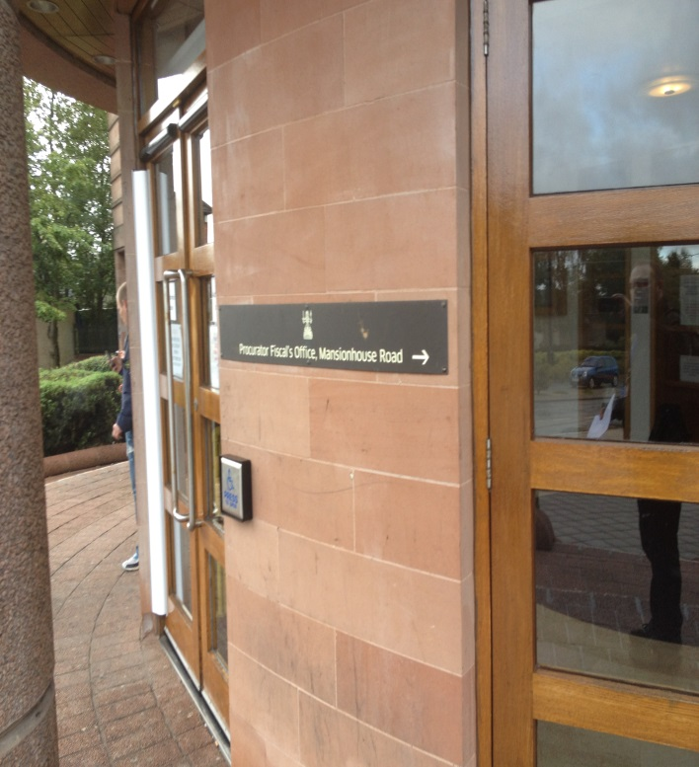



[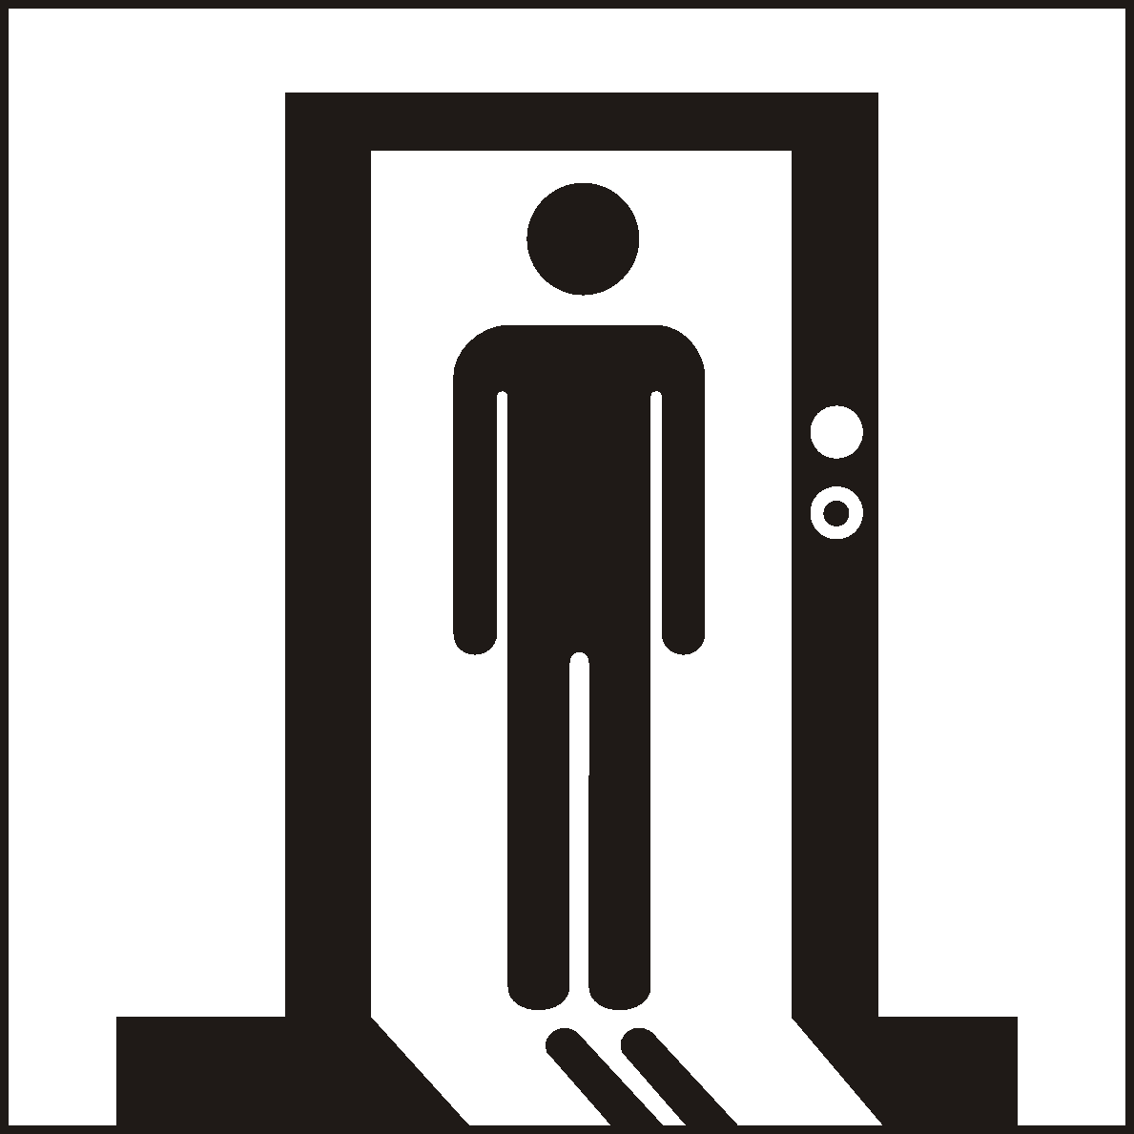](http://www.google.co.uk/url?sa=i&rct=j&q=&esrc=s&source=images&cd=&cad=rja&uact=8&ved=0ahUKEwialYnHwtPJAhUKWhoKHUKJBs4QjRwIBw&url=http://www.standard.org.cn/dgsymbol/list.aspx?sid%3D12%26stid%3D%26Page%3D5%26searchtxt%3D&bvm=bv.109395566,d.d2s&psig=AFQjCNEa1EVlPPeWeUJ-gD_trfHzICP1Hw&ust=1449913041342312)

**Entrance**

The reception desk is located straight in front of the main doors.

Please report to the reception desk and state the reason for your visit. Reception staff will then direct you accordingly.

Staff can assist you if you

have any question about the

court building or your visit.

**Assistance**

If you have a wheelchair or a pushchair or need specific access assistance, please telephone in advance :

**01324 620822**

or textphone

**18001 01324 620822**

The ground floor main lobby serves as the central point of orientation to access the rest of the building. This lobby is wide, spacious and able to accommodate large numbers at peak times. The main staircase to the first floor level is found on the eastern and western sides of this lobby and serves as an access point to the courts. A Reception Desk is located in front of the main doors.

.

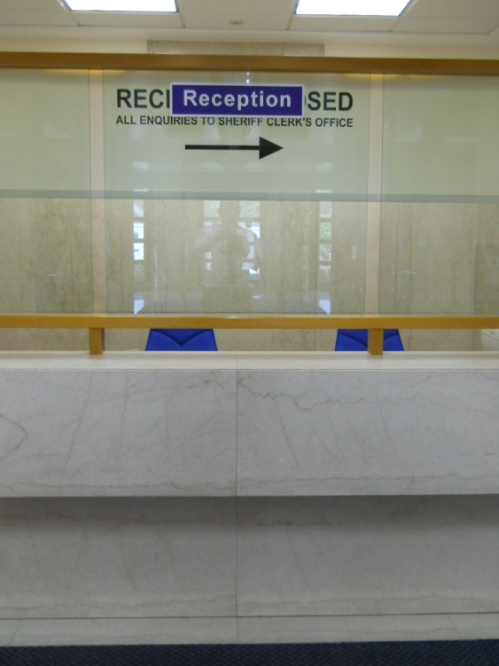

**Facilities**

**Internal Access**

A lift is available by request on the east side of the court for wheelchair users to access these. This lift found through the double doors, adjacent to the eastern staircase is a suitable size to comfortably accommodate a wheelchair and includes illuminated floor level indicators, raised floor indicator buttons, voice over floor and door alerts.

Upon reaching the first floor, the stairwell and lift opens out into the main public corridor. This corridor acts as both the route to accessing courts 1, 2 and 3, as well as the waiting area before a session. This corridor is spacious, wide and well lit.



**Hearing Loop**

For people who are hard of

hearing a fixed loop induction

service is available at all

Reception counters. Portable

mobile loop induction services

are available for all courtrooms.

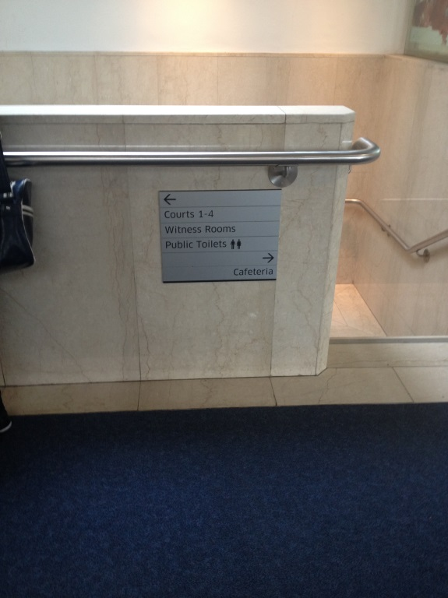

**Public Areas**

The reception desk is located on the ground floor and positioned opposite the entrance lobby. It is here that all visitors should report to for advice on direction to the appropriate court. The area around this reception is ample enough for wheelchair users to manoeuvre freely. The desk has a dropped desk as well as full induction loop. On arrival please inform the reception desk staff if you require this facility.

**Toilets**

Public male and female toilets are on the first floor public area. At ground floor level an accessible toilet and baby change facility is found to the left side of the reception desk.

High Contrast signage around

The court

[](http://www.google.co.uk/url?sa=i&rct=j&q=&esrc=s&source=images&cd=&cad=rja&uact=8&ved=0ahUKEwjxm4K289PJAhWKfxoKHbSPCJUQjRwIBw&url=http://www.zazzle.com/toilets%2Bstickers&bvm=bv.109395566,d.d2s&psig=AFQjCNE5z456mN4ypA-cvbcUyAdIjI0yVg&ust=1449926541257654)[](http://www.google.co.uk/url?sa=i&rct=j&q=&esrc=s&source=images&cd=&cad=rja&uact=8&ved=0ahUKEwiF96LM1NPJAhVL7RQKHTQCBZ0QjRwIBw&url=http://www.clker.com/clipart-23329.html&psig=AFQjCNHODAmfK5T3xc8P94NSEMLwh6WGLA&ust=1449918213568933)

[](http://www.google.co.uk/url?sa=i&rct=j&q=&esrc=s&source=images&cd=&cad=rja&uact=8&ved=0ahUKEwiF96LM1NPJAhVL7RQKHTQCBZ0QjRwIBw&url=http://www.soshified.com/forums/user/304780-chairman90/?tab%3Dstatus&psig=AFQjCNHODAmfK5T3xc8P94NSEMLwh6WGLA&ust=1449918213568933)



**Refreshments**

Hot and cold drinks and light snacks are available at the Cafeteria located at the top of the stairwells on the first floor. The Cafeteria is open every weekday from 9am until 3pm.

If you are sitting on a jury, lunch and refreshments will be provided for you if the court sits into the afternoon.

**Toilets**

Toilets are available on the following floors:

First Floor - Public Female / Male toilets.

Ground Floor - Public accessible toilets and baby change facility is found next to the eastern staircase with a key is available from the main office for this.

If you have a wheelchair or a

pushchair and you require

specific access assistance,

please telephone:

**0141 887 5291**

or textphone

**18001 0141 887 5291**

For further information on the

layout of the court building

please refer to the floor plan

layouts on pages19 and 20.

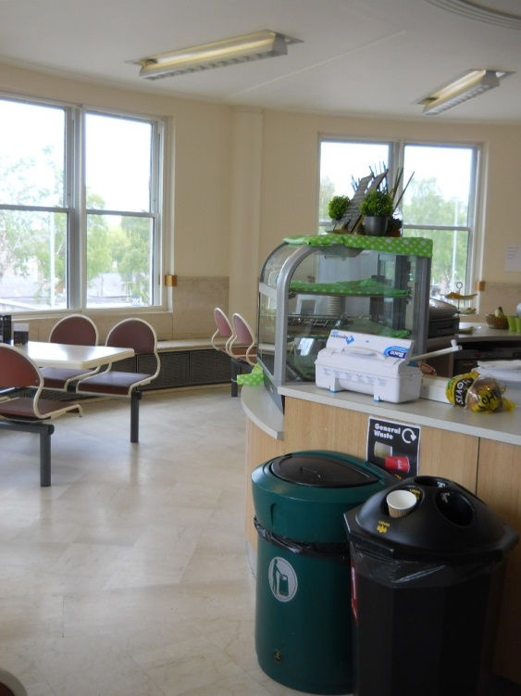

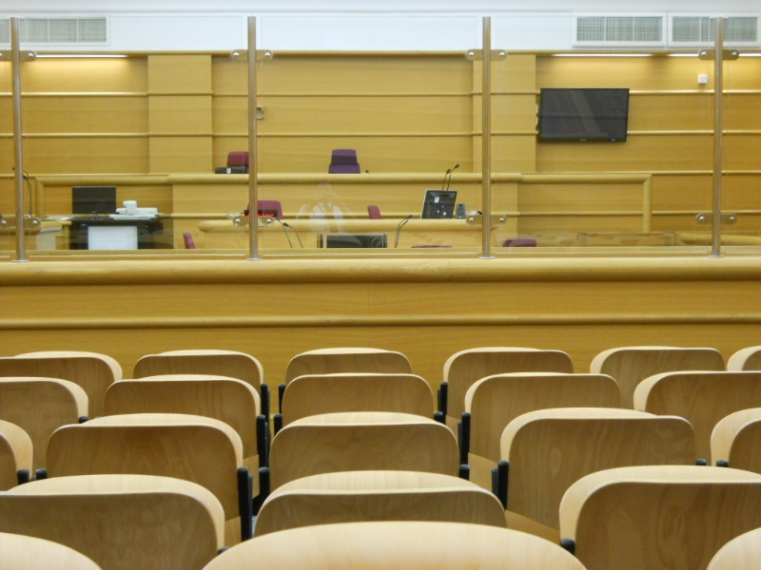

**Courtrooms**

All courtrooms are accessible

to wheelchair users on the same floor.

If you are due to attend any of the Courts and you require wheelchair assistance, please contact the court on:

**01324 620822**

so that prior arrangements

for reasonable adjustments

are made.

All Courts can accommodate

wheelchair users, however

assistance may be required

to open double doors that

lead into the public seating

area of Courtrooms 1 and 3.

Courtrooms 2 and 4 are accessed by a single door.

The Court Officers or staff will assist users into either court as required.

The Court Officers or staff

will assist users into either

court as required.

**Courtrooms**

The main Court landing on the first floor area is barrier free and well lit, however the courtroom entrances do not have automatic push pad opening.

Some building users and visitors may require assistance with accessing these areas.

Assistance will be provided if

help is required. Staff will assist users into either court as required.

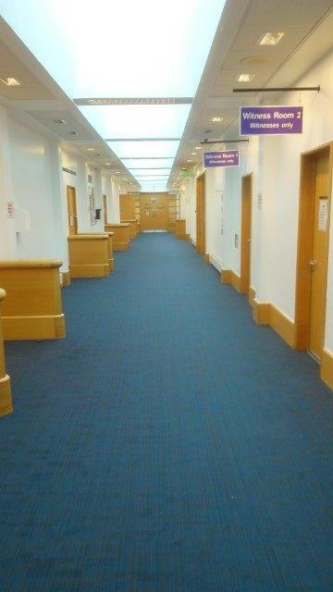

**Lifts**

A passenger lift is located on the ground floor within a secure area to the left of the Reception Desk and Court Staff will assist you to access this area. This leads to the courtrooms on the first floor level, with voice over floor and door alerts.

[](https://www.google.co.uk/url?sa=i&rct=j&q=&esrc=s&source=images&cd=&cad=rja&uact=8&ved=0ahUKEwijmeXk2NnJAhWFLhoKHaetCAcQjRwIBw&url=https://www.iconfinder.com/icons/41952/elevator_lift_icon&psig=AFQjCNFBzdPzzcb-7dUs7YIenjllh-kU0g&ust=1450125533140326)

**Witness and Jury rooms**

There are 5 Witness Rooms in total, situated on the First floor, which can accommodate wheelchair users and persons with restricted mobility.

Comfortable seating, reading materials and televisions are also provided.

Corridor doors serving the witness rooms do not have automatic push pad opening.

Some building users and visitors will require assistance with accessing the Vulnerable Witness rooms and other areas

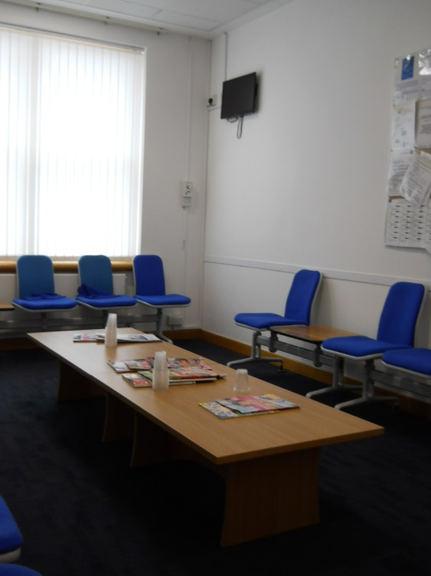

**Jury Rooms**

There are 2 Jury Rooms and these are furnished with comfortable seating.

Male and female toilet facilities are provided on this level. The accessible toilet and baby change are located at ground floor level.

**Fines and Criminal Office**

The Fines and Criminal Office are located on the ground floor level, to the right of the main entrance to the court building and clearly signed. Civil enquiries are also located in the same office.

The reception desk is provided with a dropped counter and a fixed induction loop system.

**Courts**

All courts are well lit, spacious and have good acoustic qualities including full induction loop facilities. As such they demonstrate a good ability to access all users. While no provision is given for wheelchair users to access the seated area in the public gallery or the witness box, the space in the courtrooms is ample. Wheelchairs can be accommodated in areas just outside the witness box and the gallery.

When accessing the court itself,

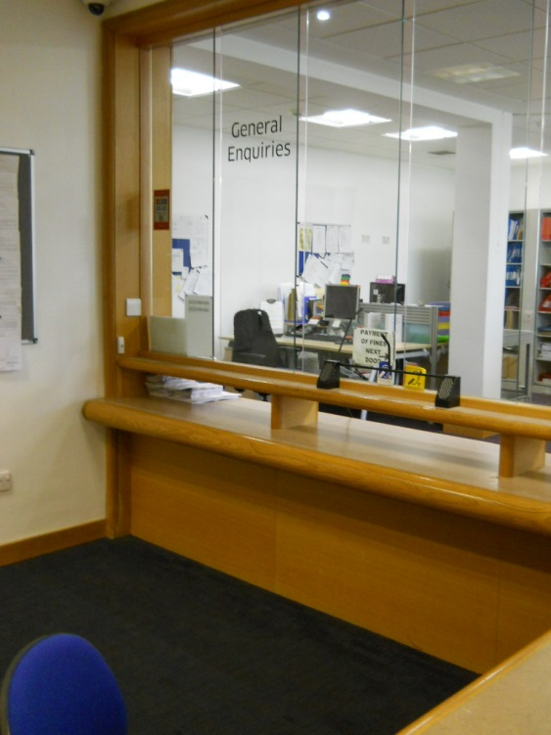

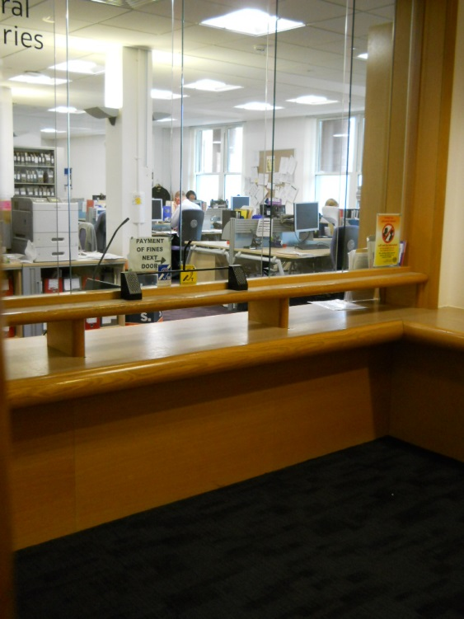

**The Civil Office**

The Civil Office is located on the ground floor level to the right of the reception desk and is combined with the Fines and Criminal Departments. It observes the same opening hours as the main court building.

There is disabled access by way of a push pad automated door to the main office.

The waiting area has sufficient space for wheelchair manoeuvrability and is provided with a dropped reception counter.

Civil Office Waiting room

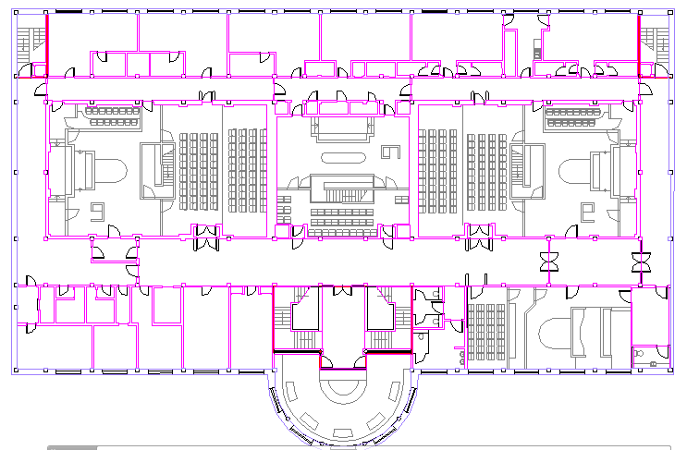

FIRE EXIT

FIRE EXIT

Restricted Area

Restricted Area

Restricted Area

Witness Room Disabled WC

Court Room Lift

Jury Muster Jury Room

Toilets M/F Reception

Witness Rm 3

Lobby

Lift

Public WC

Disabled WC

Vulnerable Witness Rm

Witness Rm 3a

Witness Rm 1

Witness Rm 2

Court Rm 1

Court 3

Corridors

Court 2

Cafeteria

Court 4

Public

WCs

**First Floor**

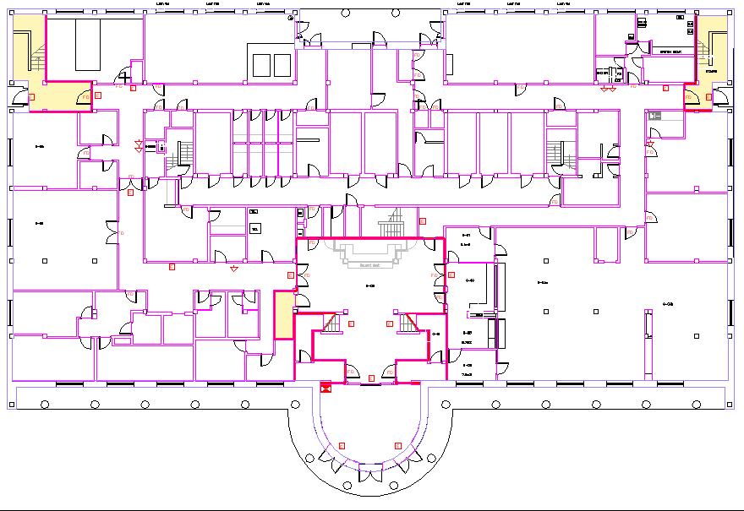

Interview Rm

Office

Reception

Court Reception

Restricted Area

Restricted Area

Restricted Area

FIRE EXIT

Lift

**Stairs to Courts**

Entrance

Ramp access

Ramp access

Lobby

General Office

Interview Rm

HallaH

Lobby

**Ground Floor**

**Opening Times**

**Weekly**

Monday to Thursday: 9 am to 5 pm

Friday: 9 am to 4.30 pm

**Public Holidays**

**2018**

25 – December Tuesday **Christmas Day**

26 – December Wednesday **Boxing Day**

**2019**

01 – January Tuesday **New Year’s Day**

02 – January Wednesday **2nd January**

19 – April Friday **Good Friday**

22 – April Monday

06 – May Monday **Early May Bank Holiday**

05 – August Monday **Summer Bank Holiday**

09 – August Friday

02 – December Monday **St Andrew’s Day (substitute day)**

25 – December Wednesday **Christmas Day**

26 – December Thursday **Boxing Day**

**Postal Address**

Falkirk Sheriff Court and Justice of the Peace Court Sheriff Court House,   
Main Street, Camelon,   
Falkirk, FK1 4AR

**Sheriff Clerk**

Dennis McCall

**Main Telephone**

**01324 620822**

**Civil Department contact**

**01324 620822**

**Criminal Department contact**

**01324 620822**

**Admin Department contact**

**01324 678229**

### Jury helpline

**01324 678237**

**Email**

[falkirk@scotcourts.gov.uk](mailto:falkirk@scotcourts.gov.uk)

**Contact Information**

[](http://www.google.co.uk/url?sa=i&rct=j&q=&esrc=s&source=images&cd=&cad=rja&uact=8&ved=0ahUKEwiA3oHW_NPJAhVM6xoKHaBaDVEQjRwIBw&url=http://www.freepik.com/free-photos-vectors/mail&bvm=bv.109395566,d.d2s&psig=AFQjCNGohM1LTDS1zSLoUXGKe3h-FiD1Dw&ust=1449929013085619)

[](http://www.bing.com/images/search?q=Phone+Symbol&view=detailv2&&id=66CED88CCFB20CC9EB9C955ABD258FACE9200A23&selectedIndex=61&ccid=NLXDtiSr&simid=608051032150313885&thid=OIP.M34b5c3b624ab2e77aecc5b51235ed993o0)



**Additional Information**

If you require this document

in an alternative format

please contact the Property

and Services Unit at the

below address.

[enquires@scotcourts.gov.uk](mailto:enquires@scotcourts.gov.uk)

**The Scottish Courts and**

**Tribunals Service**

Saughton House

Broomhouse Drive

Edinburgh

EH11 3XD

**0131 444 3300**

or text phone

**18001 0131 444 3300**



[](http://www.google.co.uk/url?sa=i&rct=j&q=&esrc=s&source=images&cd=&cad=rja&uact=8&ved=0ahUKEwiA3oHW_NPJAhVM6xoKHaBaDVEQjRwIBw&url=http://www.freepik.com/free-photos-vectors/mail&bvm=bv.109395566,d.d2s&psig=AFQjCNGohM1LTDS1zSLoUXGKe3h-FiD1Dw&ust=1449929013085619)

[](http://www.bing.com/images/search?q=Phone+Symbol&view=detailv2&&id=66CED88CCFB20CC9EB9C955ABD258FACE9200A23&selectedIndex=61&ccid=NLXDtiSr&simid=608051032150313885&thid=OIP.M34b5c3b624ab2e77aecc5b51235ed993o0)

**This Report**

This report has been compiled

using the Scottish Accessible

Information Forum, ‘Making

Information Accessible’ guidance

published September 2014.

A copy of our Court Users’ Charter can be accessed [here](http://www.scotcourts.gov.uk/docs/default-source/scs-board/charter.pdf?sfvrsn=8)

Should you require this document in another language or format please contact:

Court Services Branch

Scottish Courts and Tribunals Service

Spur N1, Saughton House

Broomhouse Drive

Edinburgh

EH11 3XD

[csbenquiries@scotcourts.gov.uk](mailto:csbenquiries@scotcourts.gov.uk)

0131 444 3455