

**Visiting Alloa Sheriff Court and**

**Justice of the Peace Court**

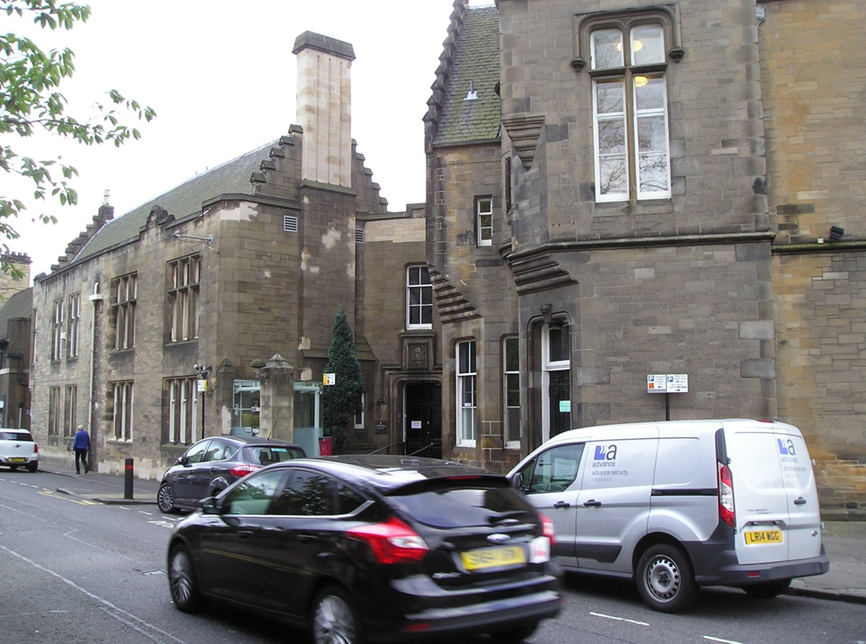This leaflet will help you to plan your visit to the Alloa Sheriff Court and Justice of the Peace Court.

If you require more information about anything here you can email:

[enquires@scotcourts.gov.uk](mailto:enquires@scotcourts.gov.uk)

or telephone the Property and Services Unit on:

**0131 440 3300**

or text phone

**18001 0131 444 3300**

(Full contact details are on

page 20)





**Contents**

**Location Details**

Page 4

……………………………………………..

**Ways of getting to the Court Building**

Pages 5 to 8

………………………………………………

**On Arrival**

Pages 9 to 11

………………………………………………

**Facilities**

Pages 12 to 16

……………………………………………….

**Floor Plans**

Pages 17 and 18

………………………………………………

**Opening Times & Public Holidays**

Page 19

………………………………………………

**Contact Information**

Page 20

………………………………………………

**Additional Information**

Pages 21 and 22

**Location Details**

The Sheriff Court and Justice of the Peace building is located at the end of Mar Street adjoining Drysdale Street. It is accessible from the A907 and is immediately opposite the Alloa Town Hall on a major roundabout

The main entrance to the court building is from Drysdale Street. The front door of the courthouse is recessed from the building line, there is a ramp access suitable for wheelchairs

[insert]





**Ways of getting to the Court Building**



**By Bus**

The nearest bus stop is Shillinghill which is approximately 5 minute’s walk from the court building.

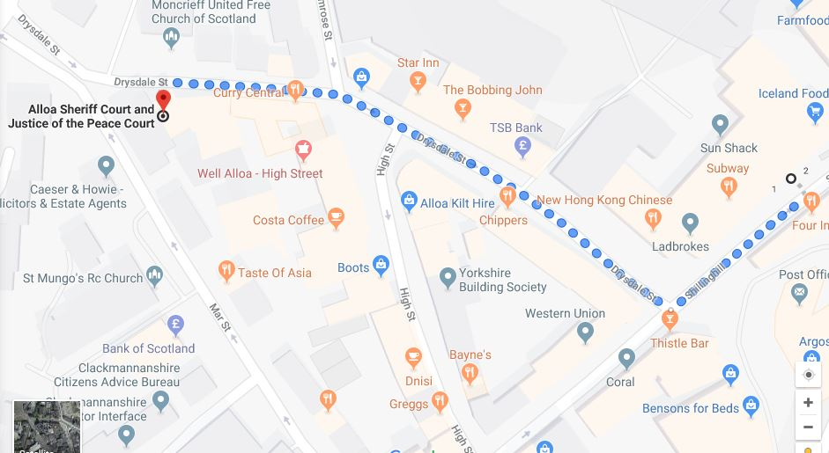

Map data @2016 Google

Bus station location

**By Train**

The main train station is Alloa Train Station which is approximately 5 minute’s walk from the court building. Trains run to and from Glasgow regularly. Visit www.nationalrail.co.uk or call 03457 484 950 for train times.

Visit[www.nationalrail.co.uk](http://www.nationalrail.co.uk)

or call **03457 484 950** for train times.



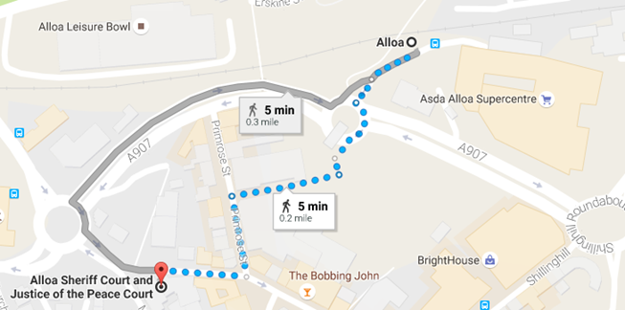

Map data @2016 Google

Train station location

**By Public Transport**

Contact Traveline Scotland for all public transport enquiries and assistance on **0871 200 22 33** or visit

[www.travelinescotland.com](http://www.travelinescotland.com)

**By Car**

There is no dedicated parking at the court building or the Fiscal’s office. However there is a free car park located just off the ring road and in Greenside Street. Both car parks are approximately 5 minute’s walk from the court.



Parking



**By Taxi**

Taxis are available at Alloa train station.

Travel by public transport is recommended.

**On Arrival**

**Entrance**

The main entrance to the building is from Drysdale Street. The front door of the courthouse is recessed from the building line.

There is ramp access suitable for wheelchairs.

The entrance to the Sheriff Clerks Office is located via the lane at the end of the building on Drysdale Street. This is where you should attend to pay a fine or for general enquiries.

The main entrance to the building located on Mar Street now acts as the staff entrance and is no longer used by the public.



Main entrance

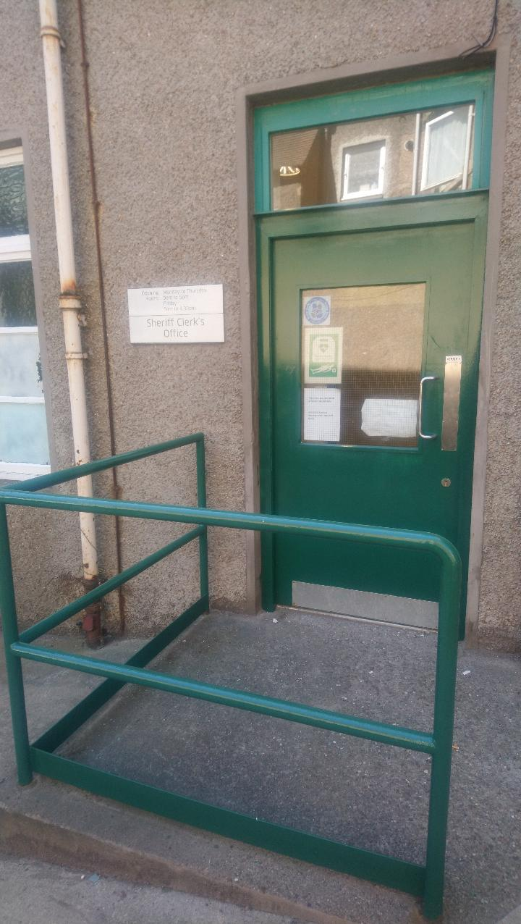

Entrance to Sheriff Clerks Office



Staff entrance

[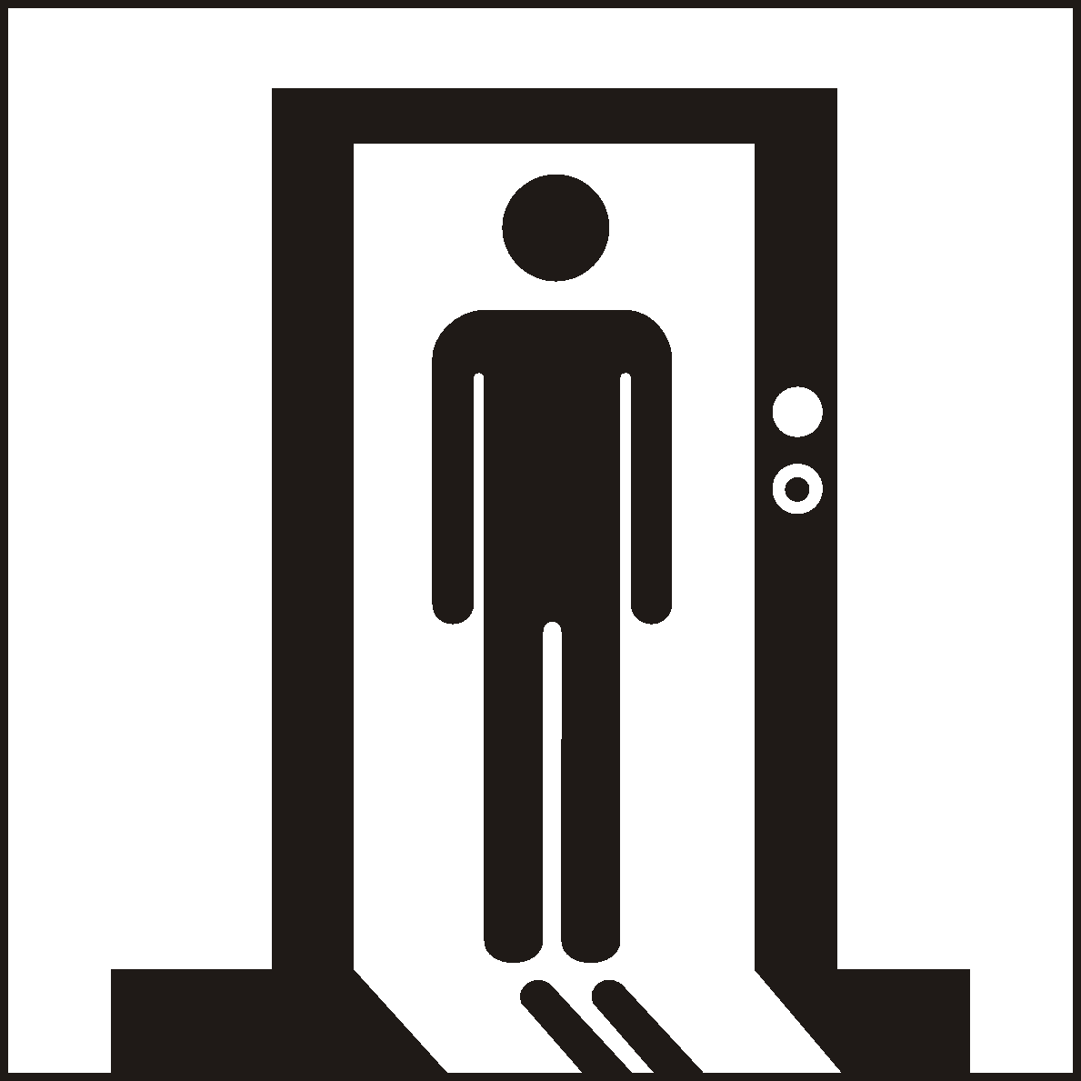](http://www.google.co.uk/url?sa=i&rct=j&q=&esrc=s&source=images&cd=&cad=rja&uact=8&ved=0ahUKEwialYnHwtPJAhUKWhoKHUKJBs4QjRwIBw&url=http://www.standard.org.cn/dgsymbol/list.aspx?sid%3D12%26stid%3D%26Page%3D5%26searchtxt%3D&bvm=bv.109395566,d.d2s&psig=AFQjCNEa1EVlPPeWeUJ-gD_trfHzICP1Hw&ust=1449913041342312)

**Security Check**

You may be requested to pass through a Security check when entering the building and scanned with a paddle scanner.

Wheelchair users are also scanned by a paddle scanner.

Your bags or briefcases may also be searched.

When you are ready, the security staff will direct you to the reception desk located to the left of the main hall, which serves as the central point of access the rest of the building.

Please report to the reception desk and state the reason for your visit. Reception staff will then direct you accordingly.

Staff can assist you if you have any question about the court building or your visit.





If you have a wheelchair or a pushchair and you require specific access assistance, please telephone:

**01259 722734**

or textphone

**18001 01259 722734**

For further information on the layout of the court building please refer to the floor plan layouts on pages 17 & 18.

**Facilities**







**Toilets**

There are toilets for both sexes near the main entrance. A disabled toilet is available at ground floor level.

**Signage**

High contrast signage is provided around all circulation areas to ensure the public zones are easily navigated.

**Refreshments**

The court has a small tea bar which is run by The Anthony Nolan Trust, selling tea, coffee and other light refreshments. The tea bar is open from 9.30am until 12noon each day.

**Hearing Loop**

For people who are hard of hearing a fixed loop induction service is available at all reception counters. Portable mobile loop induction services are available for all courtrooms.

On arrival please inform the reception desk staff if you require this facility.





**Courtrooms**

There are 2 courtrooms in Alloa Sheriff & Justice of the Peace Court. Court 1 is located on the 1st floor and the smaller Court 2 is located on the ground floor.

**Lifts**

There are 2 lifts available in the court buildings. 1 gives access to the Sheriff Clerks Office, the other gives access to Court 1. Please note the lift for Court 1 requires the assistance of a staff member to operate. Please advise a member of staff on arrival if you require to use the lift.

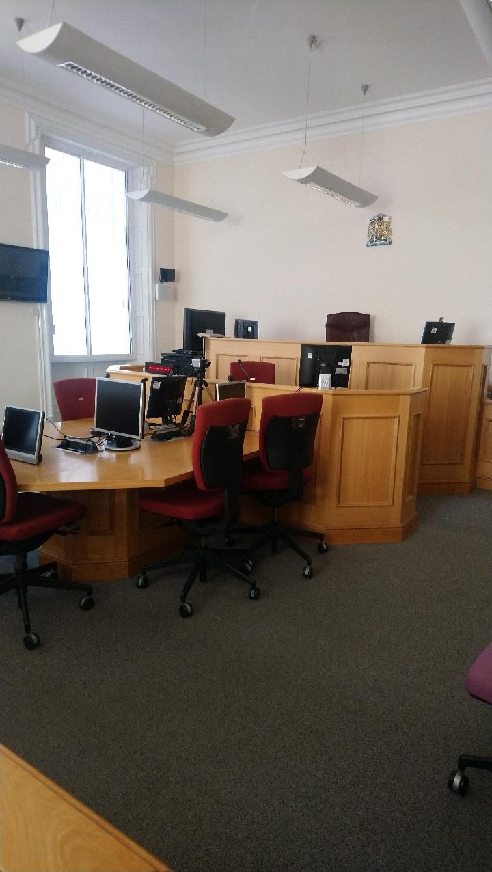

Court 2

[](https://www.google.co.uk/url?sa=i&rct=j&q=&esrc=s&source=images&cd=&cad=rja&uact=8&ved=0ahUKEwijmeXk2NnJAhWFLhoKHaetCAcQjRwIBw&url=https://www.iconfinder.com/icons/41952/elevator_lift_icon&psig=AFQjCNFBzdPzzcb-7dUs7YIenjllh-kU0g&ust=1450125533140326)

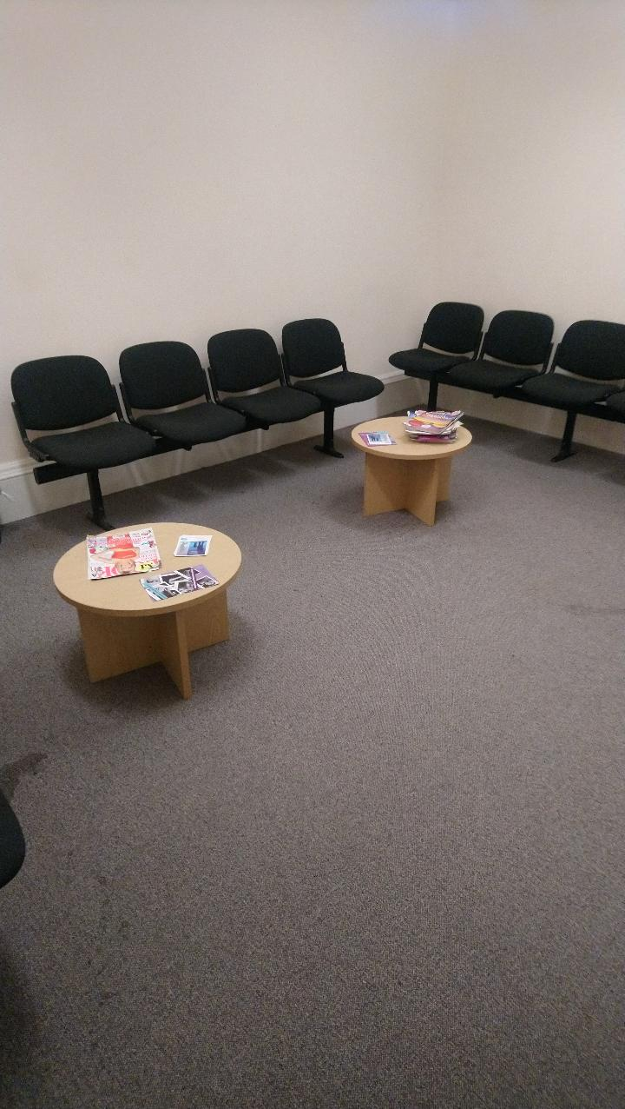

Witness room

**Witness Rooms**

There are 3 Witness Rooms located within the building. All are spacious and bright with comfortable seating and reading material provided.

Staff from Witness Service are available when trials are running to offer support and assistance to witnesses on the day.



Sheriff Clerk’s Office Reception Area

**Sheriff Clerk’s Office**

The Sheriff Clerk’s offices are located off the lane that runs behind the court building off Drysdale Street. Attend here for all civil enquiries and fines payments.

**Floor Plans**



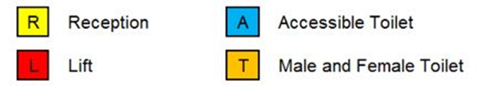

Ground Floor Layout





First Floor Layout

**Opening Times**

**Weekly**

Monday to Thursday: 9 am to 5 pm

Friday: 9 am to 4.30 pm

Office closes for lunch between 13:00-14:00 daily

**Public Holidays**

**2019**

01 – January Tuesday **New Year’s Day**

02 – January Wednesday **2nd January**

19 – April Friday **Good Friday**

22 – April Monday

06 – May Monday **Early May Bank Holiday**

01 – July Monday **Bank Holiday**

05 – August Monday **Summer Bank Holiday**

09 – September Monday

02 – December Monday **St Andrew’s Day (substitute day)**

25 – December Wednesday **Christmas Day**

26 – December Thursday **Boxing Day Contact Information**







**Postal Address**

Alloa Sheriff Court

47, Drysdale Street,

Alloa

FK10 1JA

**Sheriff Clerk**

John Bicket

**Main Telephone**

01259 722734

**Email**

[alloa@scotcourts.gov.uk](mailto:alloa@scotcourts.gov.uk)

**Additional Information**

If you require this document

in an alternative format

please contact the Property

and Services Unit at the

below address.

[enquires@scotcourts.gov.uk](mailto:enquires@scotcourts.gov.uk)

**The Scottish Courts and**

**Tribunals Service**

Saughton House

Broomhouse Drive

Edinburgh

EH11 3XD

**0131 444 3300**

or text phone

**18001 0131 444 3300**







**This Report**

This report has been compiled using the Scottish Accessible Information Forum, ‘Making Information Accessible’ guidance published September 2014.

A copy of our Court Users’ Charter can be accessed [here](http://www.scotcourts.gov.uk/docs/default-source/scs-board/charter.pdf?sfvrsn=8)

Should you require this document in another language or format please contact:

Court Services Branch

Scottish Courts and Tribunals Service

Spur N1,

Saughton House

Broomhouse Drive

Edinburgh

EH11 3XD

[csbenquiries@scotcourts.gov.uk](mailto:csbenquiries@scotcourts.gov.uk)

0131 444 3455

