

|  |
| --- |
| **SCTS Procurement Strategy 2018-2021** |
| November 2019 |
| *Scottish Courts and Tribunals Service* |



**Document History**

|  |  |
| --- | --- |
| **Document Owner:** | ***Stuart Paterson*** |
| **Document Location:** | R:\Procurement 2018\3. Strategy & Business Case\Strategy |
| **Document Status:** | ***Live*** |

***Revision History***

***Distribution This document has been distributed as follows for approval:***

|  |  |  |  |
| --- | --- | --- | --- |
| **Name** | **Responsibility** | **Date of issue** | **Version** |
| Executive Team | Stuart Paterson | 1/10/2018 | v1.0 |
| Chief Finance Officer | Stuart Paterson | 22/11/2019 | V2.0 |
|  |  |  |  |

**Section 1 – Contents**

**1.0 Contents**

**2.0 Introduction/Executive Summary**

**3.0 Procurement Vision/Mission Statement**

**4.0 Strategy Rationale/Context**

**5.0 Strategic Aims, Objectives & Key Priorities**

**6.0 Spend/Finance**

**7.0 Implementation, Monitoring, Reviewing and Reporting**

**8.0 Strategy Ownership & Contact Details**

**9.0 Policies, Tools & Procedures**

**10.0 Appendices**

**11.0 Glossary**

**Section 2 – Introduction/Executive Summary**

**Introduction**

2.1 The Scottish Courts and Tribunals Service (“SCTS”) is a non-ministerial department established by the Judiciary and Courts (Scotland) Act 2008. Its statutory function is to provide administrative support to Scotland’s courts, devolved tribunals and their judiciary - including the High Court of Justiciary, Court of Session, sheriff courts and justice of the peace courts. It also administers the Office of the Public Guardian and Accountant of Court.

2.2 On 1 April 2015 SCTS became responsible for the administration of Scotland’s devolved tribunals. The SCTS has a presence in communities across Scotland. Court and tribunal business is conducted daily across the country in over 40 locations and, in the case of tribunal business, some 70 further remote locations. A map of the locations SCTS operates from is shown at Annex A.

2.3 Supporting Scotland’s tribunals is a large part of our business and the SCTS currently supports;

* Mental Health Tribunal for Scotland,
* Housing and Property Chamber
* Health and Education Chamber
* Tax Chamber
* Lands Tribunal Scotland
* Scottish Social Security Chamber
* Pensions Appeal Tribunal for Scotland, and
* Council Tax Reduction Review Panel
* Parking and Bus Lane Tribunal for Scotland (March 2020)

**Executive Summary**

2.4 The purpose of this strategy is to provide a framework for activity within the Service’s Procurement Team from the summer of 2018 until 2021. It ensures that activity is properly aligned with other relevant strategy and policy that it is required to support.

2018/19 was a transition year to allow the Procurement Team to build resources and begin to achieve key priorities outlined in more detail in section 3. A fully resourced Procurement Team is now in place.

The Strategy is not intended to spell out the detailed work required to deliver the agreed priorities. These will be contained in the annual procurement work-plan agreed each financial year. Progress against that work-plan will be reported on an on-going basis.

2.5 The SCTS strategy map illustrates how the organisation’s purpose and vision are translated into 7 strategic priorities.

Figure 1: SCTS Strategy Map

**SCTS Strategy Map**

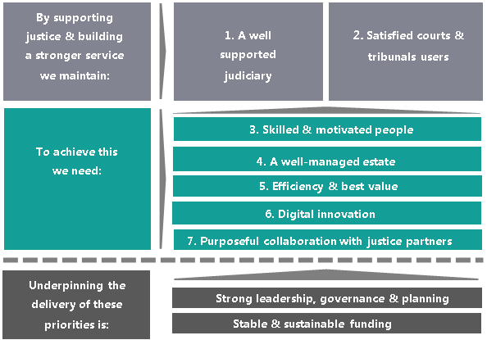

2.6 Our first 2 priorities are to ensure effective support to Scotland’s courts’ and tribunals’ judiciary, whilst maintaining or improving levels of satisfaction amongst those who use Scotland’s courts, devolved tribunals and the OPG. Our service can only be said to be effective if these priorities are met.

2.7 Priorities 3-7 relate to the people, assets, systems, processes and partnerships that we can develop, improve and invest in over the coming years to ensure our service remains efficient, responsive and innovative. Whilst these priorities set a clear direction for what we aim to achieve over the coming years, we will only be successful if the approach we take is underpinned by clear leadership, good planning and stable and sustainable funding that allows us to invest for the future.

2.8 This Procurement Strategy relates to our overall procurement approach, with specific focus on regulated procurements (defined in the Procurement Reform (Scotland) Act 2014 (“the Act”) as works contracts over £2 million in value, and supplies and services contracts over £50,000 in value), and is aimed at ensuring the SCTS procures the goods, services and works it needs in the most economically advantageous manner. Notwithstanding these financial thresholds, the European Treaty (TFEU) principles[1] of **transparency**; **equal treatment and non-discrimination**; **proportionality**; and, **mutual recognition** apply to all SCTS public procurements, irrespective of financial value.

2.9 Specifically, this Strategy has been informed by the SCTS [2019-20 Business Plan](http://www.scotcourts.gov.uk/docs/default-source/aboutscs/reports-and-data/publications/scts-business-plan-2018-19.pdf?sfvrsn=2); the [SCTS Corporate Plan 2017-20](http://www.scotcourts.gov.uk/docs/default-source/aboutscs/reports-and-data/publications/corporate-plan-2017-20-publish.pdf?sfvrsn=6), the [Procurement Reform (Scotland) Act 2014](https://www.legislation.gov.uk/asp/2014/12/contents) and associated [statutory guidance](http://www.gov.scot/Publications/2016/03/8410); the SCTS Financial Strategy 2019-2024; and, the EU [Directive 2014/24/EU](https://eur-lex.europa.eu/legal-content/en/ALL/?uri=CELEX%3A32014L0024) on Public Procurement as transposed into national legislation by the [Public Contracts (Scotland) Regulations 2015](http://www.legislation.gov.uk/uksi/2015/102/contents/made) (as amended). The Procurement Strategy will be updated annually to ensure that it is consistent with the relevant corporate plans and legislation.

2.10 The SCTS is committed to enhancing its procurement capabilities to respond to the Scottish Government’s national agenda which demands accelerated year on year improvement in procurement performance. In particular, in delivering the Procurement Strategy over the forthcoming years, the procurement function within the Finance and Procurement Unit (“FPU”) aims to achieve the following objectives:

* to build capacity and skills within the Courts to improve procurement activity;
* to increase the level of collaboration both internally, between service areas, and externally with other partner organisations;
* to engage proactively with key suppliers through contract and supplier relationship management to ensure that we extract maximum value and innovation from our supply base;
* to focus procurement activity on delivering improvements for users of the service
* to work cooperatively to support SMEs and the third sector; and
* to ensure procurement activity contributes towards the Equality Duty.

2.11 These aims and objectives reflect both national and local policies and priorities and progress against their achievement will be updated on an annual basis.

2.12 The SCTS recognises the value of existing relationships with suppliers and contractors and seeks to build and strengthen those relationships. The strategy aims to help remove the barriers often faced by smaller organisations with limited resources in bidding for work.

2.13 The Procurement Team within the Finance and Procurement Unit has provided, and will continue to provide, support to local organisations to build their capacity to respond to formal procurements through local and national “Meet the Buyer” and other training events, in addition to promotion of the [Supplier Development Programme](https://www.sdpscotland.co.uk/).

**Section 3 – Procurement Vision/Mission Statement**

**Procurement Vision**

3.1 The aim of the Procurement Strategy is to provide a strategic, ethical and professional approach to procurement that provides the SCTS with best value for the supply of Goods, Supplies and Services, enhances supplier engagement, supports innovation and enables the SCTS to achieve its statutory aims and objectives.

3.2 Procurement’s core role is to carry out tendering and contracting activity for regulated spend levels as defined in the Act. Over the lifetime of this strategy we will extend the scope of procurement activities to encompass the majority of our non-regulated procurement.

3.3 SCTS Procurement plays a critical part in ensuring that the Courts, devolved Tribunals and the Office of the Public Guardian support justice through their effective operation. SCTS Procurement is the focal point, providing leadership on all procurement related matters, specialist advice on Supplier management and guidance for commercial and contractual queries. This includes ensuring that European Treaty principles of transparency, non-discrimination, mutual recognition etc. are applied to all procurement activities, irrespective of value.

**Procurement Mission Statement**

3.4 To ensure value for money, compliant, effective procurement for the benefit of SCTS and all of our stakeholders.

**Procurement Principles**

3.5 Nine procurement principles have been identified to underpin the Procurement Mission Statement at 3.3 above. They are;

* Procurement should be a valuable tool in the promotion of SCTS’ Purpose, Vision and Values and in delivering the aims and objectives contained within the SCTS Corporate Plan and Financial Strategy;
* Procurement will only be carried out under the terms of the SCTS Procurement Policy and Procedures;
* Procurement will be carried out in line with current legislation to deliver competition, sustainability, equal opportunities and, ultimately, best value for SCTS. The process will be transparent and allow accountability.
* Best value will be achieved by obtaining Most Economically Advantageous Tender (MEAT) tender offers, taking into account whole life costs and non-financial aspects of the purchase. Procurement will be driven by desired outputs and results, including acceptable health, safety and environmental performance;
* Procurement will facilitate all regulated expenditure for goods and services contracts (over £50k) with key SCTS stakeholders, to ensure full compliance with Procurement regulations. For non-regulated contracts, Procurement will provide guidance and support to SCTS staff;
* Procurement will facilitate with key stakeholders the on-going contract management of an identified number of business critical contracts to ensure maximum performance and efficiency;
* The procurement function should be carried out in an effective but streamlined manner, which delivers added value without duplication of effort;
* Where a local or national framework or contract is in place for a commodity this will be used in all but exceptional circumstances;
* The SCTS will continue to deliver its procurement activities and meet the above opportunities and challenges in line with the [Scottish Model of Procurement](http://www.gov.scot/Topics/Government/Procurement/about/spd-aims). See Figure 2 overleaf.

**Measuring Our Progress**

3.6 We will measure our progress against our principles as at 3.4 above by:

* successfully actioning internal audit and Procurement and Commercial Improvement Programme (PCIP) recommendations.
* increasing contract coverage year on year
* increasing the number of business critical contracts managed
* capturing savings and other relatable targets such as sustainability.

Figure 2: The Scottish Model of Procurement

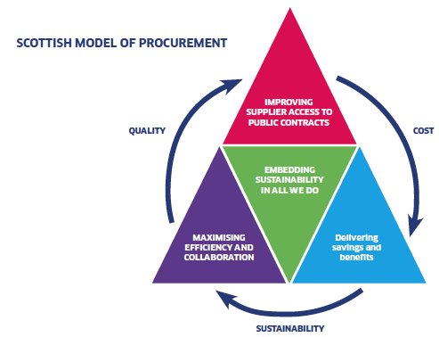

Image: [The Scottish Government](https://beta.gov.scot/publications/public-procurement-reform-programme-2006-2016-achievements-impacts/pages/8/)

**Section 4 – Strategy Rationale/Context**

4.1 This Procurement Strategy and associated activity links to the SCTS corporate priorities,

**Skilled, engaged and motivated staff in our courts, OPG and corporate headquarters;**

* Leadership – achieve commitment from Executive Team and Senior Managers to support Procurement;
* Ensure any staff with Devolved Purchasing Authority are suitably trained/supported.
* Provide Procurement information resources and guidance to support staff (link to intranet) in the discharge of their responsibilities;
* Ensure that, as far as is practicable, Procurement staff are CIPS qualified and, in all cases, maintain on-going professional development.

**A well-managed estate that makes the best possible use of our buildings and meets our environmental responsibilities;**

* Ensure appropriate contracts and contract management arrangements are in place and these cover sustainability with particular regard to environmental issues (waste management, heating and lighting).

**Clear and efficient business processes that respond to the needs of the judiciary, court users and the wider public;**

* Ensure compliance with EU, national and other government procurement policies;
* Provide clear and easy to follow procurement processes for suppliers and potential suppliers.

**Effective technology that supports our key processes and communications;**

* Ensure use of the Public Contracts Scotland website (and the Tender Module), the Scottish Government’s national procurement portal, for issuing all its tender documents and Quick Quotes to potential suppliers. This provides registered SMEs with the opportunity to tender for all appropriate Scottish public sector procurement requirements;
* Ensure use of the Scottish Government-supplied Spikes Cavell Observatory system which provides analytical tools and information on other organisations with similar purchasing requirements;
* Ensure the complete roll-out of the PECOS system to ensure efficient and controlled order processes.

**Appropriate collaboration with other justice organisations, to help drive improvement across the justice system as a whole;**

* Actively participate in the Scottish Procurement and Commercial Directorate’s central government Justice Cluster Group;
* Ensure use of collaborative contracts, not just with other bodies in the Justice sector, but identifying organisations with a similar purchasing need (e.g. Scottish Prison Service for, *inter alia,*  Architectural, Quantity Surveying, Mechanical & Electrical and Design Services; and/or Historic Environment Scotland for cash conveyancing; COPFS for off-site storage). This will continue to build on current collaborations such as with COPFS for facilities management.

**Secure Best Value across all SCTS services**

* Category Management (CM): strategic approach which organises procurement resources to focus on specific areas of spends;
* Supplier Relationship Management (SRM): assessment of strategic suppliers’ assets and capabilities to maximize the post contract value;
* Compliance with contracts and procurement policies: engagement with Procurement at an early stage to ensure appropriate Procurement routes are followed;
* Procurement Tools: Systems and indicators used to drive efficiencies in Procurement activities.
* Communication: raising awareness of Procurement throughout the Organisation.

4.2 For all of our procurement activity we aim to:

* Provide a value for money (VfM) procurement service that delivers both financial savings and non-cashable benefits;
* Provide a professional service to business units which delivers quality outcomes, and
* Procure goods, services and works in a lawful and ethical manner which encourages participation, collaboration and sustainable economic growth.

**Effective Governance across all of SCTS**

* Continue to improve procurement performance which will be assessed by Scottish Government through the tri-annual Procurement and Commercial Improvement Programme (PCIP) assessment;
* Secure the on-going commitment of internal stakeholders to implement the strategy, through continuing to increase the profile of procurement and senior sponsorship within the Courts;
* Ensure the procurement strategy remains aligned with the SCTS’ corporate priorities, and
* Continue to improve our Purchase to Pay (P2P) processes with due regard for budget constraints and the need to ensure best value, whilst reducing purchase to pay costs. The aim is to strengthen controls, increase efficiency and provide useful and up-to-date management information via the roll-out of PECOS;

4.3 Our key priorities for our Regulated Procurements are to: **Improve procurement processes and policies**. SCTS will do this by:

* Increasing levels of contracted spend throughout the organisation;
* Supporting a mixed economy of provision and developing markets, particularly local/rural markets, Small and Medium Sized Enterprises (SMEs), Third Sector organisations, and enterprises involving minority groups and those with protected characteristics under the Equality Act 2010;
* Reducing bureaucracy – ensuring our processes and templates are accessible as well as standard, simple, transparent and consistent in line with best practice;
* Protecting public spending – ensuring tax payers money is spent properly, ensuring integrity and accountability;
* Regular reporting of procurement performance and compliance in relation to regulated procurements;
* Categorising areas of spend to ensure we achieve the best balance of quality and price for our regulated procurements;
* Working collaboratively with other public sector organisations on regulated procurements where appropriate, ensuring that our partner organisations are committed to equality of opportunity for all sectors of society, and that their commitments reflect the SCTS’ [Public Sector Equality Duty](https://www.equalityhumanrights.com/en/advice-and-guidance/guidance-scottish-public-authorities) and its general equality duty; and
* Increase expertise, capacity and effectiveness.

4.4 We will do this by:

* Developing and professionalising contract and supplier management practices to ensure that we are getting the most value and innovation from our contractual relationships while maintaining appropriate standards; and improving commercial awareness across the SCTS;
* Developing staff in Procurement who lead on regulated procurements; through training, secondments and mentoring;
* Developing relationships with staff in the community justice sector to increase the potential for collaborative working on regulated procurements that will benefit each organisation; and,
* Ensuring compliance with complex European Union procurement legislation, and with Public Contracts (Scotland) Regulations 2015 and the Procurement Reform (Scotland) Act 2014 and associated statutory guidance.
* Ensuring all Procurement project strategies consider any plans for contract succession.

**Section 5 – Strategic Aims, Objectives & Key Priorities**

**5.1 Our strategic aims**

The strategic aims of the procurement function within the Finance and Procurement Unit are to support the delivery of the SCTS’s strategic priorities and key objectives for 2017-20 as outlined in the SCTS Corporate Plan.

|  |  |  |
| --- | --- | --- |
| **No.** | **Strategic Priority** | **Key Objective** |
| Strategic Priority 1 | A well supported judiciary | We aim to ensure that the right technology, people, systems and processes are in place to assist the judiciary to dispense justice effectively |
| Strategic Priority 2 | Satisfied Courts and Tribunals Users | We will consistently deliver high-quality customer service, inspiring confidence in those who use our services, promoting inclusiveness and developing our understanding of customer needs through ongoing feedback and quality assessment. |
| Strategic Priority 3 | Skilled and Motivated People | We will maintain a skilled and motivated workforce supporting the judiciary and providing excellent customer service across the tribunals, courts and Office of the Public Guardian (OPG). |
| Strategic Priority 4 | A well-managed estate | We will develop and maintain our built infrastructure to provide a high-quality, safe, secure and sustainable environment for everyone using our services. |
| Strategic Priority 5 | Efficiency and Best Value | We will achieve our savings target with a sustainable long term view. We will keep our processes under review to make sure that we deliver business in an effective, reliable and economical way. |
| Strategic Priority 6 | Digital Innovation | We will place digital innovation at the centre of what we do, making sure that we maximise the opportunities afforded by technology to improve processes, provide easy access to information, minimise physical appearance and support quicker outcomes |
| Strategic Priority 7 | Purposeful collaboration with Justice bodies | We will work with justice bodies to deliver significant change and improvement to Scotland’s justice system – through collaboration, communication and reform. |

We will do this as outlined in the following statements with reference to [Section 15(5)](https://www.legislation.gov.uk/asp/2014/12/section/15) of the Procurement Reform (Scotland) Act 2014 by:

1. **Ensure that [the SCTS’] regulated procurements:**
2. **contribute to the carrying out of its functions and the achievement of its purposes (section 2.5.1 of the Guidance accompanying the Procurement Reform (Scotland) Act)**

Through considering the approach to procurement in the context of the wide range of joint plans and strategies developed internally and externally; by utilising effective and relevant consultation when developing and aligning our procurement strategy with these plans and strategies, and for individual regulated procurements as required; and through promoting effective contract and supplier management to monitor the effectiveness of regulated procurements in achieving their purposes.

1. **deliver value for money (a balance of cost, quality and sustainability) (2.5.2)**

By applying the following key principles: Increasing our collaboration with other organisations where possible; ensuring that all opportunities are thoroughly considered and all implications of change in service areas are fully appraised; developing contract plans of future procurements to improve our services; maintaining consistency and transparency in our procurement processes; and considering, where appropriate, the whole-life cost of what is being procured and when – applying the principle of value for money, and ensuing that we do so in a clear, transparent and proportionate manner.

1. **Are carried out in compliance with its general duty to treat relevant economic operators equally and without discrimination (2.5.3)**

By, where relevant and proportionate, considering early market engagement prior to the publication of a contract notice on Public Contracts Scotland procurement portal; considering in the initial sourcing strategy stage the opportunity to break requirements into smaller lots; and by using clear and precise language preventing broad interpretation as well as offering alternative language formats if requested.

1. **Be undertaken in compliance with our duty to act in a transparent and proportionate manner (2.5.4)**

At each stage of the procurement process, SCTS will ensure that it is acting in a transparent and proportionate manner through: using electronic communications for all procurement activity, while providing alternative communications methods if requested; ensuring open public and market engagement; using clear and precise language to ensure a common understanding of the requirements; and utilising SCTS’ financial thresholds to ensure proportionality regarding the appropriate type of procurement process.

1. **Comply with the sustainable procurement duty (2.5.5)**

SCTS shall ensure that it complies with its statutory sustainable procurement duty through embedding sustainable procurement as business as usual – ensuring that sustainability issues are considered at all stages of individual procurement exercises; considering how individual procurement exercises can assist the SCTS to improve the economic, social, and environmental wellbeing of local areas facilitating the involvement of small and medium enterprises, third sector bodies, minority groups and supported business in the procurement process; and by promoting innovation at the initial stage of regulated procurements.

1. **include a statement of [SCTS’] general policy on;**
2. **the use of community benefit requirements (2.5.6)**

For every procurement over £4m, the SCTS will consider how it can improve the economic social or environmental wellbeing of its area through inclusion of community benefit clauses, to assist with its strategic objective of Efficiency and Best Value. Where possible and proportionate to the subject matter of the contract, the SCTS will examine the possibility of including such clauses in regulated procurements below the £4m threshold.

1. **consulting and engaging with those affected by its procurements (2.5.7)**

Following the SCTS’ standard practice on consulting and engaging with those affected by its individual regulated procurements including, where appropriate and proportional: consulting and engaging with relevant stakeholder groups at the commodity sourcing strategy stage of individual regulated procurements; and ensuring the outcomes of any consultations will be taken account of within our regulated procurements.

1. **the payment of a Living Wage to persons involved in producing, providing or constructing the subject matter of regulated procurements (2.5.8)**

Complying with the statutory requirements on the payment of a living wage to persons involved in producing, providing or constructing the subject matter of regulated procurements; through contributing towards improving the social well-being element of our sustainable procurement duty by promoting the Living Wage and fair work practices in regulated procurements; while ensuring a proportionate approach which provides an appropriate balance between quality and cost.

1. **promoting compliance with the Health & Safety at Work etc Act 1974 by contractors and sub-contractors (2.5.9)**

Complying with the SCTS’ corporate [Health and Safety policy](http://myscs/library/Support/H_and_S/HealthAndSafetyPolicyManual.pdf) on promoting compliance by contractors and sub-contractors with the [Health and Safety at Work etc. Act 1974 (c.37)](https://www.legislation.gov.uk/ukpga/1974/37/pdfs/ukpga_19740037_en.pdf) and any provision made under that Act, through assessing the potential health and safety risks arising from regulated contracts and considering this throughout the procurement process; and through ensuring that our requirements for individual contracts meet current legislation (as a minimum).

1. **the procurement of fairly and ethically traded goods and services (2.5.10)**

The procurement of fairly and ethically traded goods and services will be considered at the initial sourcing strategy stage of all regulated procurements during the period of this strategy.

1. **Complying with the statutory requirements on how we intend our approach to regulated procurements involving the provision of food to: (i) improve the health, wellbeing and education of communities in the authority’s area and (ii) promote the highest standards of animal welfare, by considering relevant national guidance.**

Any regulated procurements involving food will consider, *inter alia,* the following national guidance throughout the procurement process: Soil Association ‘Food for Life Catering Mark’; ‘Catering for Change: Buying Food Sustainably in the Public Sector’; and, ‘Becoming a Good Food Nation’.

Additionally, SCTS will find practical ways to supply healthy, fresh, seasonal, and sustainably grown food which represents value for money whilst improving the health, wellbeing and education of our staff and users, coupled with promoting the highest standards of animal welfare. The SCTS will manage our entire catering provision to ensure affordable contracts are put in place, which meet the nutritional requirements for food for all users of our catering services.

**5.2 Reinforcing our strategy**

To underpin the success of this strategy a number of tactical initiatives will be carried out over its lifetime:

* P2P Project to roll-out the PECOS eProcurement System where appropriate. This will ensure control and governance over all spend and ensure contract compliance.
* Increase the number of business critical suppliers/contracts managed by Procurement with key stakeholders.
* Increase contract coverage by working closely with Business Units and other areas of the organisation to ensure Procurement involvement from the outset. This includes early sight of relevant business case proposals.
* Supporting the Cost Reduction Group to identify savings and efficiencies.

**Section 6 – Spend/Finance**

6. In 2018-19 SCTS expended £48.5m of non-pay expenditure with suppliers on Construction, ICT, Business Support Services, Utilities & Energy, Legal, Facilities Management and HR services.

The table below presents the SCTS’ Top 20 suppliers by expenditure in the 2018/19 financial year – showing the level of their expenditure as a percentage of the overall non-pay expenditure of SCTS.

|  |  |  |  |
| --- | --- | --- | --- |
| **Rank** | **Company Name** | **Business Sector**[2] | **% Spend** |
| 1 | Servest Arthur McKay Limited | Construction | 27.96% |
| 2 | Willmott Dixon Construction Limited | Construction | 15.02% |
| 3 | Legal and General Assurance Pension Management Limited | Financial Services | 5.92% |
| 4 | Kainos Software Limited | ICT | 4.80% |
| 5 | EDF Energy | Utilities & Energy | 3.22% |
| 6 | Insight Direct UK Limited | ICT | 2.89% |
| 7 | AVM Impact Limited | ICT | 2.77% |
| 8 | Anglian Water Business (National) Limited | Utilities & Energy | 2.38% |
| 9 | Sweet and Maxwell Limited | Business Support Services | 2.10% |
| 10 | Parity Professionals Limited | Human Resources | 2.08% |
| 11 | Virgin Media Limited | ICT | 1.94% |
| 12 | Global Connections Scotland Limited | Business Support Services | 1.43% |
| 13 | BaxterStorey Scotland Limited | Food, Beverage & Catering | 1.20% |
| 14 | HP Inc. UK Limited | ICT | 1.03% |
| 15 | Capita Secure Information Solutions Limited | ICT | 1.00% |
| 16 | Pertemps Group Of Companies, The | Human Resources | 0.97% |
| 17 | Total Gas & Power Limited | Utilities & Energy | 0.89% |
| 18 | Bradbury Motors Limited | Travel & Accommodation | 0.85% |
| 19 | DX Network Services Limited | Facilities Management | 0.80% |
| 20 | Vodafone Limited formerly Cable & Wireless UK | ICT | 0.66% |

6.1 The top 20 suppliers to the SCTS account for 80% of the Courts and Tribunals Service’s spend in 2018/19 on supplies, services and works.

6.2 Spend with Small and Medium Sized Enterprises (SMEs) accounted for 21.4% of core procurement. The chart below shows the breakdown of spend with Small, Medium and Large Companies.

6.3 Another proxy for SCTS’ engagement with the SME business community is through geographical proximity. As the chart below illustrates, over 44% of SCTS supplier spend occurs within Scotland.

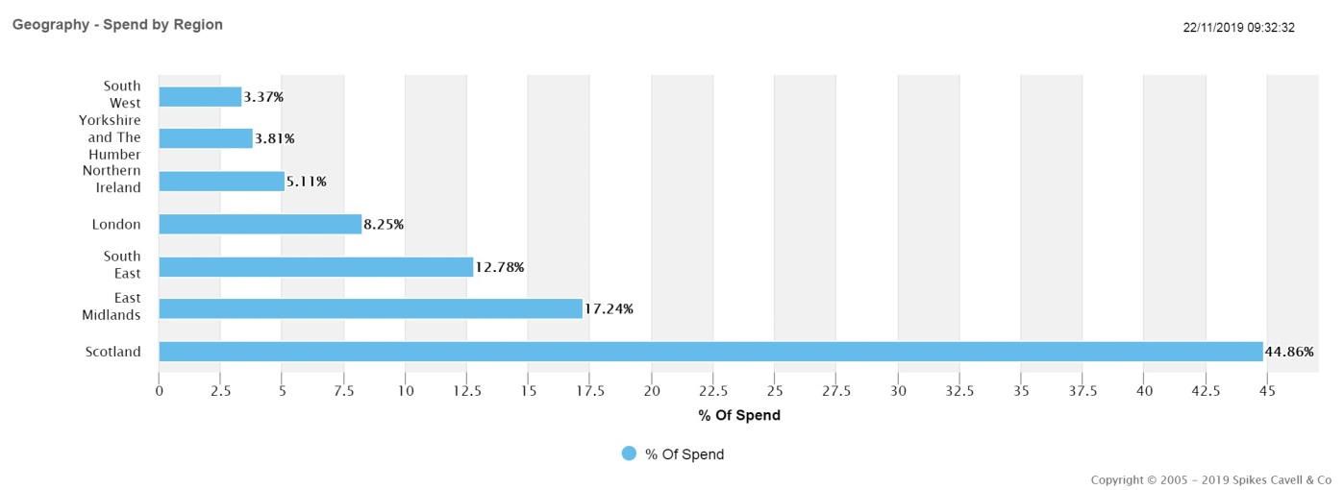

6.4 We are committed to promoting prompt payment both to, and by, our contractors and their sub-contractors. Our standard terms and conditions provide for payment in 30 days of receipt of a valid invoice. However, the Scottish Government has a prompt payment target of 10 calendar days following presentation of an invoice.

6.5 SCTS will promote a prompt payment culture through its supply chain by including a standard contract clause to require 10 day invoice payments in all our regulated procurement contracts; including a clause regarding the prompt payment of sub-contractors within our regulated procurement contracts; and through ensuring effective contract management and monitoring is undertaken to ensure that prompt payment continues to be applied throughout the duration of the contract and taking any necessary steps to rectify any prompt payment issues experienced.

6.6 An updated contract register is published on the Public Contracts Scotland website.

**Section 7 – – Implementation, Monitoring, Reviewing and Reporting**

Approval of strategy

7.1 This Procurement Strategy will be approved in accordance with SCTS’ internal management processes by the Chief Financial Officer (CFO) acting under delegated authority from the SCTS Executive Team.

Publication of Strategy

7.2 The SCTS will publish this Procurement strategy on both its external website and internal “Connect” intranet, and will notify The Scottish Ministers of publication.

Review

7.3 The SCTS will review the Procurement Strategy annually and issue an Annual Procurement Report on its findings. This will help to ensure that SCTS maintains the alignment between the Procurement Strategy and the organisation’s broader corporate priorities. Where necessary and proportionate to do so, SCTS will revise and update its Strategy.

Reporting

7.4 The SCTS will, as soon as practicable, following the end of each financial year prepare an Annual Procurement Report which, *inter alia¸* will include:

* A summary of all regulated procurements completed within the year;
* A review of whether these procurements complied with this Strategy;
* A statement detailing how it is intended that future compliance will be achieved in the instance where any procurements were found not to have been carried out in accordance with this Strategy;
* A summary of any community benefit that was completed, imposed as a part of a regulated procurement that was completed during the year;
* A summary of steps taken to facilitate the involvement of supported businesses in regulated procurements in the year;
* A summary of anticipated regulated procurements expected to commence in the next two financial years;
* Anticipated future procurements; and,
* Any other information as specified by The Scottish Ministers.

**Section 8 – Strategy Ownership & Contact Details**

8.1 The SCTS Procurement Team is operationally situated within the multi-functional Finance & Procurement Unit.

8.2 The Procurement Team is responsible for the procurement of works, goods and services for all business units of the SCTS; and for developing procurement processes, procedures, strategies and policies in accordance with national best practice.

8.3 If you have any queries in relation to this Strategy, please contact:

Stuart Paterson

Head of Procurement

Scottish Courts and Tribunals Service

Saughton House

Broomhouse Drive

Edinburgh

EH11 3XD

Tel: 0131 444 3409

E-mail: [spaterson@scotcourts.gov.uk](mailto:spaterson@scotcourts.gov.uk)

**Section 9 – Policies, Tools & Procedures**

In this section, SCTS outlines how this Procurement Strategy contributes and complements local and national policies, processes and procedures.

Local Policies

SCTS Procurement Policy and Procedures

9.1 The policy document provides the policy and procedural framework for SCTS staff engaged in procurement activity in order to ensure not only compliance with varying statutory requirements, but also the adoption of current best practice in procurement to drive down whole life costs; improve and benefit services; and, to make sustainability a priority.

9.2 All staff members of the SCTS with purchasing authority are required to refer to the policy document before committing the organisation to any expenditure. The document aims to ensure that the SCTS:

* Correctly identify the works, goods and services needed to achieve objectives;
* Perform a critical evaluation of what is purchased and why;
* Obtain the works, goods and services needed at the right price, time and quality; and,
* Can demonstrate a robust and reasonable decision-making process.

Gifts, Hospitality and Rewards

* 1. Except in very limited circumstances outlined in the [SCTS Gifts, Hospitality and Rewards](http://myscs.scotcourts.local/sectionsDocs/people/policies/Gifts_Hospitality_Rewards_policy.doc) policy, the SCTS does not consider it appropriate for employees to accept anything other than token gifts (gifts up to and including the value of £15) or hospitality from Court users, suppliers or any other person of an organisation with which the SCTS has business connections.
  2. This ensures the integrity and reputation of the SCTS by ensuring that no employee acts in any way that is inconsistent with the SCTS’s corporate values and behaviours, SCTS policies and procedures, (specifically the [Dignity at Work Policy](http://myscs/sectionsDocs/people/policies/dignity_at_work_policy.doc) and [Equal Opportunities Policy](http://myscs/sectionsDocs/people/policies/equal_opportunities_policy.doc)) and the [Civil Service Code of Conduct](http://www.civilservicecommissioners.org/Reference_Documents/Civil_Service_Code_reference/) by accepting a gift, hospitality or reward where it could influence or be seen to influence that employee’s business actions or decisions or may be perceived to be a conflict of interest by internal and external individuals.
  3. Any breaches of this policy, arising from receipt of gifts hospitality or rewards from outside bodies or attendance at outside events or any cases of management failure will be subject to investigation in accordance with the [SCTS Conduct and Discipline Policy.](http://myscs/sectionsDocs/people/policies/conduct_and_discipline_policy.doc)

Risk Management

* 1. The SCTS [Corporate Risk Register](http://myscs/pages/About_SCS/Risk_Management/home.aspx) captures the key strategic risks facing the organisation as a whole and describes how these are managed and controlled to ensure we can continue to deliver the business. It is considered 6-weekly by the SCTS Executive Team, quarterly by the SCTS Audit and Risk Committee and twice yearly by the SCTS Board.

Health & Safety

* 1. The Scottish Courts and Tribunals Service is committed to providing a safe and healthy working environment for all our employees as well as those who come to court and those who work within our buildings. So far as is reasonably practicable, we will have systems and procedures in place to ensure that all equipment, plant and premises are safe and free from adverse effects to health.
  2. These obligations extend those bidding for SCTS contracts are able to demonstrate that they are responsible contractors who comply with their legal obligations, including obligations regarding health and safety.
  3. Our aim is that employees, the public and others affected by our operations are exposed to the least possible risk. We will ensure that all employees and contractors are fully aware of the role they need to play in achieving a healthy and safe working environment, including the avoidance of any actions or omissions on their part that would compromise the health and safety of others.
  4. It is a standard condition of SCTS contracts that suppliers must comply with all applicable law, any applicable requirements of regulatory bodies and good industry practice. This includes any applicable health and safety law. Furthermore, whenever a supplier’s personnel are on SCTS premises, they are obliged under the terms of our standard form contracts, to comply with SCTS own health and safety requirements, which can be found in the SCTS [Health and Safety Policy and Procedures](http://myscs/library/Support/H_and_S/HealthAndSafetyPolicyManual.pdf) manual.

Sustainability

* 1. The Scottish Government describes the basic aim of sustainable development as securing the future, acknowledging that achieving economic growth has to be done in such a way that it does not harm the environment or squander the natural resources we depend on and having to distribute the wealth it creates to improve quality of life and to eradicate poverty.
  2. Accordingly, it is vital that the Scottish Courts and Tribunals Service minimises its environmental footprint[3] and operates in a sustainable manner. Supporting the SCTS [Corporate Plan 2017-20](http://www.scotcourts.gov.uk/docs/default-source/aboutscs/reports-and-data/publications/corporate-plan-2017-20-publish.pdf?sfvrsn=6) and the [2018-19 Business Plan](http://www.scotcourts.gov.uk/docs/default-source/aboutscs/reports-and-data/publications/scts-business-plan-2018-19.pdf?sfvrsn=2), the [SCTS Sustainable Development Policy and Procedures](http://myscs/library/support/procurement/SCTS_Sustainability_Policy.docx) document sets out the commitments and direction of the SCTS sustainability policies and the processes for their implementation over the next four years. It replaces and supports existing environmental, procurement and sustainability policy statements and provides guidance to managers, staff and suppliers on how to comply with the policy’s strategic aims.
  3. The SCTS sustainability policy:
* applies to all parts of the SCTS organisation and its contractors;
* covers all operational and support services such as business, services, utilities, facilities management, construction, procurement, office services, printing and publishing; and,
* is consistent with the United Kingdom’s and Scottish Government’s commitments to sustainable development and climate change and in particular the organisation’s commitments under the [Climate Change (Scotland) Act 2009](https://www.legislation.gov.uk/asp/2009/12/contents) and its related [Public Body Duty of Care](http://www.legislation.gov.uk/ssi/2015/347/pdfs/ssi_20150347_en.pdf).
  1. This commits the SCTS to improve its environmental performance by conserving energy, water, wood, paper and other finite resources. The organisation will therefore reduce waste through re-use and recycling of materials and by using refurbished and recycled products and materials where such alternatives are available that still offer best value. The SCTS will also ensure, where practicable, that buildings occupied by the SCTS are designed, constructed and operated in a manner which minimises their environmental impact.
  2. The SCTS will reduce and monitor emissions to air, land and water and assess what action is necessary to reduce pollution or the risk of pollution. It will minimise the release of greenhouse gases, volatile organic compounds and reduce vehicle emissions or substances that are damaging to health or to the environment.
  3. Through improved specification, the SCTS will encourage contractors, manufacturers and suppliers to supply environmentally friendly goods and services at competitive prices as per the SCTS Procurement Policy.
  4. The SCTS, together with the [Crown Office and Procurator Fiscal Service](http://www.copfs.gov.uk/) (COPFS) jointly participate in a tripartite Carbon Management Working Group with the jointly appointed Facilities Management provider, [Servest Arthur McKay Ltd](http://www.arthur-mckay.com/), with the aim of achieving ambitious carbon reduction targets over the period of 2021.

National Policies

Scotland’s Economic Strategy

* 1. There are a number of wider factors that have an influence on the SCTS and are considerations for this Procurement Strategy. For instance, Scotland’s [Economic Strategy](https://www.gov.scot/Resource/0047/00472389.pdf) sets out an overarching framework for how The Scottish Government aims to achieve a more productive, cohesive and fairer Scotland.
  2. As the strategy makes clear, the future success of Scotland’s economy depends upon the growth and competiveness of Scotland’s businesses. Without prejudice to over-arching European Treaty obligations for non-discrimination on grounds of national origin, the SCTS recognises the contribution that procurement activity can have on tackling inequality and promoting growth, whether directly or indirectly.

National Performance Framework

* 1. The Scottish Government’s revised [National Performance Framework](http://nationalperformance.gov.scot/) sets out a number of performance objectives, described as National Outcomes, which describe The Scottish Government’s policy objectives; overleaf:

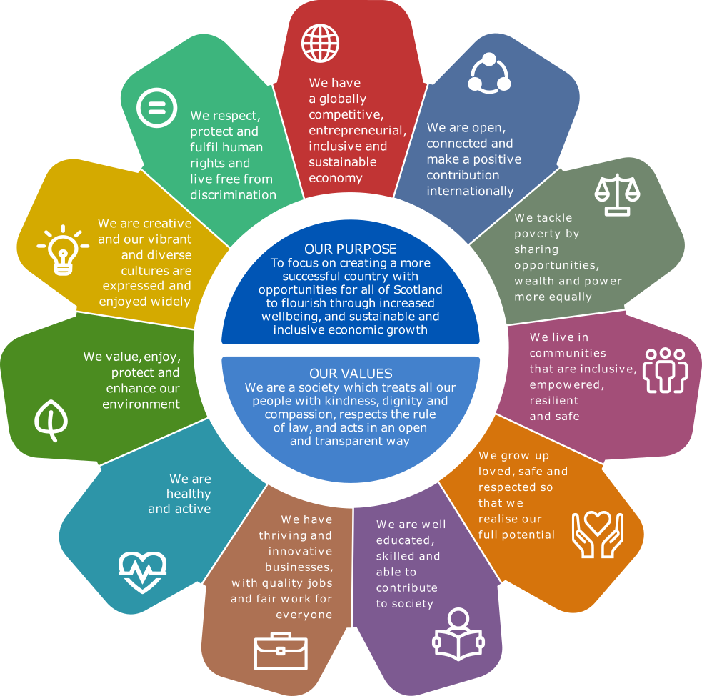

Source: The Scottish Government

* 1. In common with other central government Justice sector bodies, of particular relevance to the SCTS and the [Justice – Vision and Priorities](https://beta.gov.scot/binaries/content/documents/govscot/publications/publication/2017/07/justice-scotland-vision-priorities/documents/00522274-pdf/00522274-pdf/govscot%3Adocument) are the National Outcomes;
* We have a globally competitive, entrepreneurial, inclusive and sustainable economy;
* We live in communities that are inclusive, empowered and safe; and,
* We value, enjoy, protect and enhance our environment.
  1. The SCTS contributes to the achievement of the National Outcomes through ensuring an open and transparent approach to procurement activity thereby facilitating competitive procurement and equal access to contract opportunities in order to facilitate economic growth, whilst contributing to the efficiency of the justice system and the protection and enhancement of the environment through the delivery of its statutory Sustainable Procurement Duty obligations.

Public Procurement Reform Programme

* 1. The legislative environment within which public procurement in Scotland operates has undergone significant changes in recent years, not least by the transposition of the 2014 [European Union Public Procurement Directives](http://ec.europa.eu/growth/single-market/public-procurement/rules-implementation_en) in Scots law via the [Public Contracts (Scotland) Regulations 2015](http://www.legislation.gov.uk/ssi/2015/446/contents/made); and, the enactment of the provisions of the [Procurement Reform (Scotland) Act 2014](http://www.legislation.gov.uk/asp/2014/12/contents) via the [Procurement (Scotland) Regulations 2016](http://www.legislation.gov.uk/ssi/2016/145/contents/made) from 18th April 2016.
  2. Accordingly, SCTS’ approach to the procurement of works, goods and services aligns directly with the [Scottish Model of Procurement](https://www.gov.scot/Topics/Government/Procurement/about/spd-aims) (see Figure 2) which leverages the power of public spending to deliver genuine public value utilising the best balance of cost, quality and sustainability.
  3. The SCTS is investing heavily in its procurement resources to support a well-resourced procurement function that works closely and effectively with a broad range of customers and stakeholders, whilst ensuring that it delivers cost and resource efficiencies in a compliant and effective manner. Compliance with legislation and the Public Procurement Reform Programme increasingly supports and requires SCTS’ procurement activities to seek and deliver wider economic, social and environmental outcomes.

United Kingdom’s Exit from the European Union (“Brexit”)

9.26 Whilst the detail of these is yet to emerge, Brexit has been recognised by the SCTS as a corporate risk in order to maintain continued oversight and joint planning work has taken place with Justice partners and The Scottish Government to assess the likely impact of Brexit and the steps that need to be taken to respond effectively. Procurement will continue to provide updates on the Corporate Action Tracker.

**Section 10 – Appendices**

**Annex A – SCTS Locations Map**

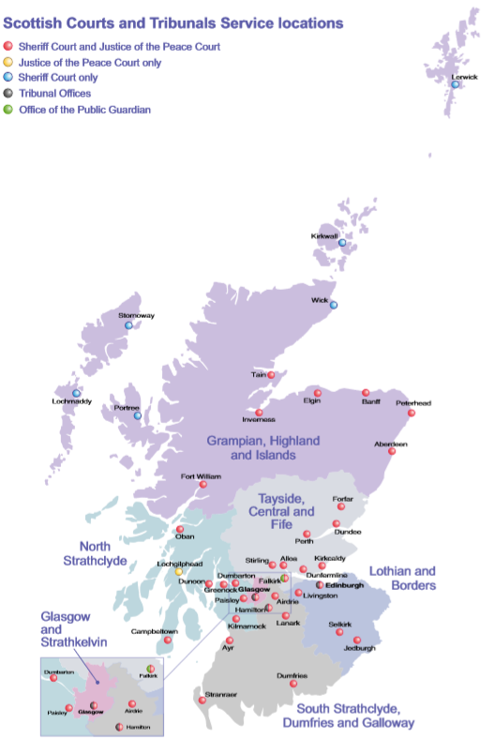

**Annex B - Procurement Strategy Action Plan 2018-21**

|  |  |  |  |
| --- | --- | --- | --- |
| **Objective** | **Outcomes** | **Main actions and commitments** | **Key Measurements** |
| Procurement will supportbusiness units to support justice by increasing levels of contracted spend throughout the organisation and developing and professionalising contract and supplier management in key spend areas. | Target the right people with the right information at the right time.  Procurement’s profile raised and relationships built with key stakeholders through regular and targeted communications  Mechanisms provided for Procurement to listen and understand stakeholders needs and implement improvement  Achieve consistency in communications by focusing on Procurement’s key messages  Project an appropriate image of Procurement as being a client-focused support function through consistent communications | Proactively engage with stakeholders to put regulated contracts in place and/or call-offs against compliant frameworks to reduce levels of addressable non-contractual spend  Procurement will engage openly and positively with all stakeholder groups to deliver a Procurement service that supports the activities of the SCTS now and in the future  Regular scheduled meetings with key stakeholder contacts  A dedicated and named Senior Procurement Specialist for each of the key spend areas of PSU and ICT  The trialling of Net Promoter Score (NPS) customer service surveys | Number of stakeholders that Procurement identifies as being key in terms of value of expenditure or value of risk  Total expenditure for these key stakeholder areas  Number and frequency of communications with key stakeholders  Output summary from NPS stakeholder and supplier feedback (quarterly) |
| Complete Roll-out of the PECOS Procurement System across SCTS with appropriate controls and governance. | A user friendly system fully integrated within the P2P project providing management with assurance around order processes and governance. | PECOS Project Team to be established and managed to ensure successful roll-out of system across SCTS where possible. Full backing with Senior Management and commitment to remove invoice register once complete. | All orders for expenditure via the PECOS system with exceptions around ePC card, virements etc. |

|  |  |  |  |
| --- | --- | --- | --- |
| **Objective** | **Outcomes** | **Main actions and commitments** | **Key Measurements** |
| Procurement will develop management information to measure and improve procurement and supplier performance, assisting key stakeholder areas in meeting their requirements for Best Value goods, works and services. | Publication of a Contract Register  Procurement intranet page to be updated with guidance on the Procurement Journey  Contract management process in operation for all key suppliers | Review annual expenditure analysis to understand regulated procurement and contracts in place  Category management of key spend areas to identify areas where collaborative agreements could be used.  Template documents produced for Procurement team to ensure strategy development will address how corporate social responsibilities - equalities, fair trade, governance, prompt payment, supporting local SMEs and sustainable procurement can be developed and achieved through regulated procurement contracts, embedding these responsibility objectives into tender documentation and evaluation criteria  Contract management process applied to all contracts and managed on a proportionate basis | Total value of expenditure across the SCTS, SCJC and SSC.  Total value of expenditure influenced by Procurement Team directly or indirectly  % expenditure through collaborative agreements |

|  |  |  |  |
| --- | --- | --- | --- |
| **Objective** | **Outcomes** | **Main actions and commitments** | **Key Measurements** |
| Procurement will embed sound ethical, social and environmental policies within the SCTS’ procurement function to ensure compliance with relevant Scottish, UK and EU legislation in performance of the sustainable procurement duty | The identification and management of high risk commodities through the use of the appropriate tools  Utilising best practice and the outputs from tools, to embed requirements in contract and maximise social, economic and environmental outcomes through the procurement journey  Tenders will promote the Foundation Living Wage, specify that contractors demonstrate Fair Work practices, and high ethical standards and values in the conduct of their business i.e. Health and Safety at Work  Fair and transparent opportunities and treatment for all current and potential suppliers including small and medium-sized enterprises (SMEs), third sector and voluntary sector organisations  Support for the purchase of Fair and Ethically Traded goods and services | Refreshing SCTS Procurement policy on how regulated procurements will be undertaken to ensure compliance with the sustainable procurement duty  As part of the Tender strategy and on-going contract management commodity areas at risk from modern slavery/ human trafficking will be considered. | Results of prioritisation exercise across the key category expenditure areas  Publication and promotion of a refreshed SCTS procurement policy  Contributing to the corporate reporting on the adoption of Fair Work practices by SCTS’ supply chain, and the promotion of equality, diversity and inclusion  Supporting the Supplier Development Programme through promotion of contract opportunities with SCTS via regular Meet The Buyer and other promotional events as appropriate |

|  |  |  |  |
| --- | --- | --- | --- |
| **Objective** | **Outcomes** | **Main actions and commitments** | **Key Measurements** |
| We will promote the delivery of value for money through good procurement practice and optimal use of procurement collaboration opportunities working with the supply chains to ensure continued value, managed performance and minimal risk throughout the life of contracts for the benefit of SCTS staff and Court users (as appropriate) | A Contract Register that provides clarity on the status of all contracts and activities  Comprehensive procurement strategies that facilitate the production of clear and concise specifications  Suppliers to be proactively managed to ensure they perform over the life of the contact  Savings and benefits generated through Procurement reported to SCTS Executive Team and Audit and Risk Committee as appropriate on a regular basis | Review annual expenditure analysis to understand regulated procurement and contracts in place and the cycle for the review and re-tender of these  Expenditure to be managed on a category basis    SCTS Procurement template documents to be developed in line with the Procurement Journey to ensure a consistent and appropriate approach to each and every procurement  Contract management processes to be consistently and appropriately applied across the entire supply base  Savings and benefits identified and collected in line with agreed methodologies | Total value of expenditure across SCTS as reported on via the Scottish Procurement Information Hub  Total number of procurement staff  No of strategic contracts.  No of managed contracts.  Value of savings and benefits generated |
| Procurement will sustain and further develop partnerships within the Justice sector, with other publicly funded bodies and, appropriately, with supply markets that will yield intelligence, innovation and deliver value to users of procurement. | Partnerships within the Justice sector and other public bodies which assist the development of potential procurement collaboration opportunities, and support and encourage shared services initiatives which would attribute value to SCTS activities  Reduction in the duplication of effort between SCTS and Justice sector and other Scottish public bodies for tendering activity | Review the expenditure of the SCTS and manage on a category basis.  Procurement Managers to identify potential areas of collaborative activity for their Category/Key spend areas  Develop forward procurement work plans which will aid discussions with Justice sector and other public bodies | Total £/value of collaborative procurement expenditure  % expenditure through collaborative agreements |

**Section 11 – Glossary**

|  |  |
| --- | --- |
| OPG | Office of the Public Guardian |
| PCS | The Public Contracts Scotland procurement portal used by the Scottish Public Sector to advertise public contract opportunities |
| SCTS | The Scottish Courts and Tribunals Service |
| SCJC | The Scottish Civil Justice Council |
| SSC | The Scottish Sentencing Council |
| WLC | Whole Life Cost – the full and total cost of a contract over its entire life to include any mobilisation and exit costs |

**End of Document**

1. Article 18(1) Directive 2014/24/EU refers. These principles comply with the principles of the Treaty on the Functioning of the European Union (TFEU) and in particular the free movement of goods, freedom of establishment and the freedom to provide services.
2. The classification system used is vCode Business Sector, provided by the [Scottish Procurement Information Hub](https://www.gov.scot/Topics/Government/Procurement/eCommerce/ScottishProcurementInformationHub).
3. Environmental / Ecological Footprint the estimated area of land required to sustain indefinitely operation or life within a site or building.