Standards of Service for
Victims and Witnesses
Annual Report on Performance
2018 – 2019





CONTENTS | Page
INTRODUCTION | 3
THE STANDARDS OF SERVICE | 5
STANDARDS AND REPORT  Police Scotland | 7
Crown Office and Procurator Fiscal Service | 18
Scottish Courts and Tribunals Service | 24
Scottish Prison Service | 35
Parole Board for Scotland | 43
WHAT TO DO IF YOU ARE NOT HAPPY WITH OUR SERVICE – How To Complain | 47
TAKING THE MATTER FURTHER –  The Scottish Public Services Ombudsman | 49

.
INTRODUCTION

We all share a vision that those affected by crime should be at the heart of the Scottish justice system. The people who are affected by crime and are involved in criminal proceedings should know that the criminal justice system is there for them and we want to make sure that their voices are heard.

The principles that victims and witnesses can look to are clear - they have the right to information about their case, their safety should be ensured, they should be supported and they should be able to participate effectively.

This is the fourth report produced jointly by Police Scotland, the Crown Office and Procurator Fiscal Service, the Scottish Courts and Tribunals Service, the Scottish Prison Service and the Parole Board for Scotland. We each established Standards of Service for victims and witnesses in April 2015 and they have been subject to review, critique and comment in that period, all of which has been welcomed.

There is a desire to do more and a willingness to do things differently that improve the support and help for victims and witnesses. However, change requires to be considered, and informed, by the collective experience of victims and witnesses. We are committed to working collaboratively with Victims’ organisations to better understand the needs of victims and how we might help and there has been much work to this end. Our agencies are also represented on the newly established Victims Taskforce. The primary role of the Taskforce is to co-ordinate and drive action to improve the experiences of victims and witnesses within the criminal justice system, whilst ensuring a fair justice system for those accused of crime.

The Standards are and should continue to be dynamic, being able to respond to the need to do things differently or better. In this fourth year we have not only continued to embed and reinforce the standards, to improve the experience of victims in the justice system, but sought to work collaboratively with others to better understand the needs of victims. This allows the Standards to be developed in an informed and measured way.

Working together, and with the Scottish Government, we are committed to helping victims and witnesses feel supported, safe and informed at every stage of the process from offence to sentence end. We all recognise that the victim’s journey can be complicated, at times frustrating, and often deeply upsetting. We do not always get it right. It is recognised that, collectively, we need to do more, and can do more, and we are committed to doing so.

Being a witness, we want to make sure that you are able to exercise your rights, that you are treated fairly, and that you are supported in making your voice heard. You are at the heart of our justice system

What has happened during the year from April 2018 to April 2019?

The following pages set out how we have continued to embed the Standards of Service during the past year and the plans we have for the continued development of services in support of victims and witnesses heading into 2018-19.

We are once again grateful to the members of the Victims Organisations Collaboration Forum Scotland (VOCFS) for their continued support and for their valuable feedback on the Standards of Service.

Where can I find the original Standards of Service document?

Police Scotland, the Crown Office and Procurator Fiscal Service, the Scottish Courts and Tribunals Service, the Scottish Prison Service and the Parole Board for Scotland each play a part in the overall justice process. As such, you can find the original standards document on each of our websites and they are available in alternative formats if required. The original document contains more information, including a flowchart, which sets out what you can expect from each organisation at each stage of the justice process if you are a victim of crime.

THE STANDARDS OF SERVICE

The Standards of Service are based on the main principles of the Victims and Witnesses (Scotland) Act 2014 and are set out in Section 1. These are:

- That a victim or witness should be able to obtain information about what is happening in the investigation or proceedings;
- That the safety of a victim or witness should be ensured during and after the investigation and proceedings;
- That a victim or witness should have access to appropriate support during and after the investigation and proceedings; and
- That, in so far as it would be appropriate to do so, a victim or witness should be able to participate effectively in the investigation and proceedings.

In relation to obtaining information you can also expect that:

- You should have access to relevant information at an early stage and at appropriate points in the process. This should include information on procedures, your role in them (if any), reports on progress (giving an explanation of any delays) and outcomes of criminal proceedings, and where, if possible, you can get further information and assistance;
- You should be able to understand the information that is given to you. The language should be easy to understand and the information should be available in alternative languages or formats if required; and
- You should be told who to contact if you want to discuss the information that has been provided and anything you do not understand will be explained to you.

We have all developed standards based on these principles.

OUR STANDARDS OF SERVICE AND ANNUAL REPORT

Being a victim of crime, or witnessing a crime, can be a very upsetting and difficult experience. We each appreciate this and we will all:

- Ensure you have fair and equal access to services throughout and are treated with dignity and respect at all times regardless of age, disability, gender identity, marriage and civil partnership, pregnancy and maternity, race, religion or belief, sex or sexual orientation. Where required, additional support will be provided and any reasonable adjustments made to ensure that you have access to information and support services;
- Work together and in partnership with victim and witness support organisations to ensure you are provided with the best service possible; and
- We will each ensure that we comply with our respective Complaints Policies details of which are found on the following pages.

Our Standards, and our reports on how we continue to implement them, can be found on the following pages:

Police Scotland pages 7-17
Crown Office and Procurator Fiscal Service pages 18-23
Scottish Courts and Tribunals Service pages 24-34
Scottish Prison Service pages 35-42
Parole Board for Scotland pages 43-46

Police Scotland

Standards
- We will discuss with you how you will be kept informed of progress in your case; we will also explain how we will deal with your case and what we may ask you to do to help us;
- If you are a victim or witness, a person who has given a statement in relation to a crime, or a family member of a victim who has died as a result of a crime, you can make a request for information.
When we receive your application we will respond within 40 days. For more detail on what information can be requested, and how to apply please go to:
www.scotland.police.uk/access-to-information/the-victims-and-witnesses-scotland-act-2014
- If you are a victim of one of these crimes you will have the option to let officers know whether you want a male or female officer to interview you. We will try to meet your request wherever possible;
- To assess your vulnerability as a witness, we will consider, with our partners, your particular needs, and thereafter try to ensure those needs are met; and
- We will ensure you receive a Victim Care Card if you are a victim of crime which provides you with the details of your enquiry officer, the crime you report and information on how you can access victim support and the Scottish Government’s Victims’ Code.

Report
General
Police Scotland’s main purpose is improving the safety and wellbeing of people, places and communities through providing high quality operational policing and working alongside our partners. There are thirteen local policing divisions who are all committed to keeping the communities they serve safe.

Victims and witnesses can experience a wide range of emotions as a result of crime and for a person who has little experience of the criminal justice process, trying to navigate it can cause additional and unnecessary stress and confusion. Police Scotland recognises victims and witnesses rely on officers and police staff to provide them with information on their rights, which includes accessing support services, and it is essential that we get this right.

We continue to work closely with our criminal justice partners to identify areas we need to prioritise which includes improving the rights, support, protection and participation of victims and witnesses within a streamlined and joined up criminal justice process.

The following information summarises what has been done in the past year by Police Scotland in relation to the Standards of Service which have not been changed.

“We will discuss with you how you will be kept informed of progress in your case; we will also explain how we will deal with your case and what we may ask you to do to help us.”

Throughout an investigation we have a duty to maintain regular contact with victims to keep them updated on the progress of their case which we have reinforced to our operational officers within our Standard Operating Procedures and internal communications which included mandatory face to face briefings.

The User Satisfaction Survey measures the level of satisfaction with how Police Scotland has dealt with members of the public who have contacted us to report crimes or incidents and, consequently, their level of confidence in the Force. A statistically representative sample of service users who have reported an incident or crime to Police Scotland are invited to participate in the survey. The participants’ feedback is closely monitored and affords us the opportunity to make informed decisions on actions required to rectify any identified issues.

The following chart shows percentages from the past 5 years of those surveyed who indicated that they had been adequately informed about the progress made on the incident they had reported to us.

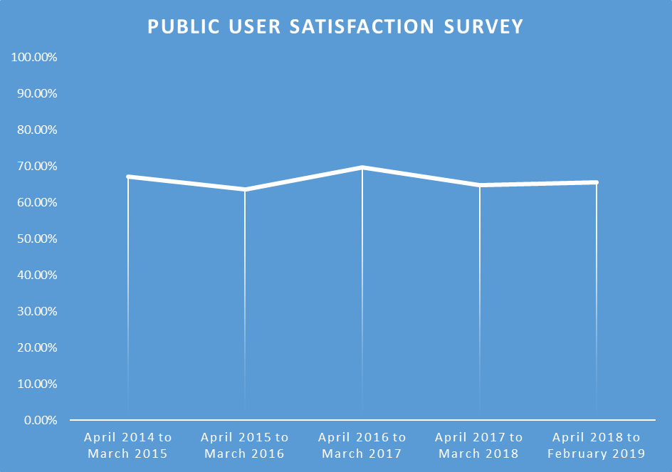
We will continue to be committed to improving this level of performance in respect of keeping victims informed.

“If you are a victim or witness, a person who has given a statement in relation to a crime, or a family member of a victim who has died as a result of a crime, you can make a request for information.
When we receive your application we will respond within 40 days. For more detail on what information can be requested, and how to apply please go to: www.scotland.police.uk/access-to-information/the-victims-and-witnesses-scotland-act-2014.”

If you are a victim or witness, a person who has given a statement in relation to a crime, or a family member of a victim who has died as a result of a crime, you can make a request for information. When we receive your application we will respond within 40 days.

Victims and witnesses have the right to enquire with us as to why we are not investigating a crime or why we have stopped an investigation. We will provide this information as long as it is not held in confidence and it is not considered inappropriate to disclose.

Between 1st April 2018 and 31st March 2019 we received 9 requests for such information, 5 of which were responded to within the specified timescale.
“If you are a victim of one of these crimes you will have the option to let officers know whether you want a male or female officer to interview you. We will try to meet your request wherever possible.”

This standard is embedded into day to day policing. We continue to support victims of such crimes which includes working closely with our partners to achieve this.

Between 1st April 2018 and 31st March 2019 we identified 37,453 victims of these crimes and 32,604 of them were given the opportunity to specify the gender of the interviewing officer. There were occasions when victims were entitled to specify the gender of the interviewing officer but we were unable to accommodate that request. The number of cases to which this applied and the reasons that we were unable to do so are as follows:

- 20 of the cases it was deemed prejudicial to the criminal investigation; and
- 4829 cases it was deemed not reasonably practicable to do so.

Over and above giving victims the choice of a female or male police interviewing officer, we continue to be dedicated to fully supporting them which includes working closely with our partners to achieve this. In relation to Sexual Crime, Human Trafficking and Domestic Abuse we commit to the following:

Sexual Crime

- Review national training to ensure responses to reports of sexual crime are victim-focused
- Monitor compliance with the Victim Strategy
- Work in partnership with Rape Crisis Scotland to promote the use of Advocacy Support workers
- Increase third party reporting mechanisms across Scotland
- Challenge negative attitudes to sexual crime through joint partner campaigns and encourage confidence to report

What we have done
We are committed to continually improving the service we provide to victims of rape and sexual crime. During regular meetings with our partners who are involved with victims of sexual crime consideration is given to feedback on our service and opportunities for organisational learning and development are identified.

In 2018 significant progress has been made in the following areas:

In response to the HMICS (HM Inspectorate of Constabulary in Scotland) recommendations within their Strategic Overview of Provisions of Forensic Medical Services to Victims of Sexual Crime report, we have worked with the NHS to make improvements to the forensic medical examinations of victims of rape and sexual assault, to ensure suitable medical examiners and appropriate facilities are provided, striving for an equity of service across the country, regardless of where the victim resides.

We are making improvements to our Early Evidence Kits and have refreshed training around the use of these in an effort to maximise opportunities for the capture of all available forensic evidence.

We have improved the initial call handling of incidents of sexual crime to ensure victims are given appropriate advice and support at the earliest opportunity and that the police provide a relevant initial response in each circumstance.

We are delivering a bespoke training course to Sexual Offence Liaison Officers, to train them in the use of Video Recorded Interviews of rape victims. A pilot of this procedure will be evaluated with its aim being to improve the police interview and subsequent experience of the criminal justice process for victims.

We have created a refresher course for our cadre of Sexual Offence Liaison Officers to ensure their skills remain current and updated.

We have worked with universities in Scotland to improve support and avenues for reporting to students who have been victims of sexual assault and Gender Based Violence, aligned to the Scottish Government’s ‘Equally Safe’ strategy.

In partnership with the Crown Office and Procurator Fiscal Service, we have put measures in place to improve and monitor compliance in relation to the submission of Victim Strategies for victims of rape and serious sexual offences, designed to provide assistance to progress them through the Criminal Justice process with minimal trauma.

Human Trafficking

- Develop measures to raise awareness and prevent labour exploitation within ‘at risk’ industries
- Collaborate with European counterparts through Joint Investigation Teams
- Ensure all National Recording Mechanism referrals result in a police crime report and associated investigation being raised
- Implement a Human Trafficking and Exploitation Organisational Learning and Development process to identify good practice and improvement opportunities
- Continue to develop sexual exploitation investigation guidance
- Monitor ‘off-street’ prostitution activity and undertake local risk assessments focusing on threats and risks, proportionately prioritising enforcement activity
- Engage with community representatives to create problem solving opportunities, while avoiding ‘displacement only’ options
- Work with local and national statutory and non-governmental organisations to improve the safety and wellbeing of individuals and enable easier access to available support, including exit services
- Endeavour to build trust and confidence by improving relationships with victims by encouraging the reporting of criminality directly to Police Scotland or via third party reporting mechanisms.

What we have done
We have taken steps, through publication of appropriate memoranda, to reinforce our commitment to protecting individuals exposed to the greatest threat, risk and harm, which includes potential victims of trafficking. Improved recording procedures have been implemented to ensure adherence to the Scottish Crime Recording Standards and recommendations from the Independent Anti-Slavery Commissioner. The National Human Trafficking Unit retains governance around this process to ensure policy, standard operating procedures and compliance rates are maintained.

We launched our first Human Trafficking media campaign, focusing on sexual exploitation. To develop the media strategy Police Scotland consulted with Scottish Government, National Crime Agency, Child Exploitation and Online Protection (CEOP), Convention of Scottish Local Authorities (COSLA), Community Safety (Glasgow, Edinburgh, Aberdeen and Dundee), Gang Masters and Labour Abuse Authority (GLAA), Migrant Help UK, Trafficking Awareness Raising Alliance and Home Office Stop the Traffic. The campaign was launched over all social media platforms as well as TV, radio and traditional media outlets and throughout rail and transport routes.

Part 4 of the Human Trafficking and Exploitation (Scotland) Act 2015 grants police and prosecutors more powers to detect, prosecute, and prevent exploitation. Trafficking and Exploitation Prevention Orders (TEPO) came into force on 30 June 2017 followed by Trafficking and Exploitation Risk Orders (TERO) on 31st October 2017. Both orders allow police, prosecutors and courts to protect the public from future harm and deter Human Trafficking and Exploitation.

Police Scotland Serious Crime Prevention Orders Unit assesses Human Trafficking cases where there is a relevant offence that would allow progression of a TEPO/TERO application. In order to evaluate the effectiveness of this process Police Scotland has established a Short Life Working Group (SLWG) to examine, review and reflect on the TEPO/TERO process within Police Scotland and across the criminal justice network. Actions from this group focus on raising awareness and reviewing previous applications and processes to understand why applications have been rejected. The group will also focus on raising awareness in respect of part three of the Act and the use of Human Trafficking aggravators.

Survivors of Human Trafficking in Scotland (SOHTIS) is a charity committed to offering victims of trafficking support, via employment and accommodation routes, after they have received support from the National Referral Mechanism (NRM). Police Scotland is currently developing close working links with SOHTIS with the aim of improving engagement with victims of Human Trafficking and Exploitation, to establish trust and improve their understanding and intelligence picture of Human Trafficking in Scotland and the reasons why it has been identified as a source country for victims.

The National Human Trafficking Unit (NHTU) continues to work with the Scottish Government to implement the Duty to Notify Process under Section 38 of the Human Trafficking and Exploitation (Scotland) Act 2015 and on-going assessment of the process to identify the most suitable methods of disseminating information/intelligence received. Upon completion of the public consultation process Police Scotland will deliver suitable training to those public bodies named within legislation to ensure an efficient process of submissions is implemented. Regular reports will be produced and distributed to all relevant bodies. Continual work will be undertaken to identify further bodies that are not named in legislation who may wish to take part in the process similar to the arrangements in place with Border Force and the Gangmasters and Labour Abuse Authority.

Police Scotland continues to identify ways in which to improve and develop our relationship and working arrangements with foreign law enforcement partners and where possible, dependent on the impact of the UK leaving the European Union, looks to continue with the secondment of foreign officers to assist and enhance our ability to effectively investigate Human Trafficking and Exploitation throughout Scotland. Discussion will continue with Vietnamese authorities to agree to more collaborative working to tackle the numbers of Vietnamese nationals encountered and all efforts will be made to continue close working with current foreign law enforcement partners.

Police Scotland published in their annual policing plan a commitment to protect people at risk of harm caused by Human Trafficking and Exploitation. One of the delivery measures in respect of this commitment was to develop an Inter-Agency Referral Discussion (IRD) approach to address reports of Human Trafficking. An IRD is the first stage in the process of joint information sharing, assessment and decision making about risk to children and vulnerable adults and, as such, is the central mechanisms to co-ordinate inter agency protection processes. This IRD is being considered by the NHTU senior management team and is likely to roll out across Police Scotland in 2019.

Domestic Abuse

We will ensure that victims of Gender Based Violence and Domestic Abuse are safer and confident that Police Scotland is responsive to their needs. To do this we will:

- Equip police officers and staff with the training to effectively target perpetrators
- Support rehabilitation and behaviour change programmes to reduce re-offending
- Improve support to victims (including expansion of the victim notification process)
- Evaluate Disclosure Scheme for Domestic Abuse Scotland to improve protection

What we have done
We have invested in delivery of training to over 14,000 of our officers and staff to support implementation of the Domestic Abuse (Scotland) Act 2018. A pioneering training programme ‘Domestic Abuse Matters (Scotland)’ has been designed and gives guidance on the practical issues like evidence gathering and reporting of coercive and controlling behaviours. Specifically, it has advanced knowledge of the dynamics of power and control in abusive relationships and tackled the many myths and misconceptions which are common in our communities.

Continuous Professional Development (CPD) is critical in ensuring our officers and staff have knowledge of current trends and practices in order to tackle the insidious behaviours of perpetrators. With this in mind we have conducted a number of CPD events including co-hosting a conference on Honour Based Abuse and the Disclosure Scheme for Domestic Abuse Scotland (DSDAS). Additionally we have contributed significantly to speaking at events delivered by our partners across Scotland, working collaboratively to increase knowledge across our communities.

We are working in partnership with a number of mobile application providers to develop applications (‘apps’) for those suffering from domestic abuse and stalking and harassment. These ‘apps’ give information and support to victims, or those concerned about them, and signpost them to organisations which can provide personal support. Additionally, we have provided training to officers and staff on the importance of Victim Support and Advocacy Services.

We have implemented a new National Mobile Alarm System for high risk victims of domestic abuse and other vulnerable people. These alarms provide enhanced notification to the police and form part of a UK-wide system of protection for victims. Feedback provides that these alarms have given victims more confidence to live their lives in the knowledge that they can seek urgent assistance if required.

We have engaged with the Scottish Institute for Policing Research (SIPR) and secured funding to evaluate the Disclosure Scheme for Domestic Abuse Scotland. This will be undertaken in late 2019.

“To assess your vulnerability as a witness, we will consider, with our partners, your particular needs and thereafter try to ensure those needs are met.”

What we have done
Through our developed processes we continue to ensure children and vulnerable witnesses have access to standard and non-standard special measures in all relevant Sheriff and High Court hearings.

The Vulnerable Witness (Criminal Evidence) (Scotland) Bill is now progressing through the consultation process so is still in the stages of development. The Bill makes provision around the use of special measures for the purpose of taking the evidence of child witnesses and other vulnerable witnesses in criminal proceedings. Police Scotland is an active participant in the consultation process and is working in close partnership with the Scottish Courts and Tribunals Service and Crown Office and Procurator Fiscal Service to ensure any agreed provisions are fit for purpose, deliverable and sustainable.

We have embedded a consistent practice model within our Divisional Concern Hubs to undertake triage, research, assessment and information sharing (where relevant and proportionate) of wellbeing concerns with our partners. The Concern Hub business process is designed to facilitate efficient, appropriate, proportionate and relevant information sharing with and across services, which is critical in ensuring the safety and wellbeing of individuals and communities. A standardised risk assessment is now used for both adults and children to consider the needs of the individual and justify sharing relevant and proportionate information with partner agencies in accordance with Data Protection and Human Rights legislation. This work has included the introduction of standardised roles and responsibilities supported by training, with further continuous improvement activity ongoing.
“We will ensure you receive a Victim Care Card if you are a victim of crime which provides you with the details of your enquiry officer, the crime you report and information on how you can access victim support and the Scottish Government’s Victims’ Code.”

What we have done
We continue to monitor performance with regards the issuing of Victim Care Cards and ensuring victims and witnesses are fully informed of available support. We have been working on ways to support our officers and police staff in this regard.

We have nationalised our referral process to victim support services which is detailed within the Victims and Witnesses Care Standard Operation Procedures which was approved and published in August 2018. The referral process is straightforward and adheres to Data Protection legislation.

The Victim Care Card has been amended to fully reflect victims’ rights under Section 3D, Victims and Witnesses (Scotland) Act 2014 to further assist and simplify the process for officers to meet Police Scotland’s statutory obligations and the needs of victims and witnesses. An additional line was also added to signpost victims to the Keep Safe section of Police Scotland’s Website for crime prevention advice and keep safe messaging.

We developed and delivered mandatory face to face briefings to all our operational officers and their supervisors across all areas of policing which focused on roles and responsibilities in respect of service delivery to victims and witnesses and statutory requirements. Posters were also created and distributed to all operational offices across Police Scotland to act as a daily reminder for our officers and police staff of the key points from the briefings.

We have developed processes and procedures around ensuring that Victim Care Cards are either emailed or posted to those who report a crime who do not require to be seen by a police officer.

Victim Care Card books have been developed and distributed as personal issue to every operational officer across all areas of policing. The reverse side of the front cover contains a flow chart which again guides officers through the Victim Care Card and victim support referral processes.

We have created a Victims and Witnesses section on our website which provides valuable information on how to access victim support services along with a link to the Victim Care Card. Further information will be added to this page as we progress through 2019.

Police Scotland supported the European Victims of Crime Day on 22nd February 2019. We used the week long campaign to reinforce the messaging within the aforementioned face to face briefings to our officers and police staff. We also shared positive feedback received from victims who have been supported by Victim Support Scotland and how this support has helped them cope with what has happened to them.

OUR STANDARDS OF SERVICE 2019 - 2020

We have reported on progress we have made to improve our processes and procedures in relation to our commitment to providing a high standard of care to victims and witnesses during their contact with the police. We will continue to monitor the effectiveness of these changes which will be reflected upon within the Victims and Witnesses Standards of Service Annual Report 2019-20.

We reviewed our standards within the Standards of Service for Victims and Witnesses 2018-19 and felt an amendment was required to the wording of the following standard to provide you with better clarity:

If you are a victim of one of these crimes you will have the option to let officers know whether you want a male or female officer to interview you. We will try to meet your request wherever possible.

This standard will now read, within the Standards of Service for Victims and Witnesses 2019-20:

If you are a victim of either a sexual offence, trafficking for prostitution, trafficking for exploitation, domestic abuse or stalking you will have the option to let officers know whether you want a male or female officer to interview you. We will try to meet your request wherever possible.

BRITISH TRANSPORT POLICE
British Transport Police (BTP) is not an agency subject to the statutory requirements regarding the setting of standards and reporting on performance. BTP is however aware of the need to provide support to those persons vulnerable within the system and has set operational standards in support of victims and witnesses and these can be viewed here. Any enquiries regarding the standards may be directed to D-Crime@btp.pnn.police.
Crown Office and Procurator Fiscal Service (COPFS)

Standards

- We will treat you fairly and with respect, we will listen to you through our Comments and Complaints and Feedback Policy and the review of our decisions, and we will communicate with you clearly and effectively;
- We will make sure that you have access to the relevant and appropriate information that you are entitled to, and in situations where we cannot provide that information we will explain the reasons why;
- We will ensure that you are given the help you need to give evidence in court. We will assess your vulnerability, explain the special measures available to you under the law and when available apply for you to be supported with the appropriate special measures; and
- We will take decisions in cases reported to us in line with our prosecution code, and continue to review the training needs of our staff to ensure that they have the appropriate skills.

Report
General
COPFS is responsible for the investigation, prosecution, and disruption of crime, the seizing of proceeds of crime in Scotland, the investigation of deaths that require explanation, and the investigation of allegations of criminal conduct by police officers. We work closely with our partners in the criminal justice system to help make Scotland a safer place.

The following outlines some of the work which has been done in the past year by COPFS in relation to the Standards of Service, which have not changed, or been modified, in the past year.
“We will treat you fairly and with respect, we will listen to you through our Comments and Complaints and Feedback Policy and the review of our decisions, and we will communicate with you clearly and effectively.”

What we have done
We maintained our aim to resolve more straightforward complaints quickly and on the frontline wherever possible. Where complaints are submitted, we continue to monitor recurring themes, using information gathered to improve services.

We continue to review decisions not to prosecute or to discontinue cases when victims ask for such reviews. The Lord Advocate has published rules on the Victim’s Right to Review, which are available on the COPFS website.

Fifty-one (51) members of our staff will have been trained in the Institute of Customer Service ‘First Impressions’ course by the end of April 2019 and more are due to commence this training.

We have continued to implement the recommendations of the Inspectorate of Prosecutions in Scotland’s Victims' Right to Review: Complaints Handling and Feedback report. This includes the creation of the Service Improvement Board whose remit includes specific reference to analysing complaints to identify thematic issues, corporate risks and lessons learned.

In line with our Memorandum of Understanding with Rape Crisis Scotland we maintain an active commitment to receiving and reacting to feedback on victims’ experiences of the criminal justice system and their views on the service provided by COPFS.

What we will do
We will continue to monitor the interaction that we have with our customers to ensure that we continue to provide an excellent service to them, thereby improving victim engagement and public confidence in our service.

“We will make sure that you have access to the relevant and appropriate information that you are entitled to and in situations where we cannot provide that information we will explain the reasons why.”

What we have done
We are currently examining and developing a suitable process to enable an extension of our Decision Notification Scheme to all relevant victims in terms of the recommendations in the Inspectorate of Prosecutions in Scotland’s Victims’ Right to Review.
We have appointed an Information Governance Manager who is the COPFS national lead on information governance including data protection and records management. This individual will manage all Freedom of Information, Information Sharing, Data Protection and Subject Access Requests.

We have reviewed the content of all of the letters that our Victim Information and Advice service sends to victims and witnesses in both High Court and Sheriff and Jury matters. We are in the process of rolling out the use of these new letters.

What we will do
We will continue to review the content of the letters that our Victim Information & Advice service sends to victims and witnesses in summary cases. The aim of the review is to ensure that victims and witnesses receive the information that they need to fully engage in the criminal justice process in clear and simple language.

We are to undertake a review into the remit of our Victim Information & Advice service to consider the level and categories of support provided to individuals referred to VIA to ensure the service provides the appropriate level of assistance based on the needs and vulnerabilities of each victim and witness.

We will continue to work towards the expansion of our Decision Notification Scheme.

“We will ensure that you are given the help you need to give evidence in court. We will assess your vulnerability, explain the special measures available to you under the law and when available apply for you to be supported with the appropriate special measures.”

What we have done
COPFS has reviewed its policy on Sensitive Personal Records and has made significant progress towards publishing an updated policy. A further judgment of the High Court of Justiciary was published towards the end of 2018. COPFS are considering the impact of this judgment and making relevant amendments to the draft policy as a consequence.

In collaboration with the SCTS, the Police Service of Scotland and VSS, COPFS are undertaking a wider review of the Joint Protocol entitled “Working Together for Victims and Witnesses” to ensure that it continues to be fit for purpose and enables the provision of the best possible service for victims and witnesses.

We have continued to implement the requirements of the High Court of Justiciary Practice note 1 of 2017 which sets out best practice for evidence by commissioner hearings. Close to 100 hearings have taken place this year.

The Lord Advocate has accepted appointment as Co-chair of the Scottish Governments Victims Taskforce which will bring together senior decision-makers from justice agencies, the legal profession, academia and the voluntary sector, including direct representation of victims to drive forward work that ensures victims’ voices are heard and streamline their journey through the justice system.

What we will do
We will ensure that vulnerable victims and witnesses are aware of all special measures available to them and will seek to ensure they are supported by the special measures which best meet their needs, where considered appropriate by the court.

We will continue to assess the vulnerability of victims and witnesses and ensure that they have relevant information and access to the most appropriate special measures available to them.

We will implement the provisions introduced in the Vulnerable Witness (Criminal Evidence) (Scotland) Bill which will necessitate pre-recording the evidence of child witnesses in many High Court cases.

We will work with Police Scotland, Scottish Government and Rape Crisis Scotland to establish a pilot project to test visual recording of the statements of complainers in rape cases.

“We will take decisions in cases reported to us in line with our prosecution code and continue to review the training needs of our staff to ensure that they have the appropriate skills.”

What we have done
On 16 November 2017, Her Majesty’s Inspectorate of Prosecution in Scotland published a thematic review of the Investigation and Prosecution of Sexual Offences in Scotland. The Inspectorate made 12 recommendations, all of which were accepted by Crown Office and Procurator Fiscal Service. We have continued the process of implementing these recommendations.

In 2015, a domestic abuse training strategy was implemented involving a rolling programme of specialist domestic abuse training for prosecutors and VIA staff. The training will continue to be provided to ensure staff who deal directly with victims and witnesses in domestic abuse cases have been trained in areas such as the typology and dynamics of abuse, our prosecution policies, and addressing issues that arise in the presentation of domestic abuse cases in court.

Since 2009, COPFS staff who prepare serious sexual offence cases must be trained and accredited to do so. In the last year, staff have continued to receive training in relevant areas, including the “Sexual Offences Core Course” and the “Evidential Interviewing of Children Course”. This training has been updated to include training on the use of Evidence on Commission in cases.

In advance of the implementation of the Domestic Abuse (Scotland) Act on 1 April 2019 we have developed and delivered bespoke guidance, face to face training and accompanying e-learning package to all relevant staff. Over 500 members of staff have received this training in advance of the implementation of the Act.

We have reintroduced a further Advocacy skills course aimed at staff conducting Sheriff and Jury trials. Nineteen (19) members of staff have completed the training to date and it is anticipated that further staff will undertake the training on an ongoing basis over the next 12 months.

In November 2018 Advocate Deputes received 2 days of training on a variety of topics including: Victims Right to Review, the Domestic Abuse (Scotland) Act 2018, contempt of court proceedings and the Vulnerable Witnesses (Criminal Evidence) (Scotland) Bill.

What we will do
We will implement the remaining recommendations of Her Majesty’s Inspectorate of Prosecutions in Scotland’s thematic review on the Investigation and Prosecution of Sexual Offences in Scotland.

COPFS remains dedicated to providing the best possible training to all staff, including our Trainee Solicitors and new Procurator Fiscal Deputes under our Trainee and Depute Accreditation programmes. Our Trainee Solicitor programme is continually improved and updated to ensure that it best equips our legal trainees with the core skills they require as prosecutors, and prepare them for work as qualified solicitors. We run an excellent and highly-regarded traineeship programme.

THE STANDARDS OF SERVICE IN THE COMING YEAR
COPFS keeps all of its procedures and policies under review, and will continue to monitor their effectiveness, working to make improvements if and when they are required, to ensure that the Standards of Service continue to meet the needs of victims and witnesses. COPFS does not intend to amend or modify the current standards of service but to continue to improve our implementation of the existing standards of service as set out above.
Scottish Courts and Tribunals Service

Standards
- If you are a witness, we will update you on the progress of the court case at least once per hour and advise you when you can leave the court;
- We will provide separate waiting rooms for prosecution and defence witnesses, and access to refreshments;
- If you are entitled to give your evidence to court by live TV link, we will meet you on the day and explain the process for giving your evidence to court;
- We will respond to requests received on behalf of witnesses, for court familiarisation visits, within 3 working days of receipt; and
- If you want to know what support is available to you when you arrive at court, we will direct you to the Witness Service or other support services which are present in the court building.

Report
General
The following report provides an annual statement of performance against the above specific standards which the Scottish Courts and Tribunals Service (SCTS) considers reflect the key engagement victims and witnesses may have with the courts, and SCTS, during their journey through the justice process.

Before looking at that assessment in more detail, it is worth considering the wider picture in terms of successful efforts that are being made to improve efficiency within the system, and which in turn will be having a positive impact upon the experiences of victims and witnesses.

Criminal Justice Reform
The SCTS continues to drive forward initiatives emerging from the Evidence and Procedure Review. This includes supporting the promotion of a greater use of pre-recorded evidence in order to ensure that children and vulnerable witnesses can give their best evidence far earlier in the criminal justice process, whilst also being protected from the further trauma that can be involved when having to go through any court process.

A High Court Practice Note issued in May 2017 provided improved guidelines to legal practitioners on the procedure for taking Evidence by a Commissioner, and that is the primary mechanism that is currently being used to capture pre-recorded evidence. Continual growth in the use of that court procedure is expected in the coming years.
The Evidence and Procedure Review proposed a legal presumption in favour of pre-recording and such a proposal is encompassed in the Vulnerable Witnesses (Criminal Evidence) (Scotland) Bill currently before the Scottish Parliament. Should those provisions be passed by Parliament, the SCTS will support the implementation of subsequent regulations which will promote growth in the use of pre-recorded evidence.

To meet that anticipated growth, and supported by the Scottish Government, the SCTS developed plans for a new state of the art Evidence Suite in Glasgow to provide a more witness friendly environment (compared to holding hearings within existing court buildings). That new facility is nearing the end of its development phase and will open for use in June 2019. A similar Evidence Suite is planned for the new Inverness Justice Centre and further fixed recording equipment will be installed in Aberdeen and Edinburgh later this year. As well as delivering significant additional capacity for undertaking commissioner hearings, those new Evidence Suites will provide environments in which the recording of evidence can be made far less intrusive or threatening for the children and vulnerable witnesses involved. This in turn will dramatically improve the experience for those children and vulnerable witnesses who need to provide evidence to the courts.

Digital Strategy
The SCTS continues with its programme of investment in the full range of technologies that need to be deployed within our courtrooms, as well as the equipment and telecommunication links that we deploy across a range of sites for those witnesses that may opt to use the special measure of appearing in court by way of a live TV link.

There is an ongoing programme of work surrounding solemn criminal cases. Solemn cases relate to more serious offences and these can be heard in the High Court and sheriff court before a jury. The programme involves increased scrutiny and case management at an early stage in the proceedings in order to ensure that when cases call for trial, both the prosecution and defence have their cases fully prepared and are ready to proceed to the hearing of evidence. This is clearly beneficial to victims and witnesses as the need for the cases to be adjourned is greatly reduced.

High Court
The promotion of a greater use of pre-recorded evidence (Criminal Justice Reform above) has seen a significant rise in the number of applications requesting that witnesses give evidence by commissioner, with volumes more than trebling since those experienced in 2017. This benefits the witnesses by enabling them to give their best evidence at a far earlier stage in the justice process and removing the need for them to attend formally at the trial hearing.
In 2018/19 the number of High Court indictments (cases) registered increased by 26% to 999. Despite this increase in new business, diligent case management at an early stage has ensured that the demand for trial diets has increased by a far smaller margin, only 10% up on the previous year. A significant increase in the number of guilty pleas has also been witnessed, up almost 20% on the same period, with the resultant removal of the need for victims and witnesses to attend court to give evidence.

Sheriff Court
In the sheriff solemn court in 2014-15, 6920 indictments (cases) were registered with 5000 (72%) calling for trial, many of which will have been adjourned on the day. Recent post reform figures (from 2018/19) show that of 3849 indictments registered 2086 trials were called, a reduction to 54%. A significantly higher percentage of cases are pleading at an earlier stage thereby negating the need for witnesses to attend to give evidence.

A similarly positive picture emerges in relation to the number of trials which proceed to evidence when scheduled. Over the same period as above, the number of trials proceeding to evidence has risen from 29% to 40%. This indicates that many of the cases which may traditionally have pled or been adjourned at that stage are being dealt with more efficiently at an earlier stage, again reducing the need for witnesses to attend unnecessarily. This period has also seen a significant reduction in the number of trials which have had to be adjourned due to lack of court time.

Sexual Offences Review
A judicially led review group will take a fresh look at how sexual offences cases are conducted by courts and ask the question - is there a better way these cases can be dealt with to improve the experiences of all the participants in the interest of justice?

The review group, chaired by Lady Dorrian, the Lord Justice Clerk, comprises members of the judiciary and representatives of the SCTS, Police Scotland, Crown Office and Procurator Fiscal Service, justice agencies and third sector organisations including Rape Crisis Scotland, Scottish Women’s Aid and Victim Support Scotland.

The group will consider what distinguishes sexual assault cases from other criminal cases and how court processes, and the experiences of complainers and witnesses, can be improved without compromising the rights of an accused. The group’s remit will have regard to the ongoing work in relation to the evidence of children and vulnerable witnesses; the increased use of evidence on commission; and the work of the Scottish Government’s Victims Task Force. The group expect to be in a position to report its findings in early 2020.
Special Measures
The following tables detail the annual volumes of requests for special measures in criminal cases over the past three years. The majority of requests relate to the use of screens in the courtroom and/or the services of a supporter. Where an application has requested more than one measure e.g. screens and a supporter, both measures will be reflected in the figures.

Solemn Special Measure Applications / Notices | 2016-17 | 2017-18 | 2018-19
TV links in court | 202 | 164 | 138
Screens | 1,497 | 1,683 | 1,826
TV links between courts | 67 | 177 | 222
TV links from other remote sites | 101 | 63 | 158
Supporter | 2,259 | 2,473 | 2,725
Other Applications | 162 | 202 | 192
TOTAL | 4,288 | 4,762 | 5,261

Summary Special Measure Applications / Notices | 2016-17 | 2017-18 | 2018-19
TV links in court | 970 | 918 | 771
Screens | 12,521 | 11,963 | 10,575
TV links between courts | 142 | 118 | 109
TV links from other remote sites | 401 | 366 | 389
Supporter | 15,187 | 14,592 | 12,876
Other Applications | 535 | 309 | 282
TOTAL | 29,756 | 28,266 | 25,002

SOURCE: Scottish Courts and Tribunals Management Information Reports. The Scottish Courts and Tribunals Service uses a live operational case management system for the processing of court business. The information held on the system is structured for these operational needs, rather than for statistical reporting or research purposes. The information provided is based on the best information available from the case management system as at 31 March 2019.

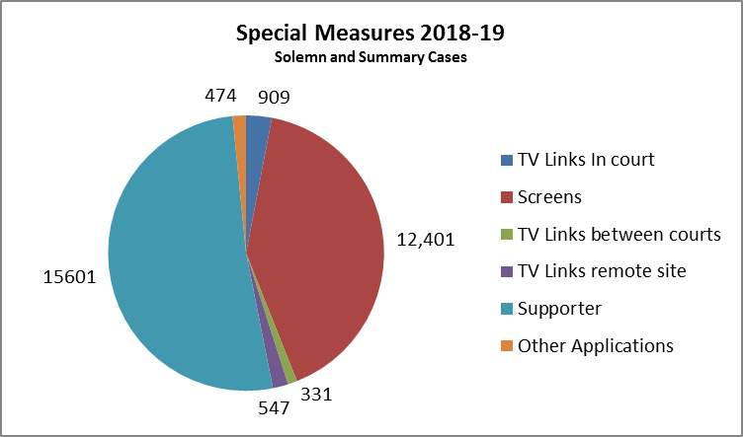
52% of special measures sought in 2018-19 involved the use of screens in court

INDIVIDUAL STANDARDS

“If you are a witness, we will update you on the progress of the court case at least once per hour and advise you when you can leave the court.”

What we have done
Where circumstances permit, updates are given to witnesses on at least an hourly basis.

Court officers, and macers in the High Court, work together with the prosecutor in court in order to convey information to the witness rooms on an hourly basis so that witnesses are kept informed of progress. This will include advising when witnesses are free to leave, when the case is adjourned or otherwise finished for the day. In some locations Witness Service volunteers also assist by relaying information.

Where it is not possible to provide detailed updates, visits to the witness rooms still take place and afford an opportunity for questions and, where necessary, the provision of support for those in need. There may be occasions when the court officer, or macer, is involved in court assisting in the presentation of evidence, in which case updates will be provided as soon as possible thereafter.

In some courts information in relation to the location and progress of cases is also relayed to waiting areas by way of wall mounted display screens.

What we will do
While there can be no substitute for the above personal engagement, there is more we can do in advance to manage the expectations of those due to attend court. We will undertake a review of the information located in the Coming to Court section of the SCTS website, adding a Frequently Asked Questions (FAQs) section to highlight processes and emphasise that there may be need to wait for a period on the day prior to cases calling for trial. This will help witnesses better prepare for their visit.

“We will provide separate waiting rooms for prosecution and defence witnesses, and access to refreshments.”

What we have done
Separate waiting areas and witness rooms are provided in court buildings for prosecution witnesses and defence witnesses.  This minimises the risk of confrontation or intimidation in the court building by other persons involved in the court proceedings. Court officers and staff at reception points direct witnesses to the appropriate waiting areas and rooms while they await the commencement of the relevant court cases. | 

Court officers visit the witness rooms on an hourly basis for the purposes of providing an information update. This is an opportunity for witnesses to raise any concerns they may have regarding any threat of intimidation or adverse contact with other persons while they have been waiting.

In many locations there will remain the possibility that witnesses and accused persons may encounter each other, for example, when entering or leaving the building or when using other public services such as catering or restaurant facilities during the lunch break.

While some larger court buildings have dedicated public restaurant facilities, refreshments at other court venues may only be available in the mornings. Those services are often provided by local charitable organisations e.g. the WRVS. | 
Refreshments in other locations may be provided through access to vending machines and, as a bare minimum, there should be access to fresh drinking water. Additional signage has been provided in witness areas to ensure that those in attendance are aware of the particular facilities available, and their location, in that court building

What we will do
Every effort is made to make best use of available space within court buildings. In some instances however, due to the protected status of a building, there may be limitations as to the extent of alterations that might be made.

Future design briefs for new builds, such as the new Inverness Justice Centre, due to open in Spring 2020, seek to incorporate requirements for improved separate waiting areas for witnesses and access routes for those considered more vulnerable.


Artist’s impression of Inverness Justice Centre

The SCTS Court User Satisfaction Survey, conducted biennially, will take place during the summer of 2019. This affords court visitors an opportunity to rate the facilities in the court building and to provide valuable feedback on factors such as comfort, security and availability of refreshments.

“If you are entitled to give your evidence to court by live TV link, we will meet you on the day and explain the process for giving your evidence to court.”

What we have done
Members of SCTS staff are available on the day to show witnesses to the facilities, explain the proceedings and to answer any questions the witness may have.

Vulnerable witnesses may give evidence to court by way of a live TV link as an alternative to appearing within the courtroom itself. This may be done from a dedicated room elsewhere in the court building, from another court building or, on occasion, from another building. This may be a building which is not part of the SCTS estate. | 

It is essential that, when attending, witnesses are aware of how the TV link will operate, how it will look and how to act during the proceedings. A familiarisation visit can be arranged in advance so that the witness may obtain an impression of the surroundings and the TV view. When attending on the day to give evidence many witnesses will be accompanied by a supporter, most often a volunteer from the Witness Service of Victim Support Scotland. Trained members of SCTS staff will also be on site to manage the facilities at those remote sites, and also to assist the witnesses if required during their attendance there. They are available to answer any questions and to explain how the process will unfold when the witness is called upon to give evidence.

Further locations across the country are used on an ad hoc basis in order to minimise inconvenience and travel time for witnesses who live in more rural areas.

What we will do
SCTS will continue to work closely with Witness Service volunteers to ensure that witnesses are best prepared and able to give their best evidence.

On a wider front, a new evidence suite in Glasgow has been designed following workshops with both internal and third sector partners. This will provide specialist facilities including hearing rooms with the option of flexible layouts to deal with children and adults, “live link” rooms for evidence given by TV link to court, waiting rooms and support spaces. It will include a sensory room and break out spaces to assist welfare. The rooms will also accommodate evidence by commissioner hearings for children giving evidence in criminal trials. | 
“We will respond to requests received on behalf of witnesses, for court familiarisation visits, within 3 working days of receipt.”

What we have done
Requests for access to courtrooms and vulnerable witness facilities, for the purposes of familiarisation visits, are handled expeditiously and responded to within 3 working days.

SCTS works closely with the Victim Support Scotland Witness Service, the primary facilitator of court familiarisation visits, in order to afford witnesses the opportunity to attend at the court to view the facilities in advance, and to obtain information regarding the court process. This is intended to allay certain fears the witness may have, and to better prepare them for their attendance at a later date. Where requested, visits are also arranged for sites remote from the court building should measures be requested for evidence to be given from that site by live TV link.

The timing of the visit is key, and SCTS and VSS liaise in order to expedite the visit when facilities are available, and at a time suitable to the witness.

What we will do
The Sheriff Principal of Glasgow and Strathkelvin has given approval for a pilot to be conducted at Glasgow Sheriff Court and JP Court involving the use of film footage as an alternative to physically attending court for a familiarisation visit. The proposal is that a witness would be able to view images of relevant courtrooms, vulnerable witness rooms etc. in short video clips in the company of a Witness Service volunteer.

This will enable the “visits” to take place at a time and location more suitable to the witness and will reduce the number of advance court attendances.

Some initial filming has taken place and it is currently planned to commence the pilot during summer 2019.

“If you want to know what support is available to you when you arrive at court, we will direct you to the Witness Service or other support services which are present in the court building.”

What we have done
Trained members of SCTS staff are available on arrival, and in reception areas, and direct witnesses to available support services where this is requested, or some assistance is required.

Court officers, macers and reception staff, the key point of contact for victims and witnesses in the court building, have received training which enables them to identify early signs of distress, and are able to direct those who may benefit from some support to the available services within the building.

What we will do
Reception staff, court officers and macers will continue to monitor witnesses on their arrival at court, and during the period they are required to wait. Where it is considered some support might be required, this will be sought from appropriate services available within the court building, or by way of support contact numbers.

Court officers attending witness waiting areas during the course of the day, to provide hourly updates, will also ensure that those who are in need of some help are able to make contact with relevant persons.

Liaison with support organisations
Throughout the year SCTS works closely with support organisations, at both local and national level, in order to continually improve services available to victims and witnesses in particular.

SCTS welcomes the engagement and support of the Victims Organisations Collaboration Forum Scotland (VOCFS) where member groups are invited to provide feedback on behalf of their clients, and in particular on behalf of those who might not have been afforded the opportunity of participating in the SCTS Court User Satisfaction Surveys. Meetings are also held with support organisations during the course of the year to discuss developments and any emerging issues.

Access to information
Section 6 of the Victims and Witnesses (Scotland) Act 2014 sets out clearly how specific participants in the criminal justice process may obtain further information relating to the case in which they have been involved. In support of the legislative requirements a joint protocol has been agreed by Police Scotland, COPFS and SCTS to aid applicants who wish to make a request, and setting out forms and procedures where these may be required.

Victims Code
The Victims' Code for Scotland clearly and simply sets out the rights of victims in one place. By ensuring victims' interests remain at the heart of our criminal justice system, victims should feel supported and informed at every stage of the process

STANDARDS OF SERVICE FOR VICTIMS AND WITNESSES 2019-20
SCTS does not intend to amend or modify the current standards of service at this time and will continue to monitor their effectiveness, working to make improvements if and when they are required, to ensure that the Standards of Service continue to meet the needs of victims and witnesses during their attendance at court.

Scottish Prison Service

Standards
- For those who have joined the Victim Notification Scheme (VNS), information that you are entitled to receive under section 16(3) of the Criminal Justice (Scotland) Act 2003 will be provided to you by the Scottish Prison Service (SPS) within two working days;
This consists of the following:
• The date of the prisoner’s release (other than being granted temporary release);
• If the prisoner dies, his date of death;
• If the prisoner has been transferred out of our custody;
• That the prisoner is, for the first time, entitled to be considered for temporary release;
• That the prisoner is unlawfully at large; or
• That the prisoner who was released or was unlawfully at large has been returned to custody.
- If you write to SPS about any matter concerning the Victim Notification Scheme, they will respond within 5 working days;
- Where a telephone enquiry cannot be answered by SPS at the time, they will call you back within one working day;
- For those of you who have joined the Victim Notification Scheme, and have expressed a desire to make representations in relation to licence conditions under section 17 of the Criminal Justice (Scotland) Act 2003, SPS will write to you no less than two weeks before any decision will be taken for release:
• On Home Detention Curfew;
• On the first occasion that the prisoner is considered for temporary release; or
• By the Parole Board for Scotland.
- For those victims of offenders sentenced to less than 18 months, they will notify you of the date of release or escape of the offender within 2 working days of confirmation that you are an eligible victim. They will do this either in writing or by telephone where you have provided a current contact number.

Report
General
The Scottish Prison Service (SPS) is an Agency of the Scottish Government and was established in April 1993. There are 13 publicly managed prisons and two privately managed prisons (HMP Kilmarnock and HMP Addiewell) and a provider of Court Custody and Prisoner Escorting Services.

How the scheme works
The operation of the scheme largely relies on a system of alerts. Our database records information about an offender. When this information changes at the prison, an alert is generated which must be interrogated. Once interrogated a decision is reached on whether there is a requirement to provide the victim with information. Whilst this brings efficiencies in monitoring around 2000 offenders, it requires those operating the scheme to have sufficient knowledge of the scheme and the potential changes that arise for offenders in the course of serving a sentence of imprisonment. It is therefore somewhat complex. The number of alerts is as expected significant and the graph below illustrates that number.

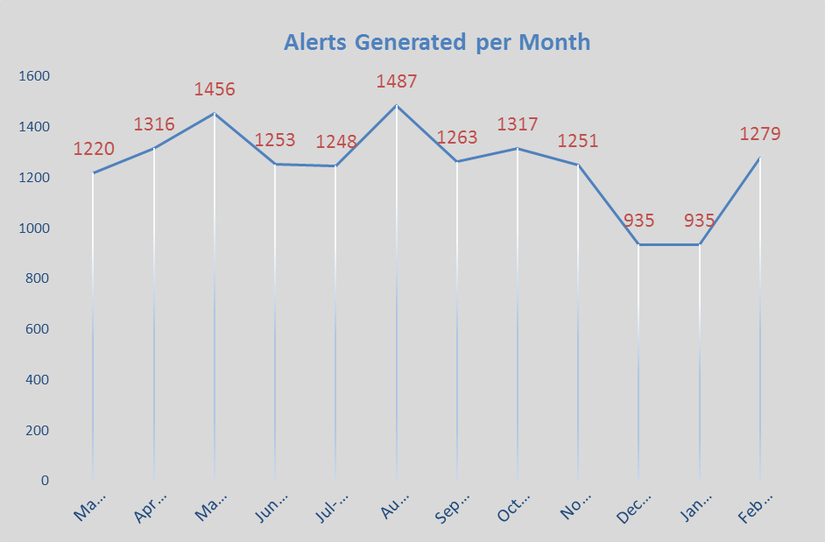

The unexpected loss of the two key staff to promotion in the latter half of the year 2017-18 impacted on our performance in the key area of issuing letters within 48 hours. As a small team the loss of one key member can be managed however the loss of two presented a greater challenge and SPS is grateful to those staff who have sought to continue to deliver the Standards of Service we have set ourselves. New members of the team were in place by the start of the new financial year and it is in the month of April where the greatest impact arose as a result of new staff “getting to grips” with the operation of the scheme.

Collaborative Working
The SPS is committed to putting victims at the heart of the justice system and collaborates at all levels to achieve this. The Chief Executive of the SPS is a member of the Victims Taskforce which has been established by the Cabinet Secretary for Justice.

The SPS also collaborates with the Scottish Government on policy development and with Victims Organisations Collaborative Forum (Victim’s Forum). Going forward we, along with the other justice agencies, are committed to greater engagement with the Victims Forum. We look forward to the opportunities that this will bring to better understand the needs of victims and how we might better deliver on those needs.

Victim Support Scotland and SPS have been working collaboratively to plan and consider how we best support those victims who choose to make representations in person or orally in relation to a decision on temporary release. A Victim Awareness Session was delivered by Victim Support Scotland on 5 March 2019 to key staff who will be involved in meeting victims who wish to make representations in person. We are committed to meeting together in the forthcoming year to consider how we might improve victims’ experience of the Victim Notification Scheme.

Not all changes arise from collaborative working. In light of the experience of and feedback from a particular victim, the SPS intends to amend a Direction to the Prisons and Young Offenders Institutions (Scotland) Rules 2011 to allow Governors to better control the photographs that prisoners are able to have in their possession.

Common Standards of Service
There are a number of common standards of service for the agencies and these are set out earlier in the document.

Complaints
The Scottish Prison Service received one complaint. The complaint was acknowledged within 3 working days and a response was provided within 15 working days. The complaint concerned an alleged failure to provide information. Whilst the complaint was not upheld there was learning from the case and SPS has included a new Standard of Service in response to the learning.

Request for Information in alternative format/language
There were no requests for information in an alternative format/language in the period. This is a reduction from seven in the previous year.

SPS STANDARDS OF SERVICE

Context
The SPS is legally required to deliver custodial and rehabilitation services for those sent to it by the courts. It achieves this by ensuring delivery of secure custody, safe and ordered prisons, decent standards of care and opportunities for prisoners to develop in a way that help them reintegrate into the community on release. This includes unescorted access to the community which many victims find difficult for understandable reasons. The SPS is acutely aware of this difficulty and we will continue to ensure that victims’ views are taken into account when making such decisions.

The table below shows the number of victims currently registered at 1 March 2019 compared with the previous three years:

Year | Total | Life Sentence  (inc. Order of Lifelong Restriction) | Long Term Sentence  (4 years or more) | Short Term Sentence  (less than 4 years)
March 19 | 2563 (+6.3%) | 919 (+6%) | 1256 (+7.4%) | 388 (+3.4%)
March 18 | 2411 (+6.7%) | 867 (+6%) | 1169 (+6.8%) | 375 (+8%)
March 17 | 2259(-1%) | 818 (+4%) | 1094 (-6%) | 347 (-6%)
March 16 | 2283 | 786 | 1124 | 371

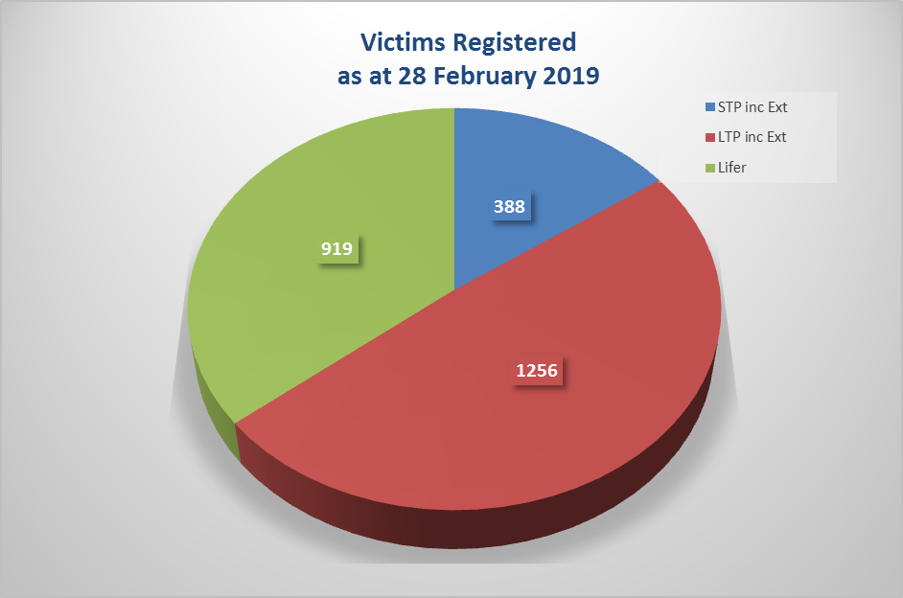
Applications to join the scheme
There were 443 (395 in 2017-18 and 350 in 2016-17) applications to join the scheme received in the year. It is considered that this continues to represent less than the number of applications issued. Victims may choose to join the Victim Notification Scheme at any time and some join some time after the offender has been sentenced however it is clear that not all victims seek information.

Year to | Total
March 19 | 443 (+12.1%)
March 18 | 395 (+12.8%)
March 17 | 350

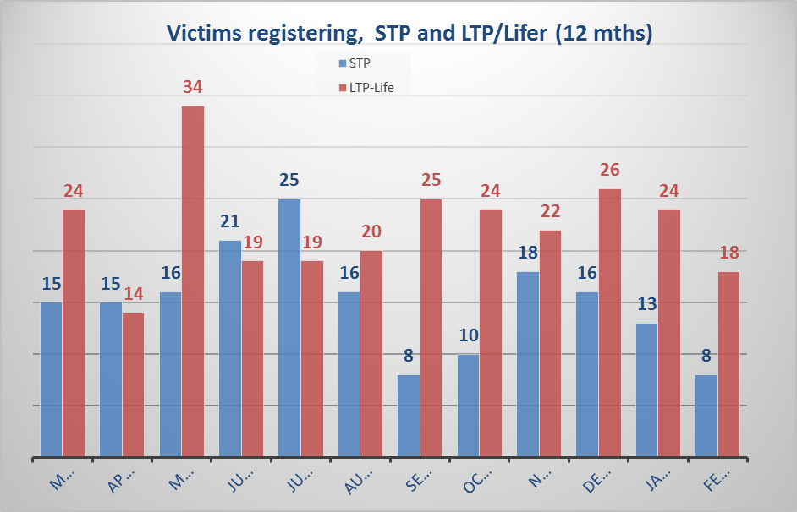

Written Enquiries
We recorded that 7 written enquiries were received and all were issued with a response within 5 working days of receipt.

Provision of Information
The table below shows the number of letters containing information sent to victims at 1 March 2019 compared with the previous two years:

Year to | Total | No. not issued within 48 hrs
March 19 | 2499 (+9%) | 25
March 18 | 2294 (+24%) | 2
March 17 | 1843 (+31%) | 6
March 16 | 1400 | -
We recorded that 2499 letters were issued to victims providing information. Twenty-five letters were not issued within 48 hours of the circumstance in which the right to receive information arose. This arose as a result of the loss and replacement of key staff and a reporting error in the database in September. This error was identified and remedial action taken. Further assurance checks were put in place and the error has not occurred since.

We continue to see letters sent to victims returned uncollected. We make a further attempt to provide the victim with the information in writing and if returned again, we will contact the individual by other means if we have them. It is not clear why these letters are returned. This may be because the registered victim has moved address, no longer wishes to receive information, or the attempts to deliver the information have failed.

In the reporting year we changed how we stored such information to allow for quick reference should victims re-establish contact with us. Going forward we will report on how many victims we have not been able to contact as a percentage of the victims eligible to receive information. At 1 March 2019 there were 125 victims with whom we are unable to contact. This represents around 5% of the victims registered. The table below shows the number of letters returned in the previous three years:

Year | Total
March 18 | 98
March 17 | 89
March 16 | 76

Representations
A total of 717 letters were issued to victims who had expressed a desire to make representations about the release, including temporary release or release on home detention curfew (HDC), of an offender. All were issued within 10 days of the key date and allowed all victims to make representations before the date that decision was to be taken. This is a key achievement given the significant increase in the number of occasions that victims have sought to make representations.

Year | Total
March 19 | 717 (+251%)
March 18 | 285 (+452%)
March 17 | 63

Telephone Enquiries
There were 674 enquiries received by telephone in the year to 1 March 2019. All enquiries were responded to within one day with the majority able to be dealt with at the time of the call. A number of enquiries (45) were received from victims of offenders sentenced to less than 18 months. The arrangements in place to provide victims of offenders sentenced to less than 18 months with information continue to work well.

Year | Total
March 19 | 674 (+29%)
March 18 | 520 (+94%)
March 17 | 268

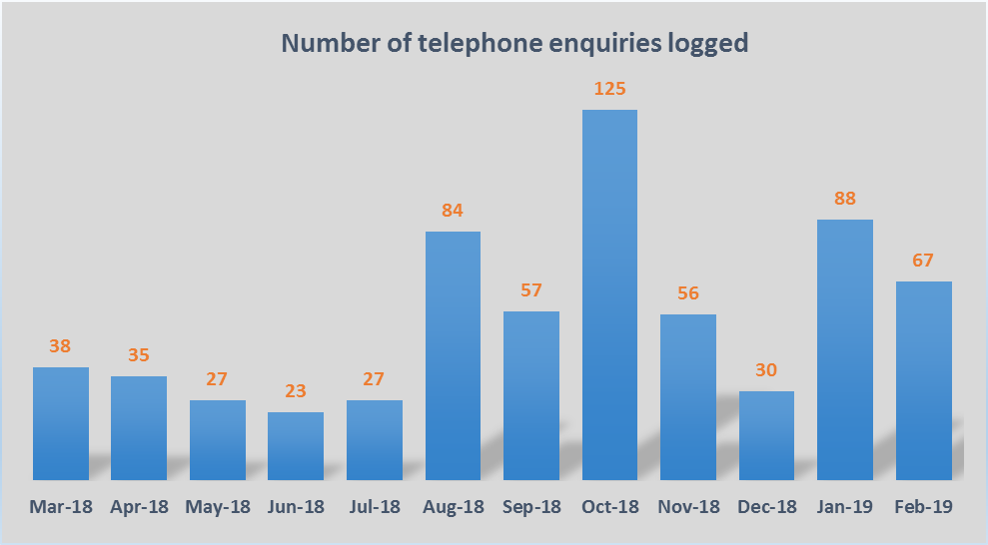

Modification of Standards of Service
There have been no changes to the Standards of Service in the year and changes are proposed to the Standards for the forthcoming year. We did not review our Standards of Service in light of the proposed changes. We have engaged with Victim Support Scotland who have agreed to jointly review our Standards in the forthcoming year.

STANDARDS OF SERVICE FOR VICTIMS AND WITNESSES 2019-20

Our Standards of Service and Text for 2019-20 will be as follows:

- For those who have joined the Victim Notification Scheme (VNS), information that you are entitled to receive under section 16(3) of the Criminal Justice (Scotland) Act 2003 will be provided to you by the Scottish Prison Service (SPS) within two working days.
This consists of the following:
- The date of the prisoner’s release (other than being granted temporary release);
- If the prisoner dies, his date of death;
- If the prisoner has been transferred out of our custody;
- That the prisoner is, for the first time, entitled to be considered for temporary release;
- That the prisoner is unlawfully at large; or
- That the prisoner who was released or was unlawfully at large has been returned to custody.

- If you write to SPS about any matter concerning the Victim Notification Scheme, they will respond within 5 working days.

- Where a telephone enquiry cannot be answered by SPS at the time, they will call you back within one working day.

- For those victims of offenders sentenced to less than 18 months, they will notify you of the date of release or escape of the offender within 2 working days of confirmation that you are an eligible victim. They will do this either in writing or by telephone where you have provided a current contact number.

- For those of you who have joined the Victim Notification Scheme, and have expressed a desire to make representations in relation to licence conditions under section 17 of the Criminal Justice (Scotland) Act 2003, SPS will write to you to seek your representations no less than two weeks before any decision will be taken on release:

- On Home Detention Curfew;
- On temporary release (but only on the first occasion that the prisoner is considered); or
- By the Parole Board for Scotland.

New Standard of Service
- For those victims of life sentenced offenders who have joined the Victim Notification Scheme, and have expressed a desire to make representations in relation to licence conditions under section 17 of the Criminal Justice (Scotland) Act 2003, SPS will provide you with an opportunity to make representations in person, orally or in writing before any decision is taken on the first occasion that the prisoner is considered for temporary release.

Parole Board for Scotland

Standards

- If you are registered for part 2 of the Victim Notification Scheme, we will take account of your representations alongside other relevant information when deciding whether to approve release. Victim Support Scotland may be able to help you prepare your representations (contact number 0345 603 9213);
- If you are registered for part 2 of the Victim Notification Scheme, we will tell you when the Parole Board has made its decision. You will be offered the option of being told by telephone and, if release is granted, we will tell you about any licence conditions that are relevant to you. If you prefer to receive a letter, we will send this by 1st class post within 1 day of the Parole Board’s decision;
- If you are registered for part 2 of the Victim Notification Scheme, we will give you the opportunity, where the prisoner has been given a life sentence, of making your representations in person to a member of the Parole Board (the Parole Board member will not be part of the Tribunal considering the prisoner’s case). Please note that the meeting with the member of the Parole Board will normally take place between 12 and 8 weeks before the date set for the Tribunal and will not normally be at your home. The meeting will be at a time that is suitable for you;
- We will answer your letters, emails or telephone calls promptly. We will answer your letters or emails within 5 working days. If we are not able to fully answer your telephone enquiry at the time of your call, we will arrange to call you back; and
- We will normally contact you by letter clearly stating why we are contacting you and, if there is any action that we need you to take, we will set that out clearly. If we need to contact you by telephone, we will check that it is convenient for you to discuss the matter and we will explain why we are contacting you and, if there is any action that we need you to take, we will tell you what that is and why it is required.

Report
General
In some criminal cases, victims have a right to receive information about the release of an offender. They may also have a right to be told when the offender is being considered for release and to make written representations about the release of the offender.

The process that allows victims to be told about an offender's release and to make representations is known as the Victim Notification Scheme, or VNS.

The VNS is in two parts, the first part allows victims to receive information about an offender's release. The second part allows victims to make representations to the Parole Board in advance of an offender being considered for release. The Board will consider these representations along with other information on the offender's case before reaching a decision. Representations are fully considered by the Board as part of its overall decision making process. If the Board does decide to release, then representations may assist in deciding the licence conditions that will be imposed.

The Board continues to develop its approach to receiving oral representations based on experience and feedback from victims. This includes victim preferences for meeting location and gender of the Board member. Feedback from victims continues to be positive. The format of the interview statement has been kept under constant review by Board members to ensure consistency.

The following provides information on what the Board has achieved in relation to the Standards of Service during May 2018 – April 2019.

What we have done
We have continued to update our processes to ensure that VNS part 2 letters are issued in accordance with the Standards of Service. If requested, we will also phone with the Parole Board’s decision and this service has been requested on a number of occasions by victims. The Board will also communicate with a victim by email if they have stated that they are happy to do so. Parole Scotland will always confirm, with the victim, that the email address is correct before any information is issued.

Since 1 April 2018, we have met with 18 victims of life sentence prisoners to receive representations with the majority of these meetings having taken place in Victim Support Scotland (VSS) offices.

Following implementation of the Victim and Witnesses (Scotland) Act 2014, the Board has met a total of 50 victims of life sentence prisoners and held 84 face to face meetings and 5 by telephone. Apart from making meeting arrangements based on the victims’ needs, it is also responsible for preparing a draft victim statement following the meeting and agreeing it with the victim before it is put in the prisoner’s dossier.

We have reviewed our methods of communication to ensure that they are fit for purpose and sought advice from VSS on all letters that we use under VNS.
We have enhanced our Casework Management System to improve our management information and processes on victim service delivery. For instance, the system can now search on Victim Notification Scheme number and victim name which means that the victim does not have to say the prisoner’s name.

As part of induction, new Board members are fully trained on specific victim training. All 40 members have now been trained which allows greater flexibility for scheduling victim interviews. All support staff have also been trained.

Victim service delivery was included in the Parole Board’s Corporate Plan for 2018-2021.

What we will do
The Board supports the principle of victims having a greater voice in the parole process and will fully engage with outcomes of the Scottish Government’s Consultation on Transforming Parole in Scotland.

The Board is considering whether to introduce a ‘publication minute’ which supports the principle that victims and their families should receive information on the reasons for the Board’s decision.

We will improve our Victim and Families section on our new website ensuring that they have all information they may need including dedicated FAQs and useful links.

Changes to our Casework Management System will be made so that VNS activities can be reported quarterly to the Board’s Management Group. We will also explore whether other changes can be made to our Casework Management System to enhance our service delivery to victims such as introducing a workflow for the victim interview process.

We will continue to develop our approach to receiving oral representations based on experience and feedback from victims and VSS. We will look at introducing a more formal feedback mechanism for victims to support future service delivery.

Victim Service Delivery will be an important part of the Board’s Business Plan for 2019-2020.

In conjunction with the Scottish Prison Service, we will bid for funding from the Scottish Government to introduce a Victim Notification Scheme Information Portal. If successful, SPS and PBS will engage with VSS and victims in the design of the portal.

We will continually look for opportunities to build on specific victim training for both members and staff.

We will ensure that Board members guidance is continuously updated in relation to victim engagement.

We will revisit the process for victims being offered a telephone call with the Board’s decision.

We will explore the process for victims who are not VNS registered to see what information can be given out following enquiry (e.g. by phone call, by email) to the Board about a specific prisoner case.

We will ensure that all our VNS letters are continually reviewed and take on board any changes from VSS and victims.

STANDARDS OF SERVICE FOR VICTIMS AND WITNESSES 2019-20

We have reviewed our standards and amended our second standard which will now read:

If you are registered for part 2 of the Victim Notification Scheme, we will tell you when the Parole Board has made its decision. You will be offered the option of being told by telephone and, if release is granted, we will tell you about any licence conditions that are relevant to you. If release is not granted, you will be told the review period. If you prefer to receive a letter, we will send this by 1st class post within 1 day of the Parole Board’s decision.

We have included a new standard as follows:

We will carefully consider representations submitted by victims, including whether any information contained in them should be withheld from the prisoner under Rule 6 of the Parole Board (Scotland) Rules 2001, which states the grounds on which information may be withheld. Where the Board is of the view that any of these grounds are met, the information will be redacted from any documentation provided to the prisoner. The victim(s) will be advised of the information which has been redacted. Where appropriate, their views may be sought in advance of deciding whether information falls under Rule 6.

WHAT TO DO IF YOU ARE NOT HAPPY WITH OUR STANDARD OF SERVICE

How to complain

Police Scotland, the Crown Office and Procurator Fiscal Service, the Scottish Courts and Tribunals Service, the Scottish Prison Service and the Parole Board for Scotland are committed to delivering the highest standards of service to you. We know that sometimes things go wrong and we will try to put things right if that happens. If you are not happy with the service you have received from one of these organisations, it is important that you let them know.

If the matter cannot be resolved, you should be offered information about the relevant complaints procedure, so that you can raise your concerns formally. Your complaint will be taken seriously and will be dealt with quickly and effectively:you should be able to complain without fear of victimisation.

Details of where to make a complaint for each organisation are found below:

POLICE SCOTLAND
www.scotland.police.uk
• Complete our online complaint form;
• Write to
Professional Standards Department
Police Headquarters Scotland
P.O. Box 21184
Alloa, FK10 9DE;
• Dial 101 and make a report of your complaint over the telephone; or
• Attend at a police station in person.

CROWN OFFICE AND PROCURATOR FISCAL SERVICE
www.copfs.gov.uk/about-us/comments-complaints
You can email RIU@copfs.gov.uk or write to:
Response and Information Unit
Crown Office and Procurator Fiscal Service
25 Chambers Street
Edinburgh EH1 1LA
From a landline, you can phone 0300 020 3000
From a mobile, you can phone 01389 739 557
THE SCOTTISH COURTS AND TRIBUNALS SERVICE
www.scotcourtstribunals.gov.uk
Our complaints procedure sets out how we will investigate and deal with your complaint and the timescales involved. The complaints procedure can be accessed:
- by clicking the Complaints and Feedback link at the foot of the home page of the SCTS website (above), or
- by requesting a copy from your local court.

SCOTTISH PRISON SERVICE
www.sps.gov.uk
- In person to the VNS Department at the SPS;
- By phone: 0131 330 3500;
- By writing to:
Victim Notification Scheme
Room G14
Calton House
Edinburgh EH12 9HW; or
- By email to vns@sps.pnn.gov.uk
Please make it clear that you want the matter to be treated as a complaint. It will help us if you give as much background information as you can, for example why you are dissatisfied and your VNS reference number.

THE PAROLE BOARD FOR SCOTLAND
www.scottishparoleboard.gov.uk
You can either write to the Chief Executive at the address on our letter or telephone on the phone number on our letter. We will acknowledge your complaint within 3 working days and will normally discuss the matter with you before writing to you within 20 working days to let you know the outcome.

You can find out how to make a formal complaint here.

TAKING THE MATTER FURTHER

If you consider that Police Scotland, the Crown Office and Procurator Fiscal Service, the Scottish Courts and Tribunals Service, the Scottish Prison Service or the Parole Board for Scotland have not dealt with your complaint satisfactorily, you can ask the Scottish Public Services Ombudsman to adjudicate. You can contact them by telephoning 0800 377 7330 or at the following address:

Freepost SPSO (that is all that is required on the envelope)

WHO YOU CAN CONTACT FOR SUPPORT OR ADVICE
- You can find further support, advice and guidance for victims and witnesses here:
http://www.mygov.scot/victim-witness-support

This document has been prepared by Police Scotland, the Crown Office and Procurator Fiscal Service, the Scottish Courts and Tribunals Service, the Scottish Prison Service and the Parole Board for Scotland working in partnership.

© Crown copyright 2018
This publication is licensed under the terms of the Open Government Licence v3.0 except where otherwise stated. To view this licence, visit nationalarchives.gov.uk/doc/opengovernment-
licence/version/3 or write to the Information Policy Team, The National Archives, Kew, London TW9 4DU, or email: psi@nationalarchives.gsi.gov.uk.
Where we have identified any third party copyright information you will need to obtain permission from the copyright holders concerned.

