

Customer Charter

Office of the Accountant of Court
Hadrian House Callendar Business Park Callendar Road Falkirk FK1 1XR

www.scotcourts.gov.uk/the-courts/more/the-accountant-of-court
 https://twitter.com/AccountofCourt

Who we are
The Office of the Accountant of Court (AoC) is part of the Scottish Court & Tribunal Service (SCTS) and deal specifically with:
(1) Section 9 of the Children (Scotland) Act 1995;
(2) Court of Session Consignations (Scotland) Act 1895;
(3) Judicial Factors Act 1849; and
(4) Proceeds of Crime Act 2002;
We want to minimise any inconvenience and reduce anxiety to our customers by setting out in this document the quality and standards of service that customers can expect and our commitment to you. It will also give us feedback on how we handle complaints. You should feel confident that we will listen to you, provide you with accurate and relevant information and treat you with courtesy and consideration at all times. We can give general information and advice about the procedures in connection with the various Acts but we cannot give customers legal advice.

About us
Our main functions are:
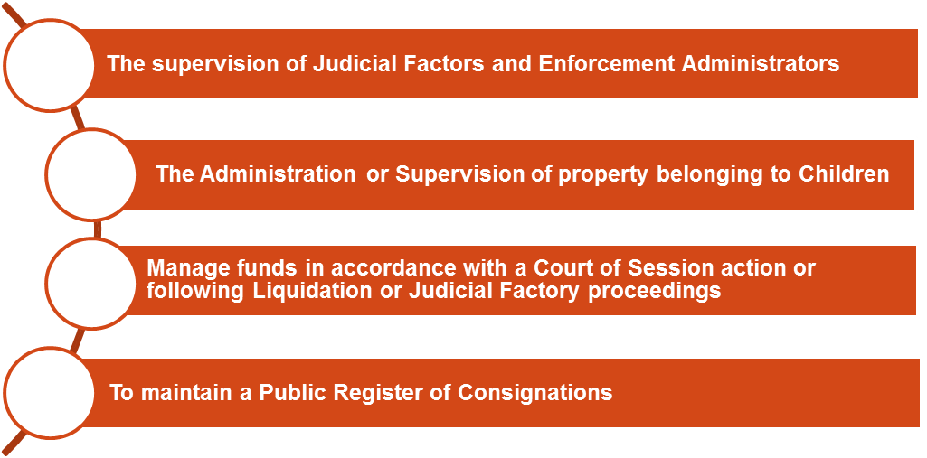

Values
The way we deliver our services is led by our values, which are:

- respect
- service, and
- excellence

We aim to treat everyone fairly irrespective of age, disability, gender reassignment, marriage, civil partnership, pregnancy and maternity, race, religion or belief, sex or sexual orientation. Further information is available in the ‘STCS Equality Statement and Outcomes’ document available on the SCTS website.

We will be professional and responsive, helpful and courteous in all our dealings with our customers. If we are unable to meet the standards set down here we will do our best to keep you informed and explain what is happening.

What you can expect from us

Visiting us

We are usually open to the public from 9.00 a.m. to 5.00 p.m. Monday to Friday. In normal times we welcome members of the public however these are not normal times and we need to minimise the number of public visitors to our building.

When it is safe to receive visitors again, maps and directions can be provided if required to assist locating the office. Visitors travelling by car should note that car parking is limited; however road parking in the locality is usually possible.

In recognition that customers or staff may have allergies to, or be afraid of animals, pets are not allowed in the office. Exceptions will be made for assistance dogs.

Our staff will be polite, friendly and treat customers with respect. We will respect the privacy of customers.

Information about accessing our office building is available from our website.

Disabled access to the building is provided and induction loops are installed in meeting rooms and the reception area.

Once the building is open again to visitors, please contact us to discuss the arrangements we can make for you.

What can you expect from us

Phone calls   | - We aim to answer all telephone calls received between 9.00am and 5.00 pm. If the office is closed for public holidays or staff training, the answerphone message will confirm the date and time when the office will re-open for business.  - If we cannot deal with your enquiry immediately, we will call you back at a mutually agreed time.  - If you have hearing and speech difficulties and you have a text phone you can contact us using the Next Generation Text Service  - If you require the support of an interpreter when you contact us a telephone interpretation service is available. To access this service, ask for telephone interpreting and the language required.  - If you use British Sign Language (BSL) and wish to phone us using a sign language interpreter, you can use the online video relay interpreting service. For more information see www.contactscotland-bsl.org
Written correspondence     | - We will respond within 5 working days of receiving a general enquiry.  - We will respond in writing or by telephone within 5 working days of receiving a request to search the public register.  - When we receive a written notification involving a change in circumstance that requires a registered power of attorney to be retrieved retrieval from storage, we will return the document within 10 working days.  - We will explain things helpfully in plain English and avoid using technical and legal jargon.  - We will respond to you in a way that is suitable to your needs. Please tell us if you have a preference.  - We provide a mailbox outside the main entrance door if you wish to hand deliver documentation to us.
Information   | - We will provide individual copies of guidance leaflets covering a range of procedures relating to the Act. A variation of the standard format can be made available on request.  - We will provide guidance notes written in plain English

Individual requirements - should you have any other individual requirements not mentioned previously we will consider all reasonable requests and take all practical steps to meet them.

Freedom of Information

The Freedom of Information (Scotland) Act 2002 gives a general right of access to all types of recorded information held by public authorities. If you want to make a request under the Freedom of Information (Scotland) Act 2002 you should write to the Accountant of Court at the address provided.

Statistical information on case volumes can be viewed on our website here: http://www.scotcourts.gov.uk/the-courts/more/the-accountant-of-court

Listening to customers

We are committed to achieving standards set out in this document. We will measure the success of our standards through regular reviews, consulting those who have used our services and by working in partnership with other agencies which have a mutual interest in the above mentioned Acts.


Feedback

Many people are pleased with the high standard of service provided. We would like to hear from you if you have been dissatisfied with our service as this helps us to recognise what is valued and ensure we build upon this. You can also offer your compliments using the feedback form, comment cards in the office or contact us by telephone, by email or by post.

Complaints

We recognise that we will not get it right every time, despite our best efforts. When we get it wrong, we want you to tell us about it. All complaints will be taken seriously and dealt with impartially and in confidence.

Ordinarily, we operate a 2 stage complaints procedure. Our feedback form sets out how to make a complaint and how complaints will be dealt with. If we receive a complaint, we aim to reply within 5 working days. In some cases we need to investigate further. In these instances, we aim to reply within 20 working days. If we are unable to provide you a full reply within these timescales, we will explain why and provide you with a revised timescale for completion.
You can write, phone or send an email to us:


The Office of the Accountant of Court
Hadrian House
Callendar Business Park
Callendar Road
Falkirk FK1 1XR

DX 550360 Falkirk 3
Tel: 01324 678300

E-mail: accountantofcourt@scotcourts.gov.uk
Twitter: @AccountofCourt

