Appendix 1



Scottish Courts & Tribunals Service

Annual People Scorecard
2015/16

Produced by the Human Resources Unit
October 2016

Annual People Scorecard 2015/16
1st April 2015 to 31st March 2016

Index

Annual People Scorecard 2015/16 Dashboard 2
Headcount by Gender | Headcount by Area of Business
Staff by Age Band | Short Term Sick Absence by Grade
Voluntary Turnover by Grade | Average Learning Days
Instant Rewards by Grade | Overtime by Grade

Section 1: Workforce Profile 3
Headcount by Grade | Headcount by Area of Business
Headcount by Age Band | Headcount by Service by Grade

Section 2: Employee Resourcing 4
Absence Data by Grade | Absence Data by Sheriffdom/Unit
Non-Sick Absence | Lost Time Rate
Promotions by Grade | Promotions by Sheriffdom/Unit
Turnover/Applications by Grade | Turnover/Applications by Sheriffdom/Unit
Recruitment Appointments | Average Recruitment Cost
Average Recruitment Journey Length | Reasons for Applicants Applying for Posts
Applications Received (Ethnic Origin & Gender) | Applications Received (Disability) for Posts
Applications Received (Age Group)

Section 3: Employee Learning 9
Learning Data | Learning Days Profile
Cost Per Learning Day | L&D Investment as % of Organisational Paybill
Learning Days by Grade & Gender - Workshops | Disability and Ethnicity: Access to Learning

Section 4: Employee Reward 10
% Staff on Pay Range Target Rate at Sep 2015 | % Staff on Pay Range Target Rate by Sep 2016
Instant Rewards by Sheriffdom/Unit | Instant Rewards (Substitution) by Sheriffdom/Unit
Instant Rewards by Grade | Instant Rewards (Substitution) by Grade
Overtime by Sheriffdom/Unit | Overtime by Grade
Travel Time by Sheriffdom/Unit | Travel Time by Grade
Average Salary by Grade | Average Salary Cost
Allowances paid to Staff | Zero Hours Costs by Sheriffdom/Unit
Zero Hours Contracts by Grade | Total Staff Salary Costs

Section 5: Employee Relations 14
2015/16 Data

Section 6: Protected Characteristics 14
Ethnicity | Ethnic Group
Religion | Marital Status
Sexual Orientation

Section 7: HRU Consultancy and Outsourced Learning Delivery 15
HR Consultancy and Outsourced Learning Spend

Section 8: Data Trends 15
Key Data Trends Over the Last Five Years

Section 9: HR Performance Indicators 2015/16 15
Key Indicators of HR Performance

Annual People Scorecard 2015/16 – Dashboard

Headcount by Gender – Table 1.1  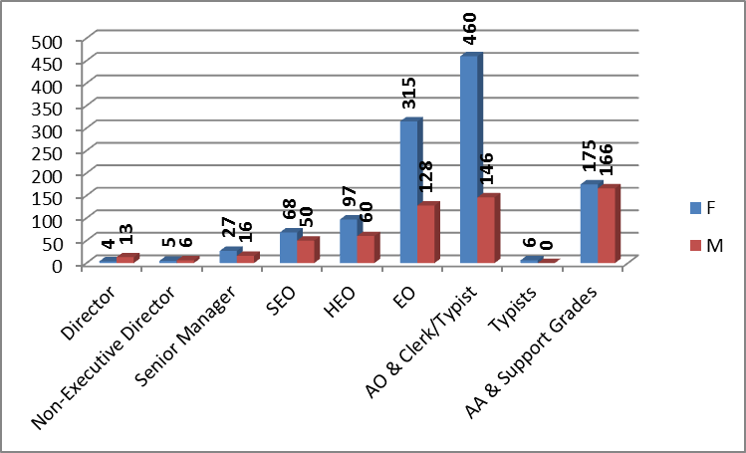 | Headcount by Area of Business – Table 1.2  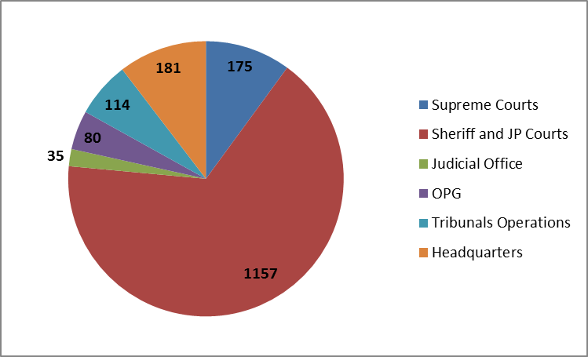
Staff by Age Band – Table 1.3  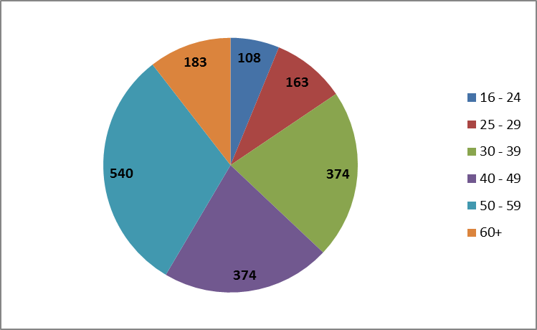 | Average ST Sick Absence Days by Grade – Table 2.1  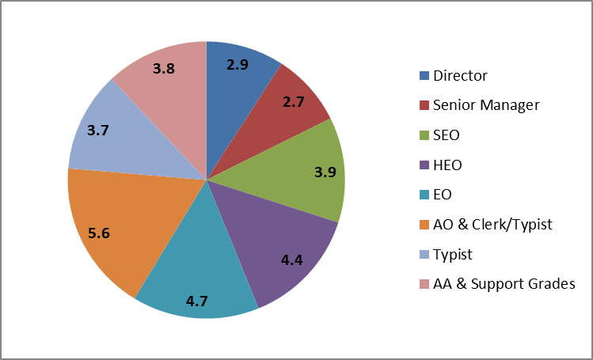
Voluntary Turnover by Grade – Table 2.7  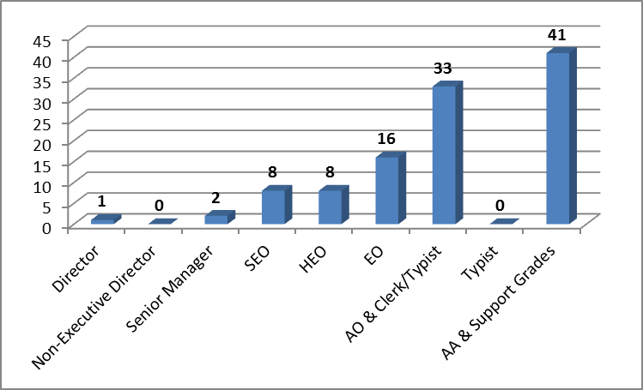 | Average Learning Days – Table 3.1  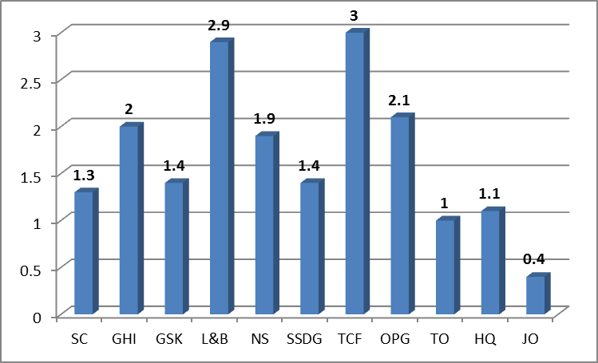
Instant Rewards by Grade – Table 4.5  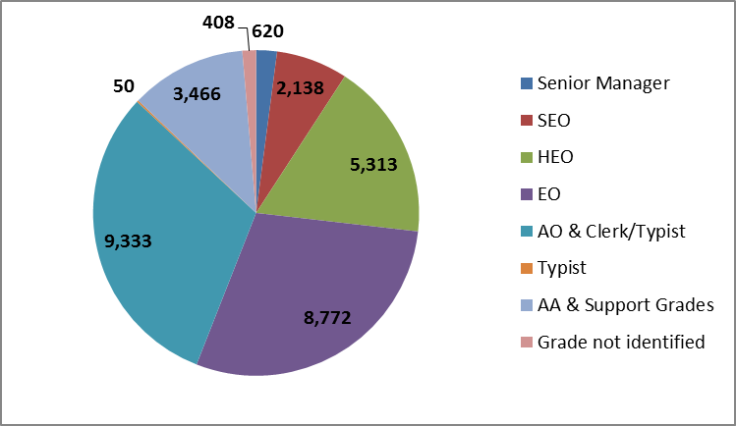 | Overtime by Grade – Table 4.8  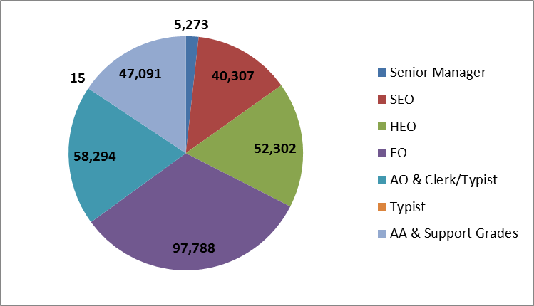

Annual People Scorecard 2015/16

Section 1: Workforce Profile
Please note, tables 1.1, 1.2, 1.3 and 1.4 in Section 1 include Casual/FT App Staff and Zero Hours Contract Staff

Table 1.1
Grade | Head count | F | M | Ethnicity  Other than white | Reported disability under DDA | Non FT as % FTE | Av  Age in Grade | Av  Length  Of Service | FTE People | FTE posts
Director | 17 | 4 | 13 | 0 | 1 | 5.9 | 52.9 | 18.5 | 16.9 | 18.8
Non-Executive Director | 11 | 5 | 6 | 0 | 0 | 100.0 | 55.9 | 2.2 | 0.0 | 2.0
Senior Manager | 43 | 27 | 16 | 0 | 0 | 4.7 | 47.0 | 15.9 | 42.6 | 45.6
SEO | 118 | 68 | 50 | 1 | 6 | 19.5 | 50.2 | 20.2 | 110.3 | 126.0
HEO | 157 | 97 | 60 | 1 | 7 | 12.7 | 44.9 | 20.5 | 151.4 | 160.9
EO | 443 | 315 | 128 | 7 | 22 | 22.0 | 42.5 | 16.9 | 403.9 | 427.4
AO & Clerk/Typist | 606 | 460 | 146 | 2 | 28 | 22.9 | 40.8 | 10.6 | 547.7 | 617.8
Typists | 6 | 6 | 0 | 0 | 0 | 50.0 | 56.0 | 30.5 | 4.8 | 5.8
AA & Support Grades | 341 | 175 | 166 | 2 | 9 | 35.6 | 50.1 | 6.8 | 262.6 | 284.8
¹Total | 1,742 | 1,157 | 585 | 13 | 73 | 24.0 | 49.0 | 15.5 | 1,540.1 | 1,689.0
Percentages of total |  | 66.4% | 33.6% | 0.7% | 4.2%
¹ For Tables 1, 2, 3 and 4; includes staff on Zero Hours contracts (not all have been utilised in 2015/16).

Table 1.2
Area of Business | Headcount | Number of staff (FTE) | Percentage
Supreme Courts | 175 | 158.4 | 10.0%
Sheriff and JP Courts | 1157 | 1003.2 | 66.4%
Office of the Public Guardian | 80 | 73.7 | 4.6%
Tribunals Operations | 114 | 110.5 | 6.5%
²Headquarters | 181 | 160.6 | 10.4%
Judicial Office | 35 | 33.6 | 2.0%
¹Total | 1,742 | 1,540.1 | 100.0%
² Includes Non-Executive Directors, senior operational managers and operational staff working on corporate projects.

Table 1.3
Staff by Age Band | Headcount | Percentage
16 - 24 years old | 108 | 6.2%
25 - 29 years old | 163 | 9.4%
30 - 39 years old | 374 | 21.5%
40 - 49 years old | 374 | 21.5%
50 - 59 years old | 540 | 31.0%
60+ years old | 183 | 10.5%
¹Total | 1,742 | 100.0%

Table 1.4
Length of Service by Grade of Current Post
Grade | < 1 year | 1-4 years | 5-9 years | 10-19 years | 20+ years
Director | 1 | 4 | 3 | 2 | 7
Non Exec Director | 3 | 7 | 1 | 0 | 0
Senior Manager | 7 | 5 | 9 | 5 | 17
SEO | 4 | 7 | 30 | 20 | 58
HEO | 1 | 9 | 30 | 49 | 68
EO | 6 | 43 | 104 | 143 | 146
AO & Clerk/Typist | 70 | 169 | 125 | 129 | 113
Typists | 0 | 0 | 0 | 0 | 6
AA & Support Grades | 72 | 101 | 72 | 73 | 23
¹Total (Headcount) | 164 | 345 | 374 | 421 | 438
Percentages | 9.4% | 19.8% | 21.5% | 24.2% | 25.1%
Section 2: Employee Resourcing
Please note, all absence figures are reported in calendar days as opposed to working days.

Table 2.1
Sick Absence by Grade
Grade | Average days lost through short term sick absence | Average days lost through long term sick absence | Average days lost through all sick absence
Director | 2.9 | 14.3 | 17.2
Non-Executive Director | 0.0 | 0.0 | 0.0
Senior Manager | 2.7 | 2.1 | 4.9
SEO | 3.9 | 12.1 | 16.0
HEO | 4.4 | 5.6 | 10.0
EO | 4.7 | 8.5 | 13.2
AO & Clerk/Typist | 5.6 | 8.8 | 14.4
Typists | 3.7 | 28.3 | 32.0
AA & Support Grades | 3.8 | 5.5 | 9.4
Overall Average | 4.7 | 7.9 | 12.6

Table 2.2
Sick Absence by Sheriffdom/Unit
Sheriffdom/Unit | Average days lost through short term sick absence | Average days lost through long term sick absence | Average days lost through all sick absence
Supreme Courts | 4.0 | 6.1 | 10.2
Grampian, Highland & Islands | 4.3 | 7.3 | 11.5
Glasgow & Strathkelvin | 6.0 | 10.5 | 16.4
Lothian & Borders | 5.5 | 8.4 | 13.9
North Strathclyde | 4.6 | 7.5 | 12.2
South Strathclyde, Dumfries & Galloway | 4.5 | 9.0 | 13.4
Tayside, Central and Fife | 4.9 | 9.4 | 14.2
Office of the Public Guardian | 5.4 | 4.3 | 9.7
Tribunals Operations | 3.4 | 8.3 | 11.7
Headquarters | 4.0 | 6.7 | 10.7
Judicial Office | 4.4 | 3.9 | 8.3
Overall Average | 4.7 | 7.9 | 12.6

Table 2.3
Non-Sick Absence |  | Average Days Lost - All Sick Absence by Grade
Absence Reasons | Days | 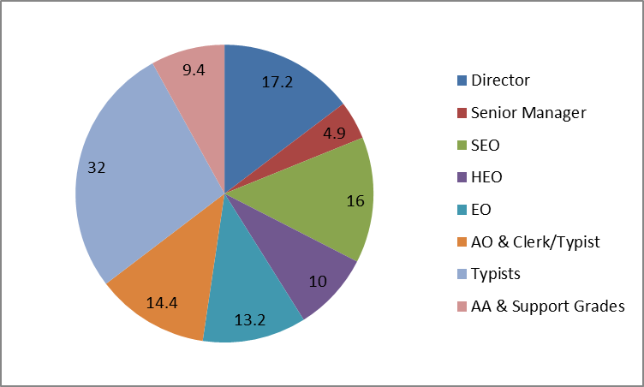
Caring Responsibilities | 580
Bereavement | 523
Compassionate Care Leave | 314
Emergency Family Leave | 226
Miscellaneous Special Leave | 160
Unpaid Leave | 126
Facility Time | 105
Study/Examination Leave | 70
Parental Leave | 67
Domestic | 30
Hospital Appointment | 23
Other Reasons | 47
Total | 2,271

Table 2.4
Lost Time Rate³ | Short Term | Long Term | All Absence
SCTS | 1.4% | 2.5% | 3.9%
³ Based on ((Absence Days/Calendar Days) x Working Days)/(FTE x Working Days) (Calendar Days = 365 days, Working Days =225 days).

Table 2.5
Permanent internal promotions by grade promoted to.
Promotions by Grade
Grade | Total | Female | Male
Director | 0 | 0 | 0
Non-Executive Director | 0 | 0 | 0
Senior Manager | 3 | 1 | 2
SEO | 5 | 4 | 1
HEO | 15 | 11 | 4
EO | 59 | 48 | 11
AO & Clerk/Typist | 38 | 23 | 15
Typists | 0 | 0 | 0
AA and Support Grades | 1 | 1 | 0
Total (Headcount) | 121 | 88 | 33

Table 2.6
Permanent internal promotions by Sheriffdom/Unit promoted to.
Promotions by Sheriffdom/Unit
Sheriffdom/Unit | Total | Female | Male
Supreme Courts | 16 | 10 | 6
Grampian, Highland & Islands | 4 | 4 | 0
Glasgow & Strathkelvin | 24 | 19 | 5
Lothian & Borders | 15 | 8 | 7
North Strathclyde | 7 | 5 | 2
South Strathclyde, Dumfries & Galloway | 10 | 9 | 1
Tayside, Central and Fife | 10 | 8 | 2
Office of the Public Guardian | 8 | 8 | 0
Tribunals Operations | 15 | 8 | 7
Headquarters | 10 | 9 | 1
Judicial Office | 2 | 0 | 2
Overall Average | 121 | 88 | 33

Table 2.7
Please note, the figure in Table 2.7 will differ from the applications received figure in Table 2.8 as Table 2.7 is looking at average applications as opposed to total numbers.
Turnover and Application Rates by Grade
Grade | Voluntary  Turnover in year |  | Non- Voluntary  Turnover  in year |  | Total Turnover  In year |  | Average number of applications  received for jobs advertised in year
Grade | No. | % | No. | % | No. | % | Internal | External
Director | 1 | 5.9 | 1 | 5.9 | 2 | 11.8 | 0.0 | 0.0
⁴Non-Executive Director | 0 | 0.0 | 2 | 18.2 | 2 | 18.2 | 0.0 | 0.0
Senior Manager | 2 | 4.7 | 1 | 2.3 | 3 | 7.0 | 4.5 | 26.0
SEO | 8 | 6.8 | 2 | 1.7 | 10 | 8.5 | 3.3 | 4.0
HEO | 8 | 5.1 | 3 | 1.9 | 11 | 7.0 | 3.5 | 5.3
EO | 16 | 3.6 | 8 | 1.8 | 24 | 5.4 | 5.0 | 1.0
AO & Clerk/Typist | 33 | 5.4 | 13 | 2.1 | 46 | 7.6 | 3.6 | 39.4
Typists | 0 | 0.0 | 0 | 0.0 | 0 | 0.0 | 0.0 | 0.0
AA & Support Grades | 41 | 12.0 | 10 | 2.9 | 51 | 15.0 | 1.4 | 78.3
Total | 109 | 6.3 | 40 | 2.3 | 149 | 8.6 | 3.8 | 49.9
⁴ Non-Executive Director campaigns are not run through EROL therefore data is not available regarding application numbers.

Total Turnover in Year by Grade
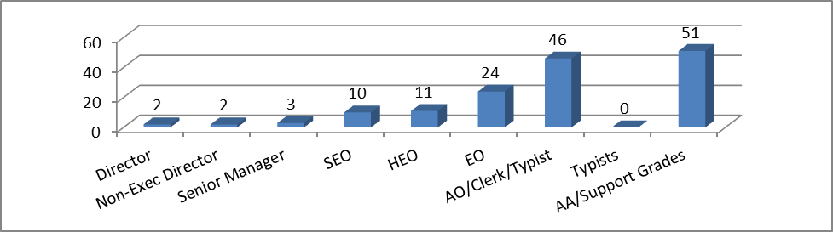
Table 2.8
The applications totals differ from the totals in tables 2.13, 2.14 and 2.15 because the report takes the advertising start date to retrieve the data. The other tables use the date that applications were last updated on EROL.
Voluntary Turnover and Application Rates by Sheriffdom/Unit
Sheriffdom/Unit | ⁵Voluntary  Turnover |  | ⁵Non-Voluntary  Turnover |  | ⁵Total  Turnover |  | Total number of applications  received for jobs  advertised in year
Sheriffdom/Unit | No. | % | No. | % | No. | % | Internal | External
Supreme Courts | 14 | 8.0 | 5 | 2.9 | 19 | 10.9 | 50 | 56
Grampian, Highland & Islands | 19 | 10.7 | 1 | 0.6 | 20 | 11.3 | 15 | 831
Glasgow & Strathkelvin | 7 | 3.4 | 2 | 1.0 | 9 | 4.4 | 82 | 381
Lothian & Borders | 13 | 7.0 | 4 | 2.2 | 17 | 9.1 | 24 | 347
North Strathclyde | 7 | 3.9 | 0 | 0.0 | 7 | 3.9 | 31 | 233
South Strathclyde, Dumfries & Galloway | 8 | 4.2 | 1 | 0.5 | 9 | 4.7 | 80 | 289
Tayside, Central and Fife | 20 | 9.1 | 7 | 3.2 | 27 | 12.3 | 37 | 415
Office of the Public Guardian | 7 | 8.8 | 4 | 5.0 | 11 | 13.8 | 35 | 73
Tribunals Operations | 1 | 0.9 | 4 | 3.5 | 5 | 4.4 | 1 | 13
Headquarters | 11 | 6.1 | 10 | 5.5 | 21 | 11.6 | 38 | 56
Judicial Office | 2 | 5.7 | 2 | 5.7 | 4 | 11.4 | 15 | 0
Advertised as ‘Various’ |  |  |  |  |  |  | 6 | 0
Overall Totals | 109 | 6.3 | 40 | 2.3 | 149 | 8.6 | 498 | 3,057
⁵ These figures are calculated by dividing the number of leavers by the head count at 31st March 2016.

Table 2.9
Recruitment Appointments During Year
Grade | Total | Female | Male | Ethnic  Minorities | Disabled
Director | 0 | 0 | 0 | 0 | 0
Non-Executive Director | 0 | 0 | 0 | 0 | 0
Senior Manager | 2 | 2 | 0 | 0 | 0
SEO | 5 | 3 | 2 | 0 | 1
HEO | 0 | 0 | 0 | 0 | 0
EO | 0 | 0 | 0 | 0 | 0
AO & Clerk/Typist | 60 | 42 | 18 | 0 | 5
Typists | 0 | 0 | 0 | 0 | 0
AA & Support Grades | 82 | 43 | 39 | 0 | 3
⁶Total (Headcount) | 149 | 90 | 59 | 0 | 9
⁶ These figures only list appointments made through EROL and therefore do not include data on Non-Executive Director appointments which are managed under a separate process. The data in the final 2 columns may not be fully representative as these columns are non-mandatory on the application form. Additionally, the figures are only for external appointments; the internal application process does not ask candidates to specify these details

Table 2.10
Average Recruitment Cost : £3,217 per vacancy
(Includes advertising spend, staff time for sift and interviews, sundries (lunch, materials, T&S) and pre-employment screening). This is a combined internal and external cost.

Cost without pre-employment screening = £3,023 per vacancy

Table 2.11
⁷Average Recruitment Journey Length: 56 Days

⁷ Includes 30 days for pre-employment checks (Disclosure, Health and references) and notice period of new starts.

Table 2.12
Reasons for Applicants Applying for Posts in SCTS as Recorded on EROL
Reason | Total Scores | Ranked (1-Most Important 11-least)
I want to work in the justice sector in Scotland | 448 | 2
Job security | 73 | 8
Overall reward package is attractive | 13 | 10
SCTS will develop my skill set and make use of my transferable skills | 960 | 1
I want to work for Civil Service | 157 | 4
I need a job | 19 | 9
Company Reputation | 112 | 6
Clear career path available in SCTS | 125 | 5
The job looks interesting | 331 | 3
I am looking for my first job | 9 | 11
Other | 98 | 7

Table 2.13
Applications Received (Ethnic Origin and Gender) for Posts in SCTS
Ethnic Group | Male | Female | Other/Not Declared | Total Number of Applications | Approx. % of total apps
Unclassified | 1 | 2 | 0 | 3 | 0.1
African | 3 | 9 | 0 | 12 | 0.5
African British | 1 | 0 | 0 | 1 | 0.0
African Scottish | 1 | 0 | 0 | 1 | 0.0
Arab | 1 | 0 | 0 | 1 | 0.0
Arab Scottish | 1 | 0 | 0 | 1 | 0.0
Asian | 1 | 4 | 0 | 5 | 0.2
Asian British | 3 | 3 | 0 | 6 | 0.3
Black | 1 | 0 | 0 | 1 | 0.0
Black British | 0 | 1 | 0 | 1 | 0.0
Black Scottish | 0 | 1 | 0 | 1 | 0.0
Caribbean | 0 | 1 | 0 | 1 | 0.0
Caribbean British | 1 | 0 | 0 | 1 | 0.0
Caribbean Scottish | 1 | 1 | 0 | 2 | 0.1
Chinese | 1 | 2 | 0 | 3 | 0.1
Chinese British | 0 | 2 | 0 | 2 | 0.1
Chinese Scottish | 0 | 1 | 0 | 1 | 0.0
Indian | 2 | 1 | 0 | 3 | 0.1
Indian Scottish | 2 | 1 | 0 | 3 | 0.1
Irish | 2 | 4 | 0 | 6 | 0.3
Mixed or multiple | 3 | 9 | 0 | 12 | 0.5
Other Asian | 0 | 1 | 0 | 1 | 0.0
Other Ethnic Origin | 1 | 3 | 0 | 4 | 0.1
Other White | 21 | 44 | 0 | 65 | 2.8
Pakistani | 3 | 4 | 0 | 7 | 0.2
Pakistani British | 3 | 10 | 0 | 13 | 0.6
Pakistani Scottish | 6 | 6 | 0 | 12 | 0.5
Polish | 6 | 19 | 0 | 25 | 1.0
Prefer not to answer | 7 | 5 | 0 | 12 | 0.5
Scottish | 424 | 901 | 3 | 1,328 | 57.0
White British | 331 | 480 | 0 | 811 | 35.0
Total | 827 | 1,515 | 3 | 2,345 | 100.0

Table 2.14
Applications Received (Disability) for Posts in SCTS
Disabled | Male | Female | Other/Not Declared | Total
No | 748 | 1,393 | 3 | 2,144
Not declared | 8 | 22 | 0 | 30
Yes | 71 | 100 | 0 | 171
Total | 827 | 1,515 | 3 | 2,345

Table 2.15
Applications Received (Age Group) for Posts in SCTS
Age  Range | Total Number of Applications | % of Total  Applications
16 – 24 years | 459 | 19.6
25 – 29 years | 416 | 17.7
30 – 34 years | 259 | 11.0
35 – 39 years | 173 | 7.4
40 – 44 years | 165 | 7.0
45 – 49 years | 261 | 11.1
50 – 54 years | 286 | 12.2
55 – 59 years | 235 | 10.0
60 – 64 years | 83 | 3.5
65+ years | 8 | 0.3
Total | 2,345 | 100.0

Total Applications Received by Age Band
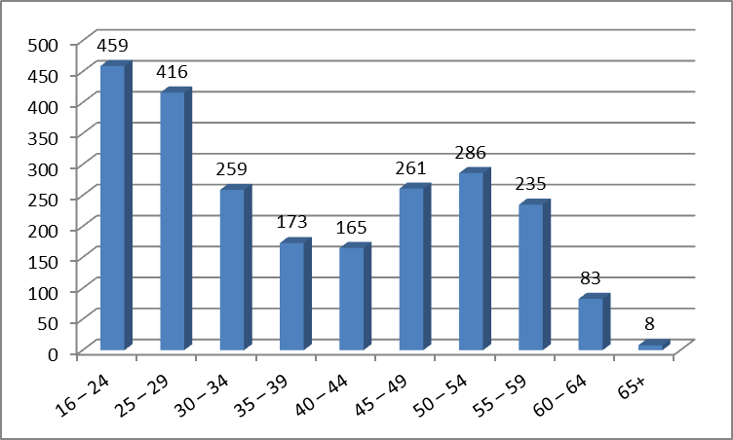

Section 3: Employee Learning

Table 3.1
Learning Data by Sheriffdom/Unit
Sheriffdom/Unit | Average Days of Formal Learning per Employee | Number of staff who completed ⁹SVQs/ILMs 15/16 | ¹⁰% of staff who completed  ⁹SVQs/ILMs  15/16 | ¹¹Average  L&D  Evaluation Score
Supreme Courts | 1.3 | 8 | 4.5 | 3.3
Grampian, Highland & Islands | 2.0 | 4 | 2.5 | 3.2
Glasgow & Strathkelvin | 1.4 | 2 | 1.0 | 3.0
Lothian & Borders | 2.9 | 11 | 6.2 | 3.3
North Strathclyde | 1.9 | 4 | 2.3 | 2.9
South Strathclyde, Dumfries & Galloway | 1.4 | 1 | 0.5 | 3.1
Tayside, Central and Fife | 3.0 | 11 | 5.3 | 3.1
Office of the Public Guardian | 2.1 | 3 | 3.6 | 3.3
Tribunals Operations | 1.0 | 3 | 2.4 | 3.6
Headquarters | 1.1 | 6 | 3.9 | 3.0
Judicial Office | 0.4 | 0 | 0.0 | 3.1
Total | ⁸1.8 | 53 | 3.2 | 3.2

⁸ The CIPD Annual Survey Report, Learning & Development 2015 averages at 3.2 days.
⁹ In Tables 1 and 2, SVQs = Scottish Vocational Qualifications and ILM = Institute of Leadership and Management.
¹⁰ Based on headcount of 1676 (head count minus non-executive directors and zero hours staff)
¹¹ L&D = Learning and Development with evaluation scores based on 1= low and 4 = high.

Table 3.2
Learning Days Profile
Category | Days | Events
Technical (inc. Floor-walking) | 1,059.0 | 102
Desk Training | 156.3 | -
General | 419.0 | 43
IT | 9.0 | 2
Management | 423.0 | 44
Personal | 13.0 | 2
E-Learning | 633.3 | -
⁹SVQs/ILM | 447.0 | -
Totals | 3,059.6 | 193

Table 3.3
Cost per Learning Day: £256¹²
¹² Based on the total investment in L&D for 2015/16 divided by the number of recorded training days for 2015/16.

Table 3.4
L&D Investment as a % of SCTS Pay Bill: 1.7%

Table 3.5
Number of Learning Days per Grade Recorded for Female and Male Staff for Workshops
F/M | AA | SGB1/2 | AO | SM3 | EO | HEO | SEO | Gd7 | Gd6 | Gd5 | Gd4 | Total
F | 4.0 | 141.0 | 685.0 | 2.0 | 419.0 | 51.5 | 35.0 | 4.0 | 0.0 | 0.0 | 0.0 | 1341.5
M | 6.0 | 148.0 | 191.0 | 3.0 | 155.5 | 29.0 | 9.0 | 2.0 | 1.0 | 0.0 | 0.0 | 544.5
Total | 10.0 | 289.0 | 876.0 | 5.0 | 574.5 | 80.5 | 44.0 | 6.0 | 1.0 | 0.0 | 0.0 | 1,886.0

Table 3.6
Disability/Ethnicity: Access to Learning for Staff with a Disability and Ethnicity Non - White
Staff  Headcount | Staff with  a Disability | % Staff with  a Disability | Staff With  Ethnicity Non- White | % Staff With  Ethnicity Non- White
1,742 | 73 | 4.2% | 13 | 0.7%
Total Workshop  Training Days | Training Days for Staff with a Disability | % Training Days for Staff with a Disability | Training Days: Staff Ethnicity Non- White | % Training Days: Staff Ethnicity Non- White
1,886 | 83.5 | 4.4 | 4 | 0.1%

Section 4: Employee Reward

Table 4.1
Percentage of Staff on Pay Range Target Rate from September 2015
Grade | Total % | Female % | Male %
Director | ¹³50.0 | 0.0 | 83.3
Non-Executive Director | ¹⁴0.0 | 0.0 | 0.0
Senior Manager | 46.2 | 48.0 | 42.9
SEO | 73.9 | 66.7 | 84.0
HEO | 62.4 | 56.7 | 71.7
EO | 76.7 | 76.6 | 76.7
AO & Clerk/Typist | 62.8 | 65.5 | 54.2
Typists | 90.0 | 91.1 | 88.8
AA & Support Grades | 100.0 | 100.0 | 0.0
Average (Headcount) | 71.9 | 71.0 | 73.5
¹³ For Tables 4.1 and 4.2, this is based only on Grade 6 Directors in SCTS.
¹⁴ For Tables 4.1 and 4.2, not applicable to Non-Executive Directors who are paid on an hourly rate.

Table 4.2
Percentage of Staff on Pay Range Target Rate from September 2016
Grade | Total % | Female % | Male %
Director | ¹³80.0 | 50.0 | 100.0
Non-Executive Director | ¹⁴0.0 | 0.0 | 0.0
Senior Manager | 54.1 | 59.1 | 46.7
SEO | 74.8 | 70.1 | 81.3
HEO | 71.6 | 68.1 | 77.0
EO | 99.5 | 99.7 | 99.2
AO & Clerk/Typist | 70.2 | 73.0 | 61.7
Typists | 98.7 | 98.1 | 99.3
AA & Support Grades | 100.0 | 100.0 | 0.0
Average (Headcount) | 83.6 | 83.3 | 84.2

Table 4.3
Instant Rewards (Special Recognition): Distribution by Sheriffdom/Unit (£)
Sheriffdom/Unit | Total | ¹⁵Average | Team | Female | Male
Supreme Courts | 5,199 | 30 | 604 | 2,700 | 1,895
Grampian, Highland & Islands | 2,821 | 16 | 346 | 2,025 | 450
Glasgow & Strathkelvin | 3,335 | 16 | 0 | 2,425 | 910
Lothian & Borders | 1,570 | 8 | 0 | 965 | 605
North Strathclyde | 4,190 | 23 | 0 | 3,175 | 1,015
South Strathclyde, Dumfries & Galloway | 2,340 | 12 | 0 | 1,700 | 640
Tayside, Central and Fife | 2,050 | 9 | 0 | 1,565 | 485
Office of the Public Guardian | 345 | 4 | 0 | 210 | 135
Tribunals Operations | 2,095 | 18 | 0 | 1,060 | 1,035
Headquarters | 5,555 | 31 | 0 | 2,895 | 2,660
Judicial Office | 600 | 17 | 0 | 310 | 290
Total | 30,100 | 17 | 950 | 19,030 | 10,120
¹⁵ For Tables 4.3, 4.4, 4.7 and 4.9 the average is based on the total amount divided by the headcount for each Sheriffdom/Unit.

Table 4.4
Instant Rewards (covering what was Substitution): Distribution by Sheriffdom/Unit (£)
Sheriffdom/Unit | Total | Average | Female | Male
Supreme Courts | 4,085 | 23 | 3,055 | 1,030
Grampian, Highland & Islands | 325 | 2 | 295 | 30
Glasgow & Strathkelvin | 9,615 | 47 | 7,550 | 2,065
Lothian & Borders | 9,465 | 51 | 6,005 | 3,460
North Strathclyde | 2,775 | 16 | 2,305 | 470
South Strathclyde, Dumfries & Galloway | 1,170 | 6 | 800 | 370
Tayside, Central and Fife | 1,025 | 5 | 950 | 75
Office of the Public Guardian | 225 | 3 | 185 | 40
Tribunals Operations | 1,300 | 11 | 860 | 440
Headquarters | 0 | 0 | 0 | 0
Judicial Office | 0 | 0 | 0 | 0
Total | 29,985 | 17 | 22,005 | 7,980

Table 4.5
Instant Rewards (Special Recognition): Distribution by Grade (£)
Grade | Total | Team | Female | Male
Director | 0 | 0 | 0 | 0
Senior Manager | 620 | 0 | 380 | 240
SEO | 2,138 | 13 | 1,045 | 1,080
HEO | 5,313 | 38 | 3,230 | 2,045
EO | 8,772 | 147 | 5,460 | 3,165
AO & Clerk/Typist | 9,333 | 248 | 6,980 | 2,105
Typists | 50 | 0 | 50 | 0
AA & Support Grades | 3,466 | 96 | 1,885 | 1,485
Grade not identified | 408 | 408 | 0 | 0
Total | 30,100 | 950 | 19,030 | 10,120

Table 4.6
Instant Rewards (covering what was Substitution): Distribution by Grade (£)
Grade | Total | Female | Male
Director | 0 | 0 | 0
Senior Manager | 30 | 0 | 30
SEO | 395 | 220 | 175
HEO | 3,015 | 2,310 | 705
EO | 7,245 | 5,925 | 1,320
AO & Clerk/Typist | 15,450 | 10,800 | 4,650
Typists | 0 | 0 | 0
AA & Support Grades | 3,850 | 2,750 | 1,100
Grade not identified | 0 | 0 | 0
Total | 29,985 | 22,005 | 7,980

Table 4.7
Overtime: Distribution by Sheriffdom/Unit (£)
Sheriffdom/Unit | Total | Average | Female | Male
Supreme Courts | 36,119 | 206 | 22,926 | 13,193
Grampian, Highland & Islands | 21,493 | 121 | 13,808 | 7,685
Glasgow & Strathkelvin | 36,274 | 177 | 29,219 | 7,055
Lothian & Borders | 25,198 | 135 | 15,138 | 10,060
North Strathclyde | 36,695 | 206 | 27,306 | 9,389
South Strathclyde, Dumfries & Galloway | 41,240 | 215 | 29,867 | 11,373
Tayside, Central and Fife | 28,247 | 129 | 23,700 | 4,547
Office of the Public Guardian | 16,361 | 205 | 13,116 | 3,245
Tribunals Operations | 9,372 | 82 | 4,695 | 4,677
Headquarters | 46,005 | 254 | 14,933 | 31,072
Judicial Office | 4,066 | 116 | 2,714 | 1,352
Total | 301,070 | 173 | 197,422 | 103,648

Table 4.8
Overtime: Distribution by Grade (£)
Grade | Total | Female | Male
Director | 0 | 0 | 0
Non-Executive Director | 0 | 0 | 0
Senior Manager | 5,273 | 4,239 | 1,034
SEO | 40,307 | 31,063 | 9,244
HEO | 52,302 | 28,356 | 23,946
EO | 97,788 | 58,172 | 39,616
AO & Clerk/Typist | 58,294 | 45,877 | 12,417
Typists | 15 | 15 | 0
AA & Support Grades | 47,091 | 29,700 | 17,391
Total | 301,070 | 197,422 | 103,648

Table 4.9
Travel Time: Distribution by Sheriffdom/Unit (£)
Sheriffdom/Unit | Total | Average | Female | Male
Supreme Courts | 36,920 | 211 | 18,004 | 18,917
Grampian, Highland & Islands | 24,767 | 140 | 14,572 | 10,196
Glasgow & Strathkelvin | 2,468 | 12 | 1,502 | 966
Lothian & Borders | 5,849 | 31 | 3,479 | 2,370
North Strathclyde | 8,424 | 47 | 2,430 | 5,995
South Strathclyde, Dumfries & Galloway | 5,520 | 29 | 2,072 | 3,448
Tayside, Central and Fife | 6,947 | 32 | 1,786 | 5,161
Office of the Public Guardian | 2,574 | 32 | 2,103 | 471
Tribunals Operations | 2,124 | 19 | 1,741 | 383
Headquarters | 12,892 | 71 | 6,743 | 6,149
Judicial Office | 298 | 9 | 240 | 58
Total | 108,784 | 62 | 54,672 | 54,112

Table 4.10
Travel Time: Distribution by Grade (£)
Grade | Total | Female | Male
Director | 0 | 0 | 0
Non-Executive Director | 0 | 0 | 0
Senior Manager | 1,323 | 1,199 | 123
SEO | 6,625 | 3,894 | 2,731
HEO | 41,700 | 25,575 | 16,125
EO | 36,866 | 14,467 | 22,399
AO & Clerk/Typist | 11,160 | 6,723 | 4,437
Typists | 0 | 0 | 0
AA & Support Grades | 11,111 | 2,814 | 8,297
Total | 108,784 | 54,672 | 54,112

Table 4.11
Average Salary: Distribution by Grade¹⁶ (£)
Grade | Overall  Average
Director | 68,405
Non-Executive Director | 2,225
Senior Manager | 50,430
SEO | 37,827
HEO | 29,775
EO | 24,675
AO & Clerk/Typist | 18,892
Typists | 16,900
AA & Support Grades | 16,886
¹⁶ This data does not include Zero Hours contracts

Table 4.12
Average Salary Cost ¹⁷ | Total (£) | Comparison v Average Salary Cost 2014/15
All SCTS | 28,598 | 1.0% increase on average salary for 2014/15 (£28,323)
¹⁷ The average salary cost is calculated by multiplying the Average Salary by Grade in Table 4.11 by the headcount (Page 1, Table 1.1) for each Grade and dividing the total by the overall headcount. Employer costs of 22.3% based on a comparison of the salary against a table of employer costs for each grade point are then added.

Table 4.13
Allowances Paid to Staff: Distribution by Allowance
Allowance | No of Staff | Total (£)
Distant Islands Allowance | 4 | 9,811
First Instance Depute Clerk Allowance | 35 | 55,901
High Work Volume Salary Supplement | 6 | 11,905
Out of Hours Allowance | 94 | 66,246
Recruitment & Retention Allowance | 34 | 67,315
Relief Officer Allowance | 24 | 35,402
Total | 197 | 246,580

Table 4.14

Zero Hours Contracts: Distribution by Sheriffdom/Unit¹⁸
Sheriffdom/Unit | ¹⁹Zero Hours Contract Staff Paid in 2015/16 | Cost of Zero Hours Contracts (£) | ¹⁹Total Number of Monthly Payments | ²⁰Average Monthly Payment (£) | ²¹Maximum Single Monthly Payment (£)
Supreme Courts | 7 | 63,610 | 73 | 871 | 1,659
Grampian, Highland & Islands | 12 | 36,794 | 60 | 613 | 2,476
Glasgow & Strathkelvin | 0 | 0 | 0 | 0 | 0
Lothian & Borders | 5 | 23,388 | 34 | 688 | 2,271
North Strathclyde | 4 | 18,520 | 40 | 463 | 1,109
South Strathclyde, Dumfries & Galloway | 2 | 4,037 | 11 | 367 | 839
Tayside, Central and Fife | 2 | 14,532 | 16 | 908 | 3,782
Office of the Public Guardian | 0 | 0 | 0 | 0 | 0
Tribunals Operations | 0 | 0 | 0 | 0 | 0
Headquarters | 2 | 17,219 | 23 | 749 | 1,256
Judicial Office | 0 | 0 | 0 | 0 | 0
Total | 34 | 178,099 | 257 | 693 | 3,782
¹⁸ SCTS has reviewed our policy and offered a transfer to a part time contract to all zero hours staff and those remaining on zero hours contracts have exercised their right to do so. Staff on zero hours contracts are entitled to benefits such as sick pay and holiday pay and we are clear zero hours contracts must only be used for ad hoc provision where it would not be feasible to have a permanent employee to provide cover and we work closely with our recognised union, the PCS, on this matter.
¹⁸ The information in Tables 14 and 15 is based on payments within the reporting period – Hours may have been worked outside of the period.
¹⁹ The information in Total Number of Monthly Payments in Tables 14 and 15 refers to the total number of monthly payments made to all zero hours staff in that Sheriffdom/Unit.
²⁰ The information in Average Monthly Payment in tables 14 and 15 refers to the average monthly payment calculated by dividing the Cost of zero hours contracts by the Total Number of Monthly Payments.
²¹ The Maximum Single Monthly Payment in tables 14 and 15 shows the single largest monthly amount paid to a zero hours member of staff in each Sheriffdom/Unit. The figure in the Total row refers to the largest payment from the Sheriffdoms/Units or Grade.

Table 4.15
Zero Hours Contracts: Distribution by Grade¹⁸
Grade | Zero Hours Contract Staff Paid in 2015/16 | Cost of Zero Hours Contracts (£) | ¹⁹Total Number  of Monthly Payments | ²⁰Average Monthly Payment (£) | ²¹Maximum Single Monthly Payment (£)
Director | 0 | 0 | 0 | 0 | 0
Senior Manager | 0 | 0 | 0 | 0 | 0
Non-Executive Director | 0 | 0 | 0 | 0 | 0
SEO | 1 | 10,634 | 6 | 1,772 | 3,782
HEO | 1 | 11,433 | 12 | 953 | 1,256
EO | 3 | 8,161 | 16 | 510 | 1,357
AO & Clerk/Typist | 6 | 22,203 | 29 | 766 | 2,271
Typists | 0 | 0 | 0 | 0 | 0
AA & Support Grades | 23 | 125,668 | 194 | 648 | 2,476
Total | 34 | 178,099 | 257 | 693 | 3,782

Zero Hours Contract Staff Paid 2015/16 – by Grade
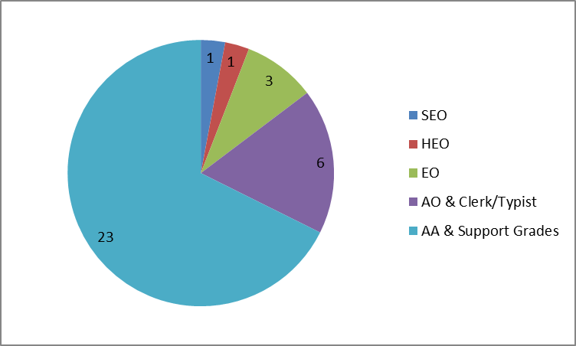
Table 4.16
Total Staff Salary Costs: £46,304,781
Section 5: Employee Relations

Table 5.1
2015/16 Data
Staff Engagement Index from Civil Service Staff Survey 2015 | 62%
Civil Service Median Staff Engagement Index from Civil Service Staff Survey 2015 | 58%
% of SCTS staff completing Staff Survey | 74%
% of SCTS staff who are members of PCS (Payroll Data Only) | 43.0%
Days lost to industrial action | 0 days
Number of Formal Grievances Recorded | 1
Number of Formal Disciplinary Penalties awarded | 18 (14 First Written Warnings; 2 Second Written Warnings; 2 Final Written Warnings)
Number of dismissals | 0
Number of staff who had probation period extended | 18
Number of staff managed under poor performance arrangements as recorded in Final IPR report | 1
Number of reported Health and Safety Incidents | 72
Number of RIDDOR H&S Incidents | 4
²²Number of reported Security Incidents | 156
Number of Reported Data Breaches | 14
²² The Security Incidents figure does not include confiscations, which are recorded separately.

Section 6: Protected Characteristics
Please note: other Protected Characteristics information is available in other sections within the Scorecard.

Table 6.1 Table 6.2
All Staff - Ethnicity |  |  | All Staff - Ethnic Group
Ethnicity | No of Staff |  | Ethnic Group | No of Staff
White | 811 |  | White | 810
Prefer not to declare Ethnic Origin | 482 |  | Not declared | 482
Unknown | 379 |  | Unknown | 438
White - English/Welsh/Scottish/N Irish | 57 |  | ²³Other Ethnic Group | 12
²³Other Ethnicity | 13 |  | Total | 1,742
Total | 1,742
²³ For tables 6.1 – 6.5, where the number of staff in a category is less than 5, categories have been grouped to preserve anonymity.

Table 6.3 Table 6.4
All Staff - Religion |  |  | All Staff – Marital Status
Religion | No of Staff |  | Marital Status | No of Staff
Unknown | 1,156 |  | Married | 921
Christian Protestant | 233 |  | Single | 630
No Religion | 108 |  | Divorced | 122
Christian Roman Catholic | 104 |  | Ex-Married | 26
Prefer not to declare Religion or Belief | 79 |  | Widow/er | 26
Christian Other | 36 |  | Unknown | 11
²³Other Religion or Belief | 26 |  | Civil Partner | 6
Total | 1,742 |  | Total | 1,742

Table 6.5
All Staff - Sexual Orientation
Sexual Orientation | No of Staff
Unknown | 1,170
Heterosexual | 476
Prefer Not to Declare Sexual Orientation | 75
²³Gay Man/Bisexual | 13
²³Gay Woman/Lesbian/Bisexual | 8
Total | 1,742

Section 7: HRU Consultancy and Outsourced Learning Delivery

Table 7.1
HR Consultancy & Outsourced Learning Delivery Spend
HR Activity | Amount (£)
Recruitment | 6,061
Legal Costs | 11,069
HR Consultancy | 4,356
²⁴HR IT Consultancy | 11,762
Health & Safety Training | 0
Job Related Training | 16,324
²⁵Corporate Training | 20,437
Total | 70,009
²⁴ These figures do not include updates to EROL including Situational Judgment Tests or HR projects.
²⁵ These figures do not include information on the Further Education spend.

Section 8: Data Trends

Table 8.1
Key Data Trends Over Last 5 Years
(HRU have identified the four key corporate indicators below as indicators for trend analysis)
 |  | 15/16 | 14/15 | 13/14 | 12/13 | 11/12
Headcount | Data | ²⁶1,742 | 1,603 | 1,551 | 1,539 | 1,516
Headcount | +/- Prev Yr | +8.7% | +3.4% | +0.8% | +1.5% | -6.5%
Turnover (Voluntary) | Data | 109 | 119 | 92 | 83 | 172
Turnover (Voluntary) | +/- Prev Yr | -8.4% | +29.3% | +10.8% | -51.7% | +196.6%
Average  Absence Days | Data | 12.6 | 12.0 | 10.7 | 11.8 | 10.3
Average  Absence Days | +/- Prev Yr | +5.0% | +12.1% | -9.3% | +14.6% | -7.2%
Training Days | Data | 3,059.6 | 3,000.7 | 3,735.0 | 3,469.9 | 3,298.3
Training Days | +/- Prev Yr | +2.0% | -19.7% | +7.6% | +5.2% | -25.4%
²⁶ The increase in Headcount in 2015/16 is due to the merger with Scottish Tribunals Service in April 2015.

Section 9: HR Performance Indicators

Table 9.1
Key Indicators of HR Performance
Indicator | Performance
Payroll: Cost per payslip | £4.48
Payroll Accuracy | 99.9%
Ratio – HR Unit compared to all SCTS staff | 1:48
Ratio – L&D Teams compared to SCTS staff | 1:121
Ratio – HR Unit (not L&D) compared to SCTS staff | 1:79
HR cost per employee | £813
Average Recruitment Cost | £3,217
Average Recruitment Journey | 56 days
Cost per training day | £256
HR Query Tracker April 2015 – Mar 2016 | Overall 98.2 % of queries resolved within KPI Time Limits  98.4 % of Standard Queries resolved within KPI (3 days)  96.2 % of Complex Queries resolved within KPI (10 days)
Number of Complaints | 4 (1 Upheld, 3 Not Upheld)
% of staff who receive contract within 28 days of employment start | 100%
Average L&D evaluation rating | 3.2

Human Resources Unit
Scottish Courts & Tribunals Service
October 2016

